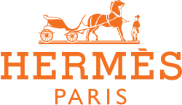

PRODUCT PROFILE

Name: Terre d'Hermès

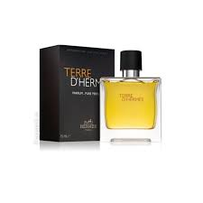
Brand: Hermès
price: $145.00
Gender: Men
Rating: 4.8/5
Description:A symbolic narrative exploring the earth and sky.
Ingredients:
• Orange

• Flint

• Vetiver

• Benzoin

