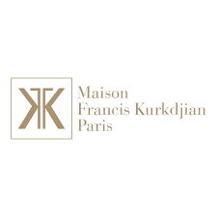

PRODUCT PROFILE

Name: Baccarat Rouge 540

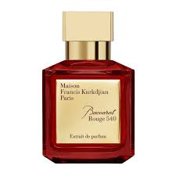
Brand: Maison Francis Kurkdjian
price: $325.00
Gender: Unisex
Rating: 4.9/5
Description:A poetic alchemy of jasmine, saffron, and ambergris.
Ingredients:
• Saffron

• Jasmine

• Amberwood

• Cedar

