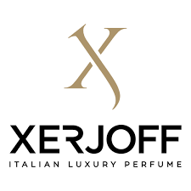

PRODUCT PROFILE

Name: Naxos

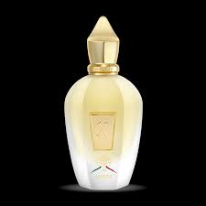
Brand: Xerjoff
price: $250.00
Gender: Unisex
Rating: 4.9/5
Description:A tribute to the deep heart of Sicily.
Ingredients:
• Honey

• Tobacco

• Lavender

• Citrus

