

PRODUCT PROFILE

Name: Daisy

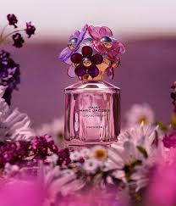
Brand: Marc Jacobs
price: $101.00
Gender: Women
Rating: 4.5/5
Description:A whimsical, bright, and charming floral.
Ingredients:
• Strawberry

• Violet Leaves

• Jasmine

