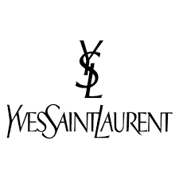

PRODUCT PROFILE

Name: Y Eau de Parfum

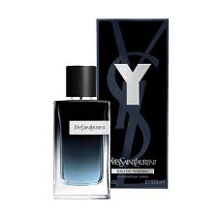
Brand: Yves Saint Laurent
price: $155.00
Gender: Men
Rating: 4.7/5
Description:The scent of accomplishment for the creative man.
Ingredients:
• Sage

• Apple

• Ginger

• Cedar

