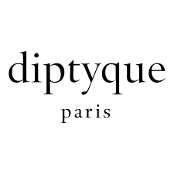

PRODUCT PROFILE

Name: Philosykos

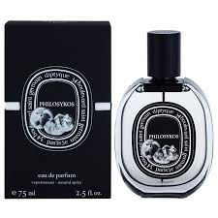
Brand: Diptyque
price: $175.00
Gender: Unisex
Rating: 4.8/5
Description:Memory of a Greek summer at Mount Pelion.
Ingredients:
• Fig Leaf

• Fig Tree Sap

• White Cedar

