

PRODUCT PROFILE

Name: Flowerbomb

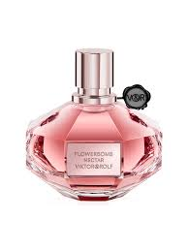
Brand: Viktor
price: $180.00
Gender: Women
Rating: 4.8/5
Description:An explosive floral bouquet that makes everything positive.
Ingredients:
• Cattleya Orchid

• Freesia

• Rose

• Patchouli

