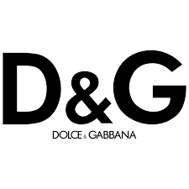

PRODUCT PROFILE

Name: Light Blue Pour Homme

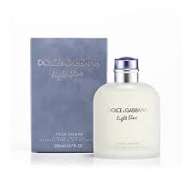
Brand: Dolce
price: $115.00
Gender: Men
Rating: 4.4/5
Description:Captures the fresh spirit of the Mediterranean.
Ingredients:
• Juniper

• Grapefruit

• Oakmoss

• Pepper

