

PRODUCT PROFILE

Name: Imagination

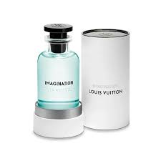
Brand: Louis Vuitton
price: $320.00
Gender: Unisex
Rating: 4.9/5
Description:An infinite creative impulse driven by citrus and tea.
Ingredients:
• Citron

• Black Tea

• Ambrosan

• Cinnamon

