

PRODUCT PROFILE

Name: Born in Roma Donna

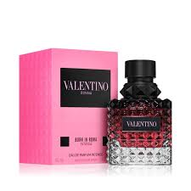
Brand: Valentino
price: $156.00
Gender: Women
Rating: 4.8/5
Description:A high-fashion floriental made of three jasmines.
Ingredients:
• Jasmine

• Vanilla Bourbon

• Blackcurrant

