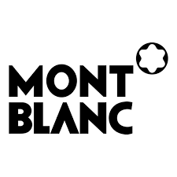

PRODUCT PROFILE

Name: Explorer

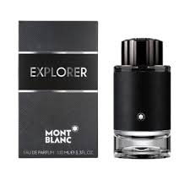
Brand: Montblanc
price: $115.00
Gender: Men
Rating: 4.6/5
Description:A woody-aromatic-leather scent for the adventurer.
Ingredients:
• Bergamot

• Vetiver

• Patchouli

