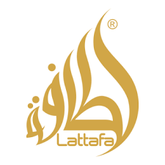

PRODUCT PROFILE

Name: Khamrah

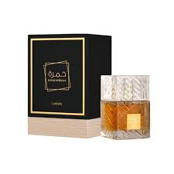
Brand: Lattafa
price: $45.00
Gender: Unisex
Rating: 4.7/5
Description:An oriental vanilla spicy fragrance with a warm trail.
Ingredients:
• Dates

• Cinnamon

• Vanilla

• Amber

