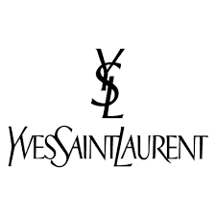

PRODUCT PROFILE

Name: Black Opium

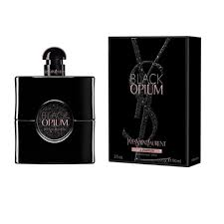
Brand: Yves Saint Laurent
price: $155.00
Gender: Women
Rating: 4.7/5
Description:An addictive gourmand with notes of black coffee and vanilla.
Ingredients:
• Black Coffee

• White Flowers

• Vanilla

