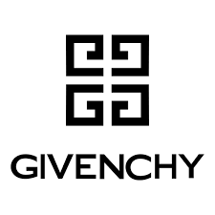

PRODUCT PROFILE

Name: L'Interdit

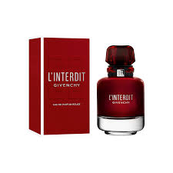
Brand: Givenchy
price: $136.00
Gender: Women
Rating: 4.7/5
Description:A tribute to bold femininity and the thrill of the forbidden.
Ingredients:
• Orange Blossom

• Jasmine

• Patchouli

• Vetiver

