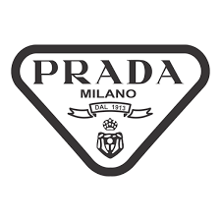

PRODUCT PROFILE

Name: Luna Rossa Ocean

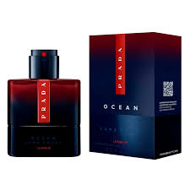
Brand: Prada
price: $125.00
Gender: Men
Rating: 4.5/5
Description:A neo-fresh fragrance exploring new horizons.
Ingredients:
• Bergamot

• Iris

• Vetiver

• Saffron

