

PRODUCT PROFILE

Name: Missing Person

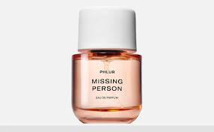
Brand: Phlur
price: $99.00
Gender: Unisex
Rating: 4.2/5
Description:A skin scent that evokes the memory of a loved one.
Ingredients:
• Skin Musk

• Sheer Jasmine

• Sandalwood

