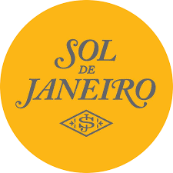

PRODUCT PROFILE

Name: Cheirosa 62

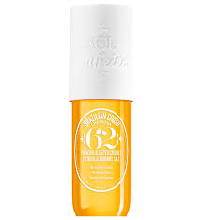
Brand: Sol de Janeiro
price: $38.00
Gender: Women
Rating: 4.9/5
Description:Summer in a bottle inspired by the beaches of Rio.
Ingredients:
• Pistachio

• Salted Caramel

• Vanilla

