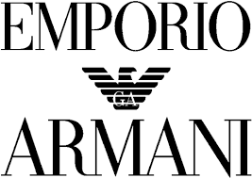

PRODUCT PROFILE

Name: Stronger With You

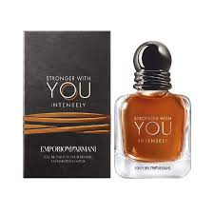
Brand: Emporio Armani
price: $115.00
Gender: Men
Rating: 4.8/5
Description:A charming, mysterious, and confident fragrance.
Ingredients:
• Cardamom

• Chestnut

• Vanilla

• Sage

