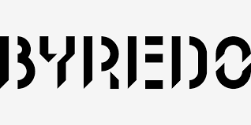

PRODUCT PROFILE

Name: Gypsy Water

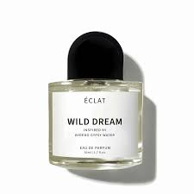
Brand: Byredo
price: $225.00
Gender: Unisex
Rating: 4.6/5
Description:A fever dream of nomadic life in the woods.
Ingredients:
• Juniper Berries

• Lemon

• Pine Needle

• Vanilla

