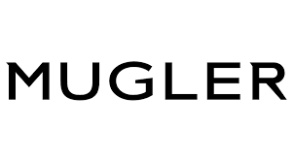

PRODUCT PROFILE

Name: Alien

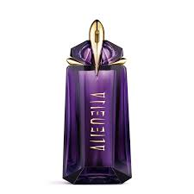
Brand: Mugler
price: $185.00
Gender: Women
Rating: 4.6/5
Description:A solar, mystical fragrance from another world.
Ingredients:
• Jasmine Sambac

• Cashmeran Wood

• White Amber

