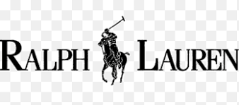

PRODUCT PROFILE

Name: Polo 67

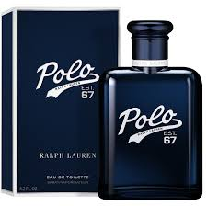
Brand: Ralph Lauren
price: $108.00
Gender: Men
Rating: 4.6/5
Description:The spirit of athletic excellence and masculine power.
Ingredients:
• Bergamot

• Pineapple

• Vetiver

