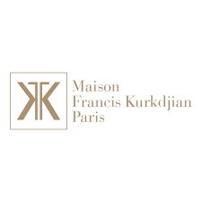

PRODUCT PROFILE

Name: Oud Satin Mood

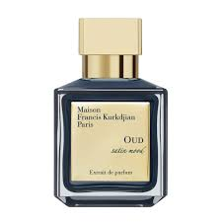
Brand: Maison Francis Kurkdjian
price: $330.00
Gender: Unisex
Rating: 4.8/5
Description:A shimmering oriental fragrance that mimics satin on skin.
Ingredients:
• Oud

• Bulgarian Rose

• Violet

• Vanilla

