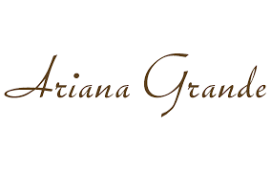

PRODUCT PROFILE

Name: Cloud

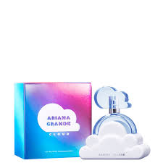
Brand: Ariana Grande
price: $65.00
Gender: Women
Rating: 4.5/5
Description:An uplifting, artistic expression of positivity.
Ingredients:
• Lavender

• Pear

• Coconut Cream

• Praline

