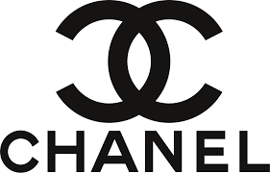

PRODUCT PROFILE

Name: Bleu de Chanel

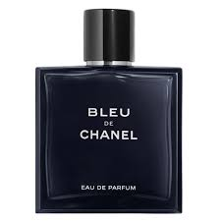
Brand: Chanel
price: $154.00
Gender: Men
Rating: 4.9/5
Description:A tribute to masculine freedom in an aromatic-woody trail.
Ingredients:
• Grapefruit

• Cedar

• Sandalwood

