

PRODUCT PROFILE

Name: Vanilla 28

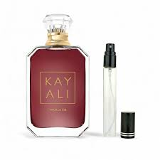
Brand: Kayali
price: $150.00
Gender: Women
Rating: 4.6/5
Description:A masterpiece of refined and cultivated nuance.
Ingredients:
• Vanilla Orchid

• Brown Sugar

• Amber

