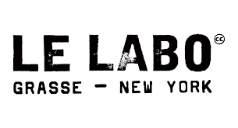

PRODUCT PROFILE

Name: Santal 33

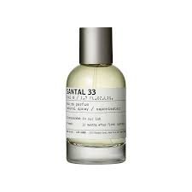
Brand: Le Labo
price: $310.00
Gender: Unisex
Rating: 4.6/5
Description:The soft drift of smoke and an open fire.
Ingredients:
• Sandalwood

• Cardamom

• Leather

• Violet

