

PRODUCT PROFILE

Name: Good Girl

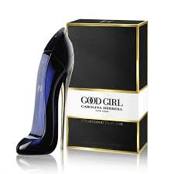
Brand: Carolina Herrera
price: $144.00
Gender: Women
Rating: 4.6/5
Description:A bold blend of dark and light elements.
Ingredients:
• Tuberose

• Tonka Bean

• Cocoa

• Jasmine

