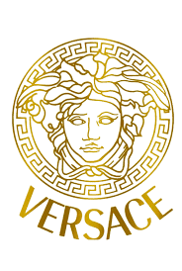

PRODUCT PROFILE

Name: Eros

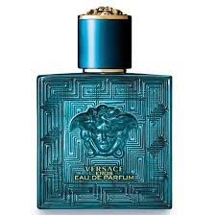
Brand: Versace
price: $105.00
Gender: Men
Rating: 4.6/5
Description:Love, passion, beauty, and desire in a bottle.
Ingredients:
• Mint

• Green Apple

• Vanilla

• Ambrosan

