

PRODUCT PROFILE

Name: Tobacco Vanille

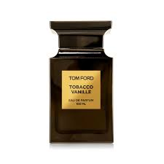
Brand: Tom Ford
price: $295.00
Gender: Unisex
Rating: 4.7/5
Description:A warm English gentleman’s club with spiced tobacco.
Ingredients:
• Tobacco Leaf

• Vanilla

• Cacao

• Tonka Bean

