**Docker and Containers:The Big Picture – Nigel Poulton**

Physical Servers – One application per server

VMware – Multiple applications in a server. There will be a single server and VMware will be just slices of physical server sharing each sharing memory, CPU. But they needed a dedicated OS.

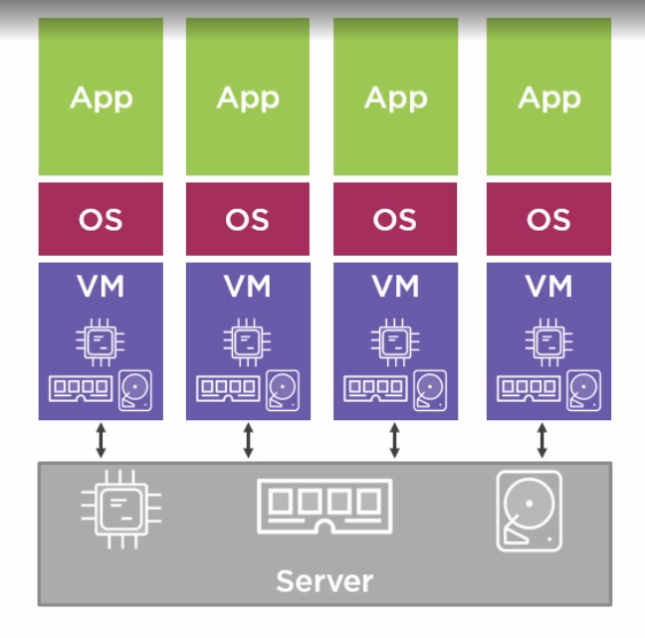

Container Architecture

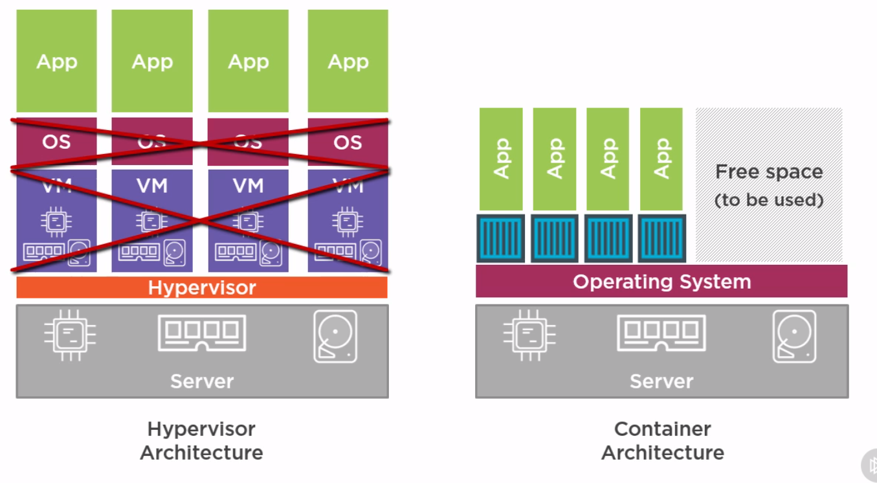

Docker : Container = VMWare : Hypervisor

**Docker Image:**

Image is a stopped or powered off container. It will have a container with a web app. When we kick it off, we have a running web server

To start the container in the image,

*Docker run -d –name web -p 8080:8080 <docker image name>*

This will start the docker in turn the web server

To stop the webserver,

*Docker stop web*

Docker Engine is used for building images and running containers. Security,Orchestration, registry are all built around the engine

Docker hub – repository to store and retrieve docker images

**Docker Hub and Container Registries:**

Docker Hub is the official Docker Registry. Basically store and container images. Third party registry also exist. Registry can have repositories

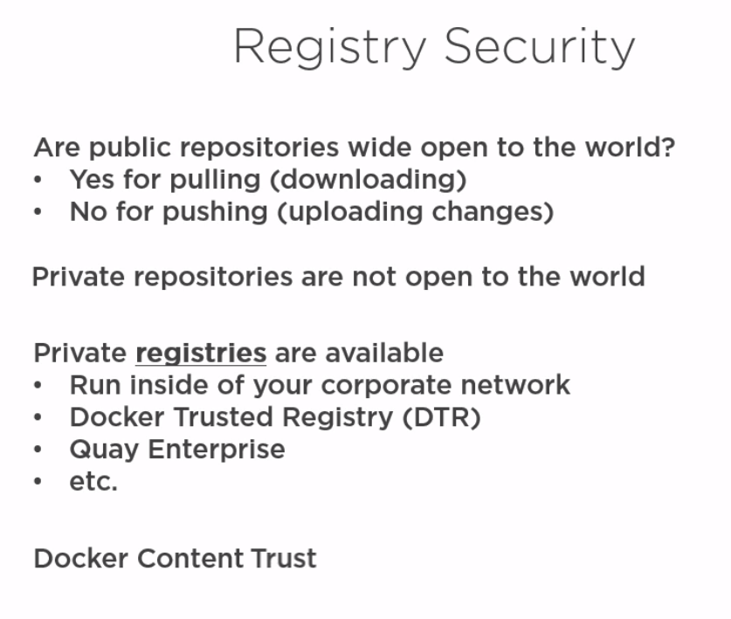

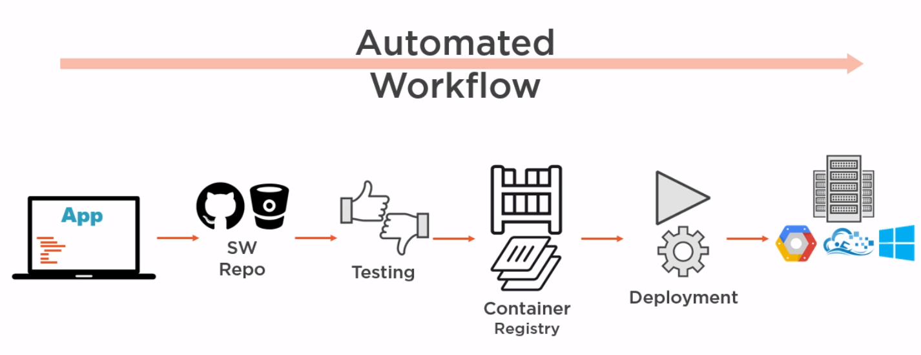

Docker Engine:

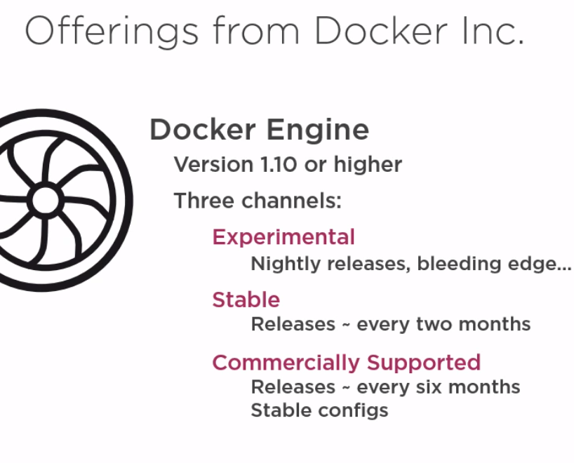

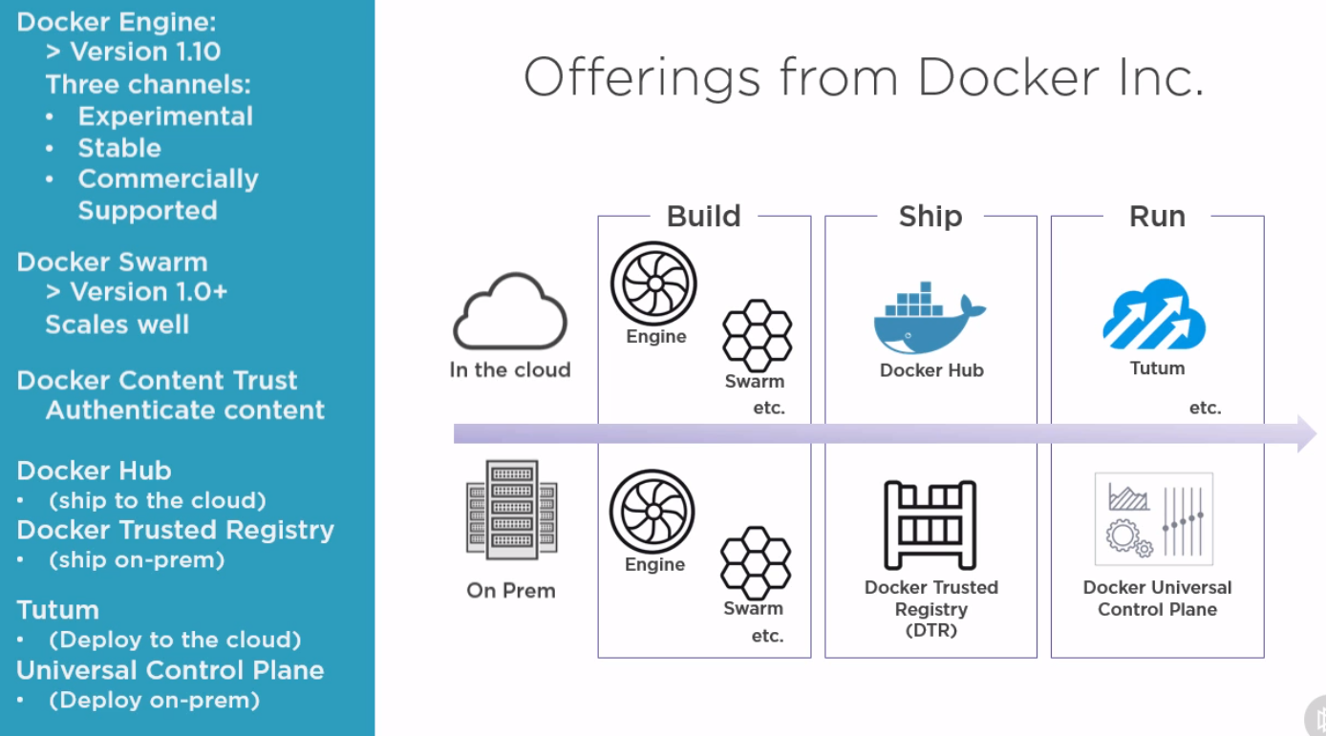

Docker Content trust should be enabled on the docker hub to configure security

**Integrating Docker with DevOPs Automated workflow – Nigel Poulton**

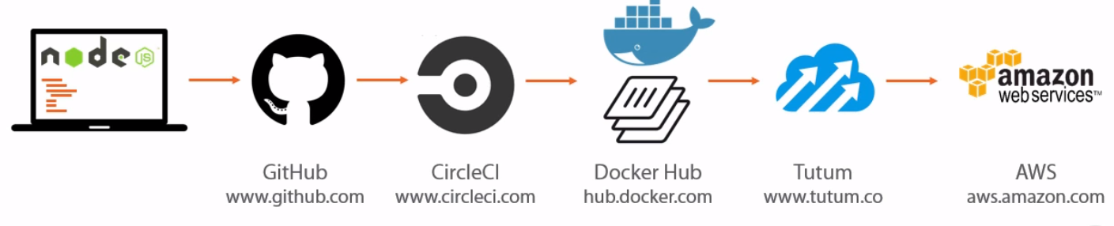

Tutum no longer exists. It is acquired by docker Inc and its named as Docker cloud

Dockerized App – An app configured to run in containers

Docker File – Configuration File containing instructions how to build a Docker Image

Step 1 : Build a node js app

Step 2 : Push the code to GIT HUB

Step 3 : Circle CI – Continuous Integration platform for continuous integration and automated build

1. Log on to Circle CI(<https://circleci.com/>)
2. Grant access to GITHub
3. Select the project
4. Perform a build

Whenever there is a push from git hub, there is a test build in circle which in turn triggers a build in dockerhub. That link between circle ci and dockerhub has to be set up.

Step 4 : Sign up in hub.docker.com/ raajeekumar/Rajee@3483 and link the git hub account with this.

Each time there is a build in circle CI, there will be a new docker image created in docker hub

Step 5 : Next created docker image has to be pushed to production, that is any cloud environment like AWS using Tutum(Docker Cloud).

1. Link Tutum to AWS
2. Create Tutum Node Cluster
3. Create Tutum service
4. Create Docker Hub Web hook – To set up trigger from docker hub to tutum

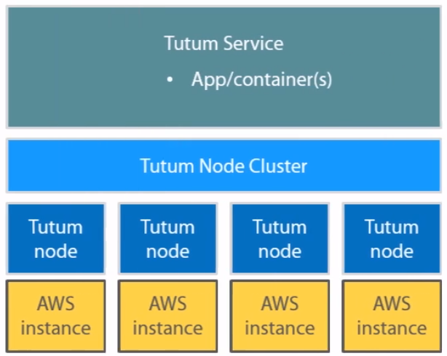

**Getting Started with Docker – Nigel Poulton**