Automated Underwriting Project

Software Architecture Document

Document Version: | 1.7

Revision History Page

Date | Version | Description | Author
10/25/2005 | 1.0 | Initial Version | COGNIZANT
11/01/2005 | 1.1 | Review comments incorporated | COGNIZANT
11/02/2005 | 1.2 | Review comments incorporated | COGNIZANT
11/04/2005 | 1.3 | Review comments incorporated. | COGNIZANT
11/07/2005 | 1.4 | Review comments incorporated. | COGNIZANT
11/08/2005 | 1.5 | Review comments incorporated. | COGNIZANT
11/09/2005 | 1.6 | Review comments incorporated. | COGNIZANT
12/30/2005 | 1.7 | Updated for Dependency Injection | COGNIZANT

Table of Contents
1. Introduction 1
1.1. Purpose 1
1.2. Scope 1
1.3. Intended Audience 1
1.4. Architectural Views 1
2. Architecture Overview 2
2.1. Presentation Tier 4
2.2. Service Tier 5
2.3. Business Tier 6
2.4. Data Access Tier 7
3. Presentation Layer 8
3.1. JSF 8
3.1.1. Validation Framework 8
3.1.2. Action Listener 9
3.1.3. JSF Managed Bean design 9
3.1.4. Managed Bean and Dependency Injection 10
3.2. Presentation Tier – Detailed Flow 11
4. Business Objects 11
5. Service Layer 11
5.1. Business Delegate 11
5.2. AUP Delegate Framework 12
5.3. Service Locator 13
5.4. Session Adapter 14
5.4.1. Different Flow of Sequence Diagram from EJB Layer. 14
6. Business Layer 16
6.1. Application Services 16
7. Data Access Layer 16
7.1. UHG Data Access Framework 17
7.1.1. Class Diagram 17
7.1.2. Generic DB Operation Sequence Diagram 17
7.2. Data Transfer Object 17
8. Connection Pooling 18
8.1. Retrieval of Connection Object 18
9. Transaction Management 18
10. Common Services 19
10.1. Audit Framework 19
10.2. Issue Framework 19
10.3. System Process Framework 19
10.4. Exception Handling 19
10.5. Logging 19
11. Glossaries/ Acronyms 20
12. References 20
13. Appendix A – JSF Lifecycle 21
14. Appendix B - Design Approaches 23
14.1. Validator Framework 23
14.2. Action Listener 23

Introduction

Purpose

The purpose of this document is to formulize the architectural approach on the design and implementation of the projects under AUP program. The key architectural driver is the reuse of existing UT architectural frameworks that helps reusability, portability and extensibility.

Scope

This document outlines the architecture for the Medical Underwriting module of AUP program.

Intended Audience

The intended audience of this System Architecture document is anyone within the Cognizant and Uniprise Technologies team who are part of the development of the Medical Underwriting Application.

Architectural Views

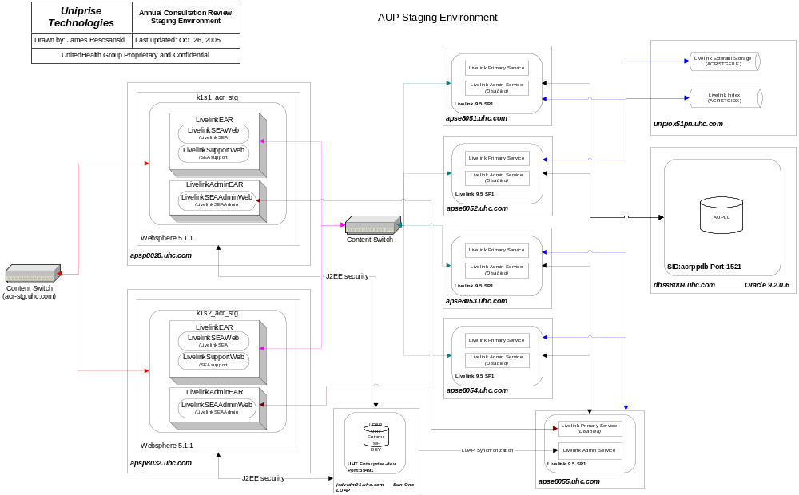

Architecture Overview

The overall architecture is depicted below.

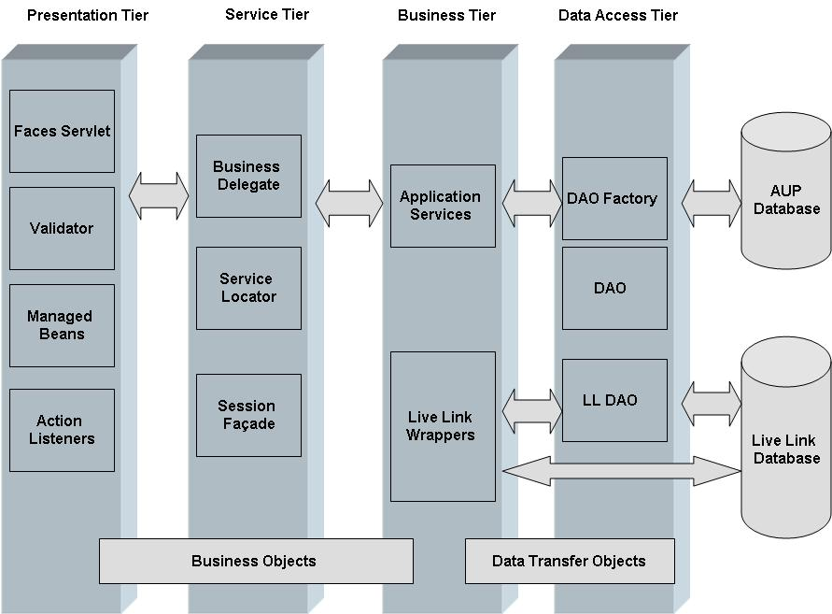

A more detailed flow of the above said architecture is shown below,

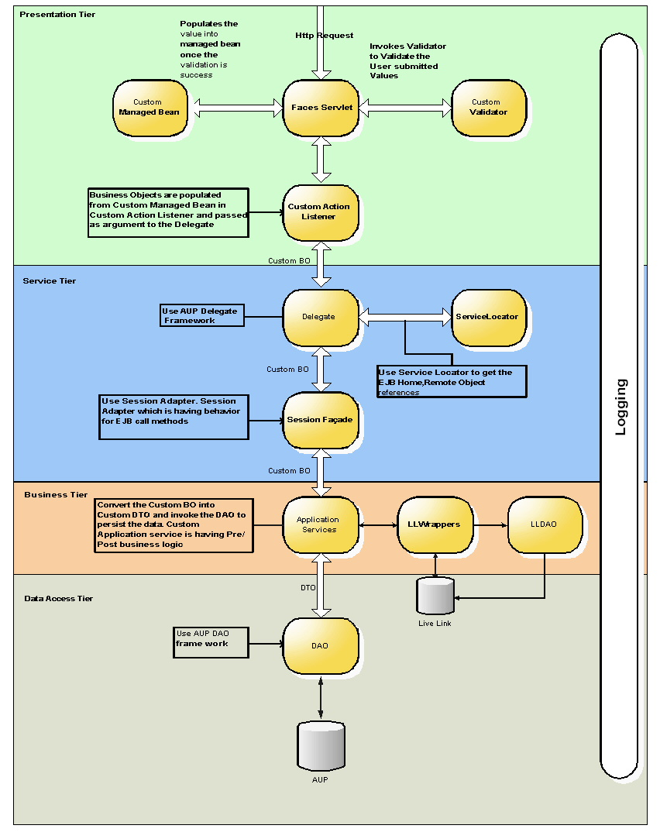

Presentation Tier
The presentation tier flow is depicted in the flow diagram below

PRESENTATION TIER
JSPs with JSF UI
FacesServlet
Controller
Process
Validation
Validator.validate
Ok
Call to Business
Delegate
Request
1
No
Yes
Action
Listener
Set View
Values to
Managed Bean

Service Tier
The Service tier flow is depicted in the flow diagram below

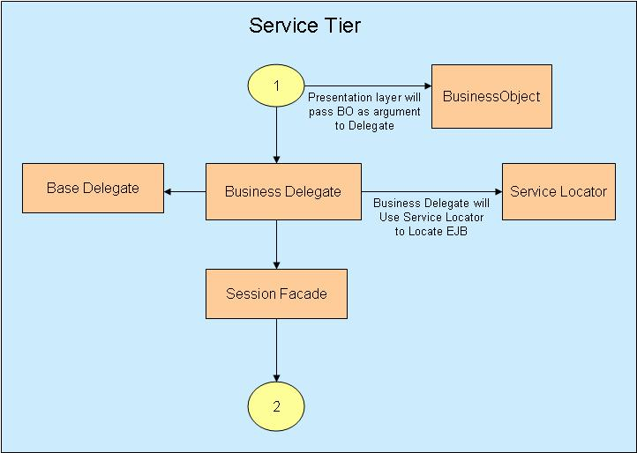

Business Tier
The Business tier flow is depicted in the below diagram

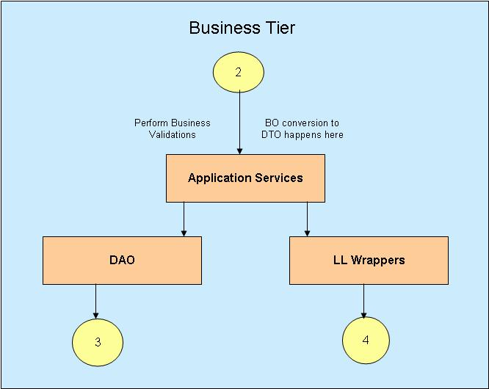

Data Access Tier
The Data Access tier flow is depicted in the flow diagram below

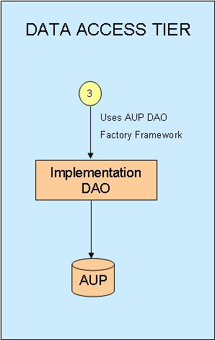

The Data Access tier flow pertaining to LiveLink is depicted in the flow diagram below

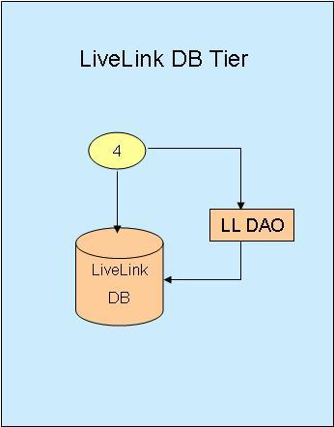

Presentation Layer

The web tier is designed using JSF. JSF framework based architecture gives more control of the form elements at the server side.

In the JSF programming model, the web request is handled by the central controller which invokes the Validator framework to validate the form values and populate the values into managed bean and finally executes the action listener. For a detailed explanation of the various stages of the JSF lifecycle refer Appendix: A – JSF Lifecycle.

The following sections explain the validation and the controller framework in detail.

JSF

Validation Framework

The Validation Framework consists of a single Base Validator which performs most of the common validations and each UI specific validations are handled by individual Validators that extend the Base Validator. The ID of the Validator in the faces-config.xml is mapped with the hidden value and used as a reference in the faces jsp file.

Implementation Logic:

- Create an abstract “BaseValidator” class which would implement Validator Interface. The abstract class serves to provide all common validation logic required by Custom Validators.
- All the custom Validators should extend the BaseValidator abstract class and provide custom validate implementations.
- All Validator classes should be registered in the faces-config.xml

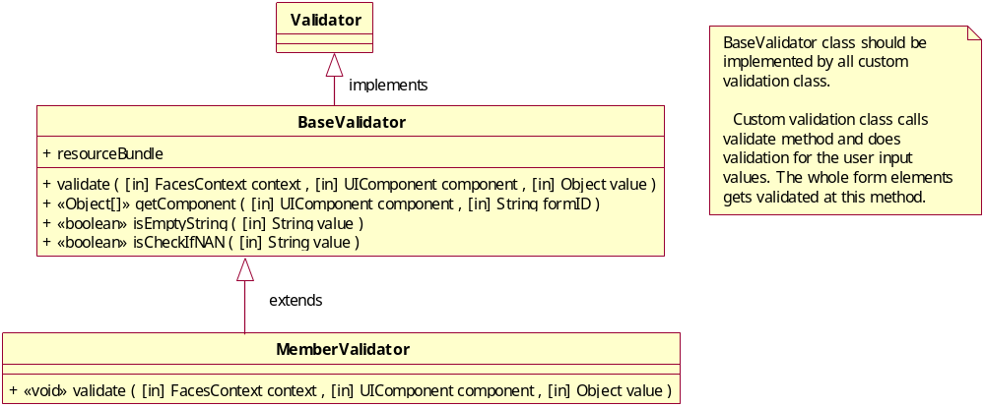

- BaseValidator class should implement all common validations. Custom Validator class overrides validate method and does necessary validations

- The validate method of the respective custom class gets invoked from the faces jsp in the process validation phase

- The getComponent method - The component values are obtained by the base classes using this method

- isEmptyString method is a generic method and can be utilized to check for required fields

- isCheckIfNAN method is another generic method used to check for numeric entry in a text field

- MemberValidator class would validate the form values in the Member search page and the validate method would evaluate the form values. If errors are found then ValidatorException is thrown from the validate method and it gets displayed in the respective page

Action Listener

In AUP, controller layer is modeled using the JSF Action Listener interface. All faces jsp file would call appropriate method in the listener classes.

In order to achieve abstraction, all controller class would extend a BaseActionListener class that provides the common behavior for all Faces request which are being submitted on various user actions. The BaseActionListener would implement ActionListener interface of JSF and realize the template method pattern.

Action Listener Abstraction
The common behavior identified for all controllers

- Getting the values to be processed from the request, session and application scope
- This action listener invokes business functionality using delegate. In case of success the request will get forwarded to the next logical page, in case of exception, exception details are added in FacesContext and sent to request
- The response is forwarded back to the user

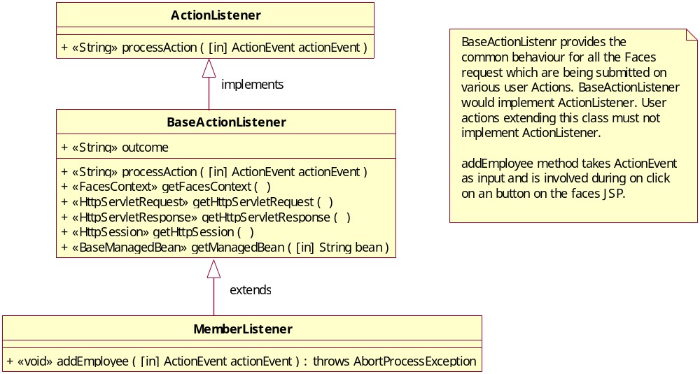

JSF Managed Bean design

JSF managed beans is typically in the model layer of the MVC pattern.

MemberBean extends a BaseBean which contains all common attributes. It contains the necessary getters and setters.

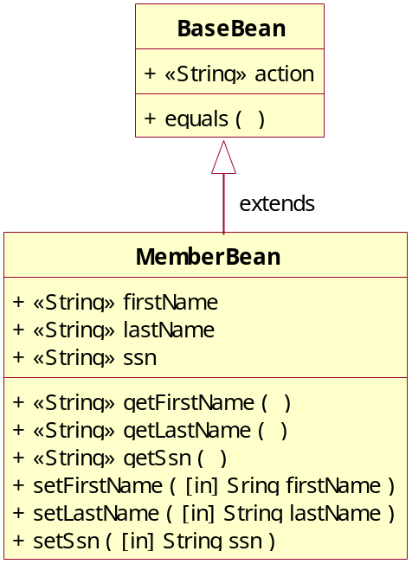

Managed Bean and Dependency Injection

Dependency injection (DI) is a programming design pattern and architectural model, sometimes also referred to as Inversion of Control or IoC.

The pattern seeks to establish a level of abstraction via a public interface, and to remove dependency on components by (for example) supplying a plug-in architecture. The architecture unites the components rather than the components linking themselves or being linked together. Dependency injection is a pattern in which responsibility for object creation and object linking is removed from the objects themselves and transferred to a factory. Dependency injection therefore is obviously inverting the control for object creation and linking, and can be seen to be a form of IoC.

In JSF, Dependency injection is introduced by having Managed Beans as properties for Action Handlers.

Consider the portion of Code below

<managed-bean>
<managed-bean-name>CensusAction</managed-bean-name>
<managed-bean-class>com.uw.census.action.CensusAction</managed-bean-class>
<managed-bean-scope>request</managed-bean-scope>
<managed-property>
<property-name>censusBean</property-name>
<value>#{CensusBean}</value>
</managed-property>
</managed-bean>

Here the Managed Bean CensusBean has been assigned as a property to the CensusAction class.

Presentation Tier – Detailed Flow

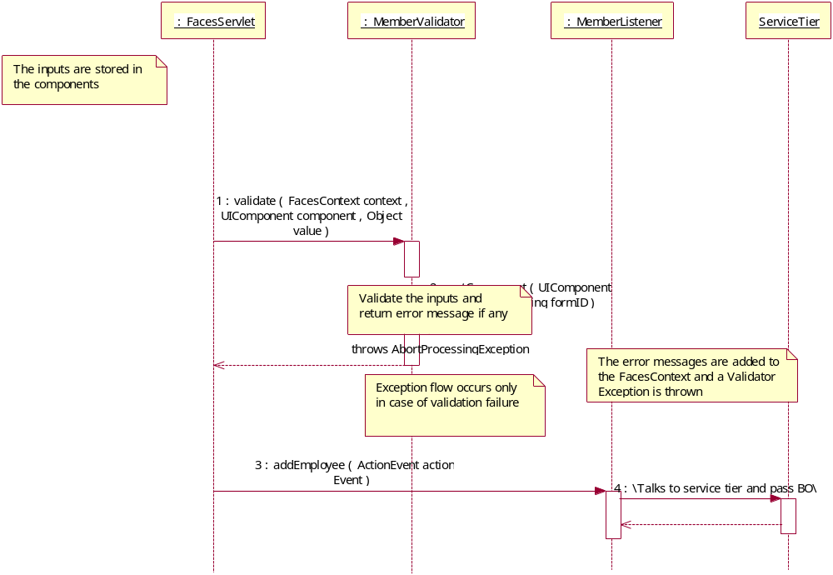

Business Objects

Business Object is value object that is used to transfer data between presentation tier and service tier. All Custom Business Objects will extend BaseBO that implements Serializable interface.

Service Layer

Business Delegate
Each Action Listener delegates the request to the business tier to perform the business functionality. Typically, the Action Listener takes the form data (from managed bean) and creates a business object using this data. It then invokes a method of the corresponding business delegate using the business object. The purpose of the business delegate is to encapsulate the remote interface lookups, caching of objects and translate remote exceptions to application exceptions.

All Business Delegate classes extend the BaseDelegate class and implement the appropriate business delegate interfaces.

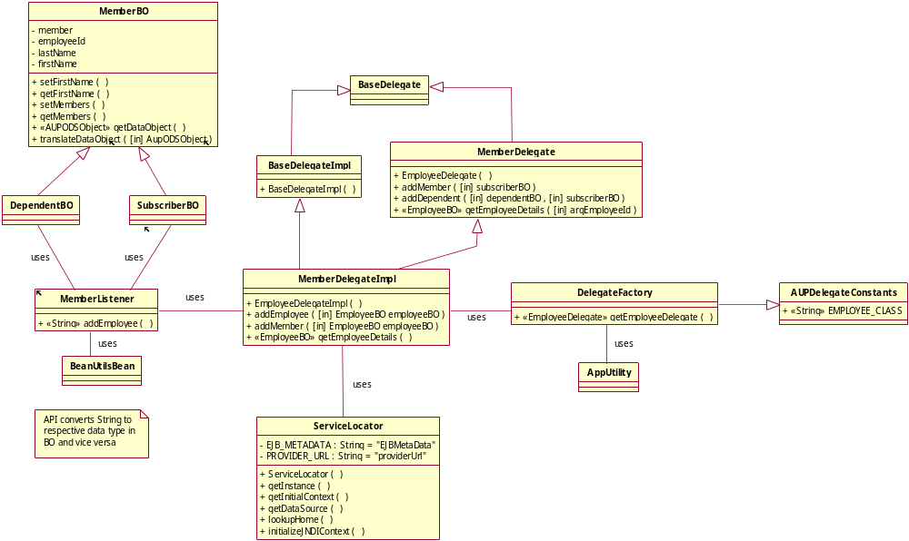

AUP Delegate Framework

Framework contains BaseDelegate interface and BaseDelegate Implementation class which has common functionality, which is used across the module. AUPDelegateConstants interface contains class names of the Business Delegate Implementation classes. DelegateFactory class is used to create implementation Business Delegate Class, this factory class implements the AUPDelegateConstants. All Business Delegate interface extends Base Delegate interface. All Business Delegate implementation class extends BaseDelegate Implementation class and Business Delegate interface .All Business Delegate classes will be exposed as an interface to the caller (ActionListener).

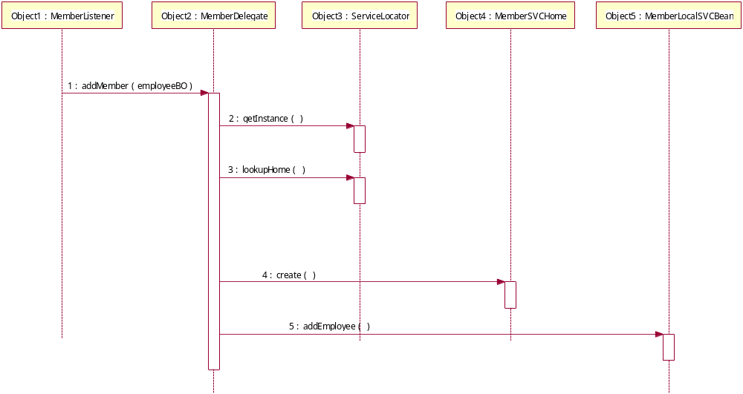

Service Locator
The service locator will be used to locate all the resources registered in the JNDI registry. This includes EJB services, Datasources, Connection Factories and Queues.

In the case of services, service locator will do a JNDI lookup to find the home interface for the service being requested. If an exception occurs, a ServiceLocatorException will be thrown and the delegate must translate this exception to an application exception.

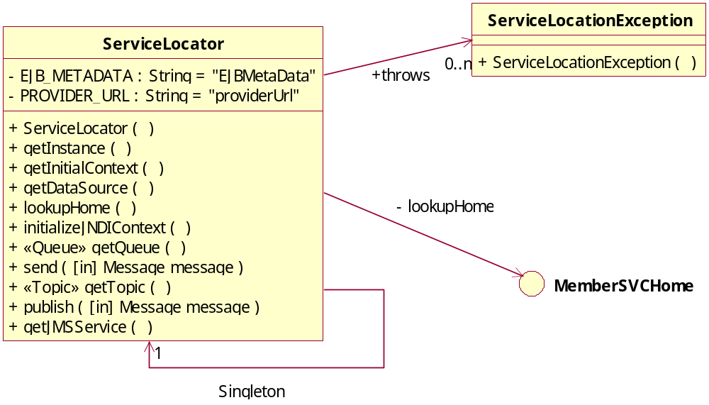

Session Adapter
All Session Beans in the AUP system should extend the SessionAdapter class. This class represents an adapter for a SessionBean. It simplifies the appearance of bean class definitions by hiding callback methods that are never used or that have minimal implementations. Session Adapter implements a SessionBean interface and defines the behavior for callback methods of the EJB.

All the stateless service in the application should have local interface. The idea of having the local interface is to avoid the network invocation since the web and ejb application will be deployed in the same server.

The class diagram shows the relationship that must exist for each service modeled in the AUP system that is designed as a stateless session bean.

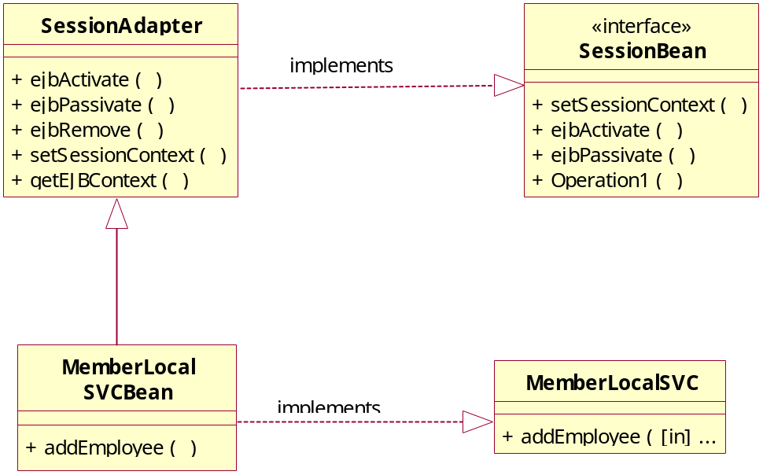

Different Flow of Sequence Diagram from EJB Layer.

EJB service will interact with business layer to perform the functionality.

Flow 1: For performing the pre & post business operation, EJB service will invoke the Application Services. Below Sequence Diagram depicts the flow.

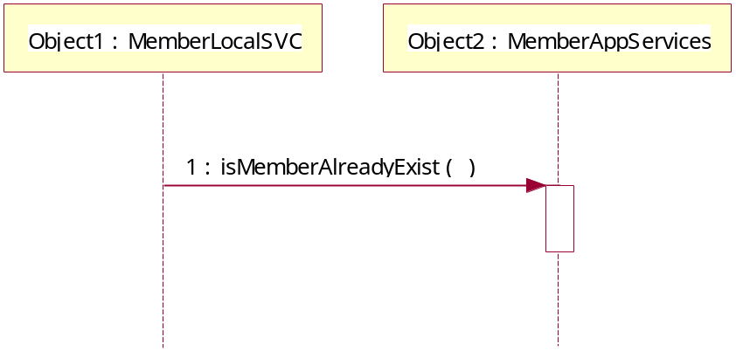

Flow 2: For all database related operations, EJB service will invoke Application Service classes in the Business Layer. Before calling to the DAO functions, Application Service will invoke getDataObject of corresponding Business Object, this function will return Data Transfer Object for the passed Business Object. This DTO will be passed as an argument to the DAO functions. Similarly DAO functions will return either List or single Data Transfer Object to the Application Service. Application Service in turn converts the DTO to Business Object by invoking translateDataObject of corresponding Business Object, Application Service will return Business Object to the caller that is EJB.

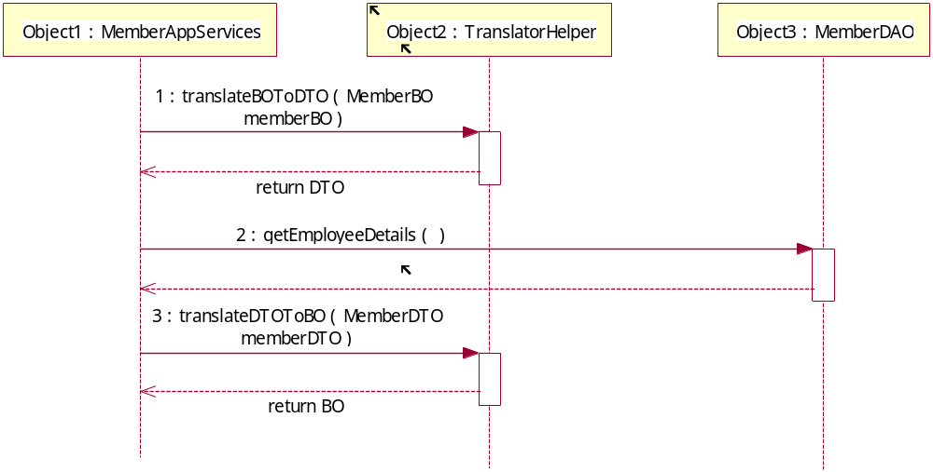

Flow 3: Application service will interact with LiveLink Wrapper classes to perform the workflow related LiveLink functionality.

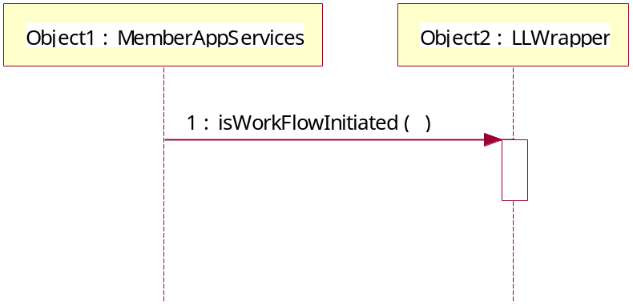

Business Layer

Business Layer contains Application Services where the Business Rule Validations are implemented. EJB Service will call Application Services methods to perform validations. Application Service will invoke other services like Messaging / Data Access Layer to accomplish the task. Application Service will throw Application Specific Exception if business validation fails.

Application Services
Application Services are plain Java Objects where the Business Rule Validations are implemented. Application Service will be called during pre and post business validations as well DAO related calls from the EJB.

MemberAppService extends AUPAppService which will have common functions.

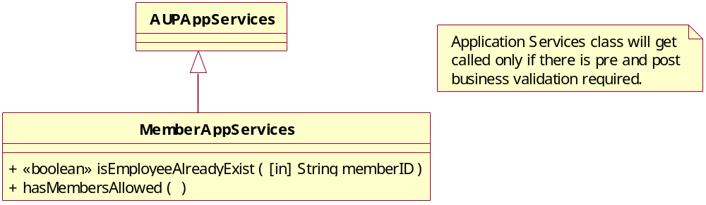

Data Access Layer
Access to the AUPDB will be accomplished using Data Access Objects (DAO) designed to abstract and encapsulate all access to the AUP data source. Business components rely on the DAO using a simple interface exposed by the DAO thus hiding the complexity and implementation details. This pattern allows the DAO to adapt to different storage schemas without affecting its clients or business components.

UHG Data Access Framework

Class Diagram
The generic DAO implementation is given below.

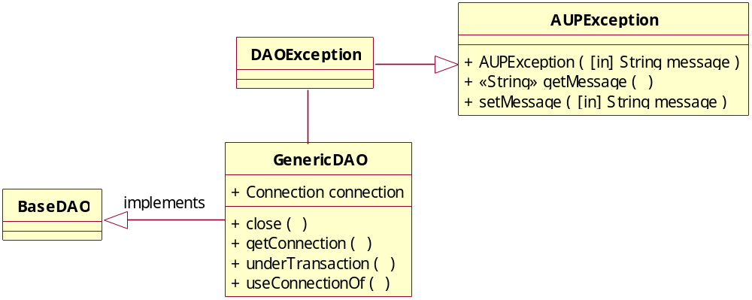

Generic DB Operation Sequence Diagram

The generic DB operation sequence diagram is given below. With the help of DAOFactory class the respective DAO object is obtained.

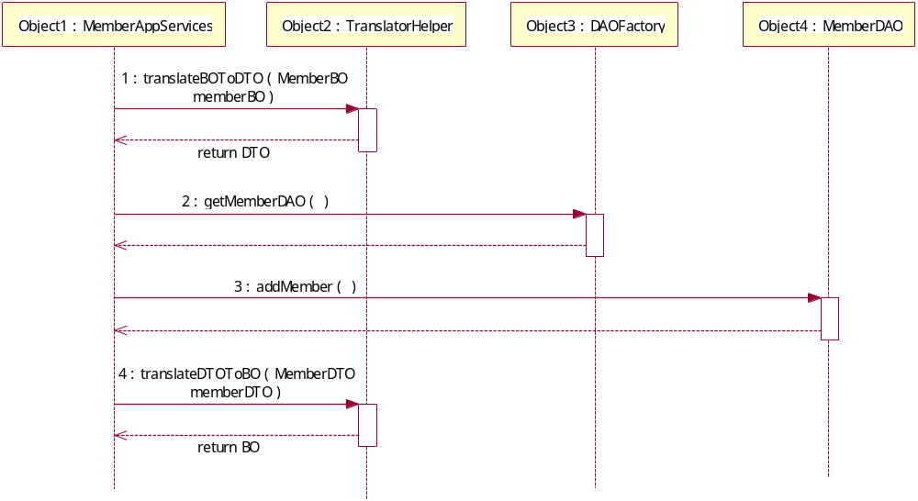

Data Transfer Object
Data Transfer Object is value object that is used to transfer data between Business Tier and Data Access Tier. All Data Transfer Objects will extend Base Data Transfer Object which will implement the Serializable interface.

Connection Pooling
Stand-alone java programs as well as service layer defined within a J2EE container will utilize Data Access Objects. To provide a single code base for all Data Access Objects, a J2EE sub-class will be created. This sub-class will override the getConnection method so that the J2EE pooled connections can be utilized.

Retrieval of Connection Object
All J2eeOracleDAO class has getConnection method, which will retrieve the connection object through DataSource lookup which has configured in Application Server. Name of the JDBC Data Source will get from AUPDAOMetaData.xml configuration file. For each DAO, JDBC DataSource Name is mapped in this configuration file. J2eeOracleDAO getConnection method will call getDataSource of ServiceLocator, this function will return DataSource Object. We are using the existing connection pooling framework of uhg.

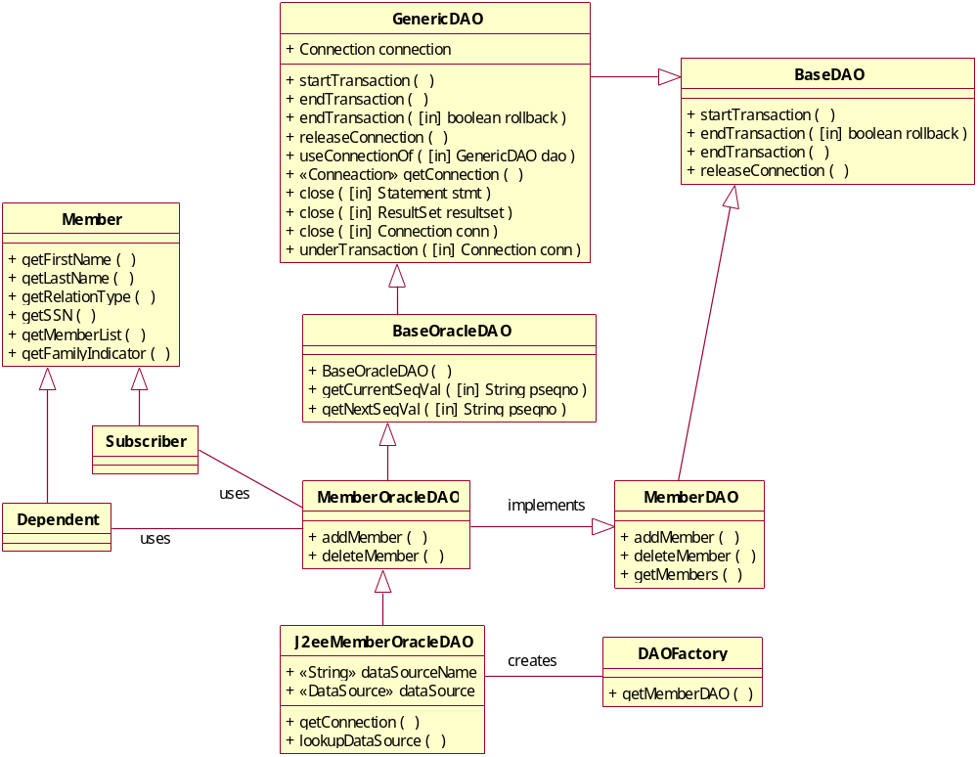

Transaction Management
The entire application is configured to use declarative transaction management. In declarative transaction management it is the responsibility of Application server to control the behavior of transaction which is configured in the ejb-jar.xml.
Transaction Configuration

Database Operation | Is Transaction Management Required
Create | YES
Read | NO
Update | YES
Delete | YES

Common Services

Audit Framework


Issue Framework


System Process Framework
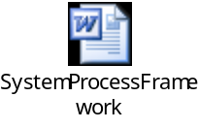

Exception Handling
The AUP system will use the AUPException as the base exception where all the custom exception classes should extend this base class. The exception / error code of the each exceptional scenario will be passed as argument to the AUPException constructor where the appropriate message will be fetched from the message file.

Each exception class used in the AUP system will be extended from a base exception class, AUPException. This exception class will provide an interface for setting and getting alarms when an exception occurs. When an exception is thrown, it will be caught and logged at an ERROR level of severity in the log file. Below is an exception class diagram for a given exception.

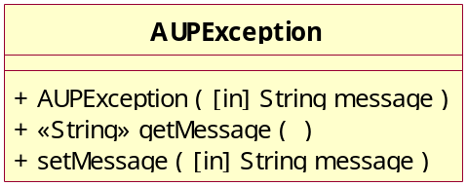

Logging

Logging for the AUP system will be done using Log4J. Reporting the progress of the application should be done at a DEBUG level. All exceptions that are caught should be logged at an ERROR level of severity. Logging can be categorized using the class name (including the package structure). Logging will be sent to a file and/or the database. In the event of exception that will abruptly terminate the program or process a fatal log message will be registered in the log file.

Glossaries/ Acronyms

Acronym | Details
AUP | Automated Underwriting Project
BO | Business Object
DTO | Data Transfer Object
DAO | Data Access Object
EJB | Enterprise Java Beans
J2EE | Java 2 Enterprise Edition
MVC | Model-View-Controller Framework
SAD | Software Architecture Document
JSF | Java Server Faces
LAPI | LiveLink Application Programmer Interface

References

Title | Version | Author | Link
Core J2EE Patterns |  | Sun | http://java.sun.com/blueprints/corej2eepatterns/Patterns/index.html
Developing Web Applications with Java Server Faces |  | Sun | http://java.sun.com/developer/technicalArticles/GUI/JavaServerFaces/
Using Java Server Faces Technology Components |  | Sun | http://developers.sun.com/prodtech/javatools/jscreator/reference/themes/jsf/index.html
UI development with Java Server Faces |  | IBM | http://www-128.ibm.com/developerworks/edu/j-dw-java-jsf-i.html?S_TACT=105AGX02
JSF Conversion and Validation |  | IBM | http://www-128.ibm.com/developerworks/java/library/j-jsf3/

Appendix A – JSF Lifecycle

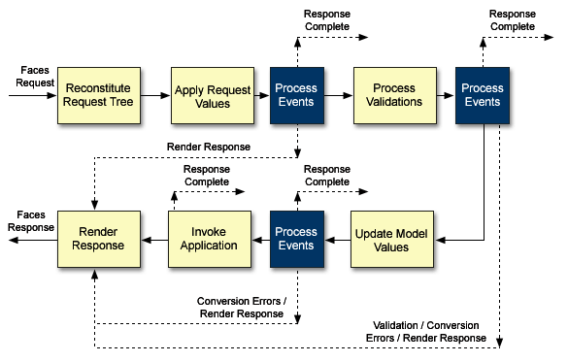
Figure 7 – JSF Request processing Lifecycle

The standard phases of the request processing lifecycle are described in the following subsections.

Restore View:
The JSF framework controller uses the UIViewRoot (view) instance from the FacesContext of the submitted request to look up the components for the current view. If the view doesn't already exist, the JSF controller creates it. If the view already exists, the JSF controller uses it. The view contains all the GUI components.

Apply Request Values:
The purpose of the Apply Request Values phase of the request processing lifecycle is to give each component the opportunity to update its current state from the information included in the current request (parameters, headers, cookies, and so on).

Process Validations:
At the end of this phase, all conversions and configured validations will have been completed. Conversions and Validations that failed will have caused messages to be enqueued via calls to the addMessage () method of the FacesContext instance for the current request and the valid property on the corresponding components will have been set to false.

Update Model Values:
If this phase of the request processing lifecycle is reached, it is assumed that the incoming request is syntactically and semantically valid (according to the validations that were performed), that the local value of every component in the component tree has been updated, and that it is now appropriate to update the application's model data in preparation for performing any application events that have been enqueued.

Invoke Application:
If this phase of the request processing lifecycle is reached, it is assumed that all model updates have been completed, and any remaining event broadcast to the application needs to be performed.

Render Response:
This phase accomplishes two things:
- Causes the response to be rendered to the client
- Causes the state of the response to be saved for processing on subsequent requests

Appendix B - Design Approaches

Validator Framework

There are three possible approaches for choosing which validation framework should be used for validating a submitted form data

JSF validation approaches

- Approach 1: By adopting JSF’s way of validation - calling the validator classes from each component that needs to be validated
- Approach 2: By referencing a backing bean method from each of the input components
- Approach 3: By calling the validation routine on a validator class from the ActionListener

Problem

- Validating the entire form is not possible with approaches 1 and 2, because a Validator Exception is thrown as soon as an element is found invalid. The rest of the form elements would not be validated even if it is invalid

- Approach 3 would violate the JSF lifecycle and performs the validation in the Invoke Application phase rather it should be done in the Process Validation phase

Recommended approach

- The validation framework recommends one single validator class for every individual JSF file for validating the input contents rather than specifying a validator for the individual components

- The ID of the validator in the faces-config.xml is used as a reference in the faces jsp file

Action Listener

JSF controller approach

- The choice of implementing the action classes/controller classes can be implemented either as a backing bean method or as an ActionListener class.

Problem

- Implementing processing logic in the backing bean would violate the MVC architecture because it’s the controller’s job to do the same. (A backing bean models the model layer of the MVC pattern). Hence the choice of using an ActionListener interface for the controller layer fits into the MVC model

- AUP architecture proposes a consistent programming model for modeling and coding the use case specific ActionListeners. A unified approach of coding ActionListeners would result in loosely coupled action listener classes

Suggested approach

AUP architecture proposes to model the controller layer using the JSF Action Listener interface. All faces jsp file would call appropriate ActionListener classes.

In order to achieve abstraction all subclasses would extend an Abstract BaseActionListener class that provides the common behavior for the all Faces request which are being submitted on various user actions. This approach would provide a consistent way for the developers who would concentrate more on usecase specific logic. The BaseActionListener would implement ActionListener interface of JSF and realizes the template method pattern. The processAction method in the ActionListener interface is implemented in this abstract class and implements the template method pattern.

