Tivoli Work load Scheduler Documentation
AUP - OM

Version | Date | Prepared/Modified By | Comments | Reviewed by | Approved by
1.0 | 09/15/2011 | Uma Maheswari | Created | Raajee
1.1 | 09/19/2011 | Uma Maheswari | Updated

Table of Contents
1 Introduction 3
1.1 Objective 3
2 ITG User Requests 3
3 TWS Terminology 4
3.1 Environment Terminology 4
3.2 Processing Terminology 5
3.3 Monitoring Terminology 7
4 Jobs and Job Streams 7
4.1 Naming Standards 8
4.2 Naming Convention 9
4.3 Calendar Standards 10
4.4 Exit Code Standards 11
5 Status 12
5.1 Internal Status 12
6 TWS User Interface 13
6.1 Monitor Jobs 13
6.2 Monitor Job Streams 14
6.3 Monitor Critical Jobs 14
6.4 Work Load Definitions 15
7 Dependencies 16
7.1 Defining Dependencies 17
7.2 File Dependencies 17
7.3 Prompt Dependencies 18
7.4 Resource Dependencies 18
8 TWS Requests 19
8.1 TWS UPDATE CURRENT PLAN 19
8.2 TWS Job Recovery 20
8.3 TWS Job SCHEDULING 20
9 Pre Requisites 21
9.1 On Call Repository 21
9.2 Script Files 22
9.3 Feed Files 22
9.4 Other Files 22
10 Summary 22
10.1 Links 23

Introduction
TWS is a single point of management of multiple engines from a single point of access (Broker, Applications, Distributed, and z/OS).
Multiple users accessing a single installation of the console concurrently, using their browser. No need to install and patch different clients on different workstations.
Centralized authorization management using single sign-on. The Tivoli Workload Scheduler IT administrator assigns roles and corresponding permissions to different users from "Settings".

Objective
The purpose of this document is to serve as a reference manual for understanding of TWS Process, its terminologies, way of access etc.

ITG User Requests
A person should have approved ITG User Security request for the particular Security Group to access the jobs under that group.

He has to obtain User access to the TDWC and load Citrix IE8 to desktop.

The following needs to be followed to get it done.
- Login to SATS: https://sats.uhc.com/sats/
- fill in all fields
2) Select Platform IDs
3) Select 'Change ID Access'
- click 'Next"
4) Click dropdown in 'Select System'
- select 'Windows'
- click 'Next'
5) Click dropdown in 'Select Domain'
- select 'MS'
- click 'Next'
6) 'Available Users' will default to your name
- click '>>' to move over to 'Selected User(s)'
- perform searches if others will be included in the one request
- click 'Next' when User selection completed
7) In 'Search For' field
- type tws
- click 'Search'
- locate/select twsusr in 'Available Groups'
- click '>>' to move over to 'Selected Groups'
- type citrix
- click 'Search'
- locate/select Citrix_IE8 in 'Available Groups'
- click '>>' to move over to 'Selected Groups'
- locate 'Business Justification' field
- type the following: access required to support TWS batch jobs for application list your application
- click 'Next'
8) Review request, then either
- click 'Back' to make changes
- click 'Cancel Request' to cancel
- click 'Submit' to submit request to be approved

TWS Terminology

Environment Terminology

Job Definition is the definition of a unit of work that resides in the database of the distributed Tivoli Workload Scheduler engine and can be added to a job stream. Job definitions can be created before creating a job stream, or can be created as part of the creation or modification of a job stream. The Job Definition includes the job name, work station, login ID, executable command or script, and description of the Job.

Job Stream is a list of jobs that run as a unit (such as a weekly backup application), along with run cycles, times, priorities, and other dependencies that determine the exact order in which the jobs run.

Tivoli Dynamic Workload Console (TDWC) is a Web-based graphical user interface used to create, modify, and maintain job scheduling objects, to manage the production environment, and to produce reports.

Current Plan contains all job scheduling activity planned for a period. The plan is created or extended each Business Day. It is stored in the Symphony file, and consists of all the jobs, job streams, and dependency objects that are scheduled to run for that period, including any jobs or job streams carried forward from the previous plan.
NOTE: Changes to the Current Plan are handled by the Enterprise Operations Operators.

Database in Tivoli Workload Scheduler distributed environments it consists of a set of tables defined in a DB2 relational database, containing the definitions for all scheduling objects (jobs, job streams, resources, workstations, domains, parameters, prompts, and variables). It also contains data such as job and job stream statistics, user data, and object creation and modification time stamps.
NOTE: Changes to the Database are handled by the Job Scheduling team.

Fault-Tolerant Agent (FTA) is an installed agent component in a distributed Tivoli Workload Scheduler network capable of resolving local dependencies and launching its jobs in the absence of a domain manager.

Master Domain Manager (MDM) - An installed component that performs the role of management hub of the top-level domain in the Tivoli Workload Scheduler network. It maintains the database of all scheduling objects in the domain and the central configuration files. The master domain manager generates the plan and creates and distributes the Symphony file. In addition, logs and reports for the network are maintained on the master domain manager.

Symphony File is the file containing the scheduling information needed by the production control process to run the current plan. The file is built and loaded when the current plan is created or extended on the master domain manager. During the production phase, it is continually updated to indicate the current status of production processing: work completed, work in progress, and work to be done.

Processing Terminology

Recovery Options – A listing of Actions available if a job run should end in abend status. Default is Stop, which will stop the job stream and any successor batch processing from running until the failure is resolved.

Variable Table – contains groups of variables that are common to each other. They can be defined to run cycles, job streams or workstations. A variable name can be in multiple variable tables with different values.

Variables – are objects that contain values that are used in job definitions, file definitions and passed to scripts. A variable will use the default variable table if no variable is defined.

Valid from/to – are the dates that a Job stream will start loading to the current plan, and to the date it will that it will stop loading to the current plan. This allows scheduling changes to be done prior to when they are actually needed.

Priority – is a way of determining the order in which jobs and jobs streams start. A priority of 0 (zero) is equal to HOLD and will not allow a job or job stream from executing in the current plan until the priority is changed. Default value is 10.

Time Zone – allows jobs and jobs streams to run according to a time zone, instead of the system time of the Master Domain.

Run Cycle – defines when a job stream is selected to run in the current plan. A job stream can have multiple run cycles. The run cycles can be either inclusive or exclusive (exceptions to the inclusive days).

Run Cycle Start/End – are the valid dates that an individual run cycle will use to determine when it is active and scheduling the job stream to run.

Prompt – a message dependency that requires a response to allow a job or job stream to run. Its usage is not recommended as it puts a manual hold into the batch cycle.

Resource – a dependency where a job or job stream cannot start until the required quantity of the defined resource is available. Resources can be used across multiple job streams or jobs. When a job or job stream ends the resource is released.

Workstation Class – is a group of workstations. Job streams and jobs can be assigned to run on a workstation Class instead of a workstation. This allows a job or job stream definition to be replicated and run across many workstations, with the same executed code. Any number of workstations can be placed in a class. To have a job or job stream run on another server / workstation, only requires the workstation to be added to the class instead of creating new jobs and/or job streams.

Job / Job Stream Dependency – is a dependency where a job or job stream cannot start until other jobs or job streams have completed successfully within the current plan.

File Dependency – is a dependency where a job or job stream cannot start until it finds a specific file is present in a specific path on a specific workstation. By default it only checks that a file exists. It can have qualifiers for more detailed checking of the file.

Draft – is an option in the TWS/d data base that indicates that a job stream is incomplete or in development, and not allowed into the current plan. A job stream in a draft state cannot be added to the current plan for execution. The Draft option can be used to take older job streams out of production temporarily or retire them.

Forecast Plan - is a projection of a current plan over a selected time frame based on the jobs streams and dependencies defined in the data base. This plan is viewable from the TDWC.

Cancel – is an Action that fulfills all successor dependencies immediately. Canceling a job will cause the job to not execute. Doing a cancel on a job stream cancels all the jobs within the job stream.

Cancel Pending – is an action that fulfills successor dependencies only after its predecessor dependencies, including start times are resolved. It can be used on both jobs and job streams.

Monitoring Terminology

Job Log – also known as stdlst (Standard List) are created when a job starts running. Jobs that end in a FAIL status do not create job logs as they never launched. Job logs open in a separate window within the TDWC, and can be copied by highlighting and pressing Ctrl+C, to be pasted into other media. Job logs can be used to diagnose and solve workflow problems.

Jobs and Job Streams
Jobs & Job Streams:
As said earlier
Job Definition is the definition of a unit of work that resides in the database of the distributed Tivoli Workload Scheduler engine and can be added to a job stream. Job definitions can be created before creating a job stream, or can be created as part of the creation or modification of a job stream. The Job Definition includes the job name, work station, login ID, executable command or script, and description of the Job.

Job Stream is a list of jobs that run as a unit (such as a weekly backup application), along with run cycles, times, priorities, and other dependencies that determine the exact order in which the jobs run.

Naming Standards

For Job names (Job Streams and individual Command Jobs) the following character sets are allowed:
- Upper case alpha characters: (A-Z)
- Numeric: (0-9)
- Dashes (-)
- Underscores (_)

Naming Convention
Job Name Format: AAA_BBB_CC_DDDDDDDDDDDDDDDDDD_EE_FFF
Key | Length & Format | Component – Job Name Description | Examples
A | (4)  Upper Alpha  Lower Alpha  Numeric  Underscore  Period  Dash | Application Group – The high-level application family or technology. A MUI will be will be assigned for application teams followed by a underscore (_).  *** MUST START WITH A LETTER *** | EES_ – Employer eServices  CMT_ – COMET  JCA_ – Job Control Admin  EBZ_ – eBiz Operations Group  ORA_ – Oracle Operations Group
B | (4)  Upper Alpha  Lower Alpha  Numeric  Underscore  Period  Dash | Business Process or Application Name – Specific business process or application area. A Sub MUI will be will be assigned for application teams followed by a underscore ( _). | PEG_ – CMT_PEG Pega processing  PAY_ – PSF_PAY PeopleSoft Payroll
C | (3)  Upper Alpha  Lower Alpha  Numeric  Underscore  Period  Dash | Platform Type – The remote agent hardware platform type followed by a underscore (_). | UX – Unix  WT – WinTel  AS – AS400 (iSeries)
D | (1 – 21 or 18 if using E below)  Upper Alpha  Lower Alpha  Numeric  Underscore  Period  Dash | Tivoli Workload Scheduler Job Name – Provide as much identifiable information relating to the job as possible within the available character limit | claimloads, reportingext
E | (3)  Upper Alpha  Lower Alpha  Numeric  Underscore  Period  Dash | Sequence Number – Distinguishes between similar jobs running at different times or with different run controls.  *** This component is optional *** | _01, _02, _03
F | (4)  Upper Alpha  Lower Alpha  Numeric  Underscore  Period  Dash | Environment Suffix – Distinguishes different Tivoli Workload Scheduler (TWS) instances (DEV, STG, PRD) and different job streams within the same instance with similar jobs running on the same or different servers. | _DEV, _DVL, _TST, _UNT, _STG, _PRD etc.
→ 36 = Maximum Character job name limit for all jobs (including “_” separators) NOTE: no special characters allowed

Job Stream Name Format: AAA_BBB_CCCCCCCC

Key | Length & Format | Component – Job Stream Name Description | Examples
A | (4)  Upper Alpha  Lower Alpha  Numeric  Underscore  Period  Dash | Application Group – The high-level application family or technology. A MUI will be will be assigned for application teams followed by a underscore (_).  *** MUST START WITH A LETTER *** | EES_ – Employer eServices  CMT_ – COMET  JCA_ – Job Control Admin  EBZ_ – eBiz Operations Group  ORA_ – Oracle Operations Group
B | (4)  Upper Alpha  Lower Alpha  Numeric  Underscore  Period  Dash | Business Process or Application Name – Specific business process or application area. A Sub-MUI will be will be assigned for application teams followed by a underscore (_). | PEG_ – CMT_PEG Pega processing  PAY_ – PSF_PAY PeopleSoft Payroll
C | (8)  Upper Alpha  Lower Alpha  Numeric  Underscore  Period  Dash | Job Stream Name – Provide as much identifiable information relating to the job stream as possible within the available character limit | CMT_PEG_STREAM01  PSF_PAY_DAILYJOB
→ 16 = Maximum Character job name limit for all jobs (including “_” separators) NOTE: no special characters allowed

Job Naming Environment Suffix Function

The job name suffix (_DEV, _STG, _PRD) is appended to each job name to not only easily recognize the instance your jobs are running in but also allows multiple sets of jobs per instance when there is a one-to-many mapping within an instance (DEV, STG). For example, an application requires two sets of jobs in DEV, one set for development and one set for break-fix, both sets of jobs can be created in the DEV instance and easily identified when named _DEV for one set of jobs and _BFX for the second set. This provides the separation of jobs by name within a single instance.

NOTE: For the production (PRD) instance, there will only be a one-to-one mapping with an application production environment (only _PRD will be allowed).

Calendar Standards
For Calendar names the following character sets are allowed:
Upper case alpha characters: (A-Z)
Numeric: (0-9)

The following are the standards for calendars that are shared across all application groups. Dates are static and do not change in the shareable calendars. Custom calendars are for use within application groups specifically.
TWS Calendar Naming Format: MUISUBxx

Key | Length & Format | Component – Calendar Name Description |  | Examples
A | (6)  Upper Alpha  Lower Alpha  Numeric  Underscore  Period  Dash | MUISUB = Calendar designation using full job family without an underscore (_)  *** MUST START WITH A LETTER *** | JCAJCA  PCSPCS  UBHBDW
B | (2)  Upper Alpha  Lower Alpha  Numeric  Underscore  Period  Dash | xx = Numeric designation with leading zeroes | JCAJCA00  PCSPCS99  UBHBDW12
→ 8 = Maximum Characters NOTE: no special characters allowed

Exit Code Standards

The following are standard Job Program exit codes. These codes determine how UHG standard escalation and severity levels are managed.
Exit Code | Type | UCC Priority | Job Control Automated Actions
0 | Successful (Default) | n/a | None
1–9 | Success (User Defined) | n/a | None
<0, 10-29, >49  (see NOTE below) | Abend / Error | Priority 2 | HPOV/HPSD Alert Submitted
30-39 | Abend / Error | Priority 3 | HPOV/HPSD Alert Submitted
40-49 | Abend / Error | Priority 4 | HPOV/ HPSD Alert Submitted
50-120+ | UHT Only | n/a | ** Do not use

Job Control Scheduling reserves exit codes greater than 50 for internal use. Do not use exit codes of 50 or greater.

NOTE: Exit Code information given for United Command Center (UCC) Priority 2 tickets above is to inform you of what exit codes WILL generate a Priority 2 alert ticket, however, your program code should be designed to generate exit codes 10-29 only when a Priority 2 alert ticket is required.
PRIORITY 2 TICKETS WILL NOT GENERATE A UCC WARROOM.

Status

Status is defined as the over all state of job or job stream within TDWC.
Each status will have more than one corresponding Internal Status.

Types:
- Waiting
- Ready
- Running
- Successful
- Error
- Cancelled (Job Stream)
- Cancelled (Job)
- Held
- Undecided
- Blocked (Job Stream)
- Blocked (Job)

Internal Status
- ABEND – Job terminated with a return code that does not satisfy the return code expression for the job.
- ABENDP – ABEND confirmation received, but job is not complete
- ADD – Job is being submitted
- CANCEL – Job was cancelled.
- CANCELP – Job is pending cancellation. (Cancellation is deferred until all dependencies are resolved.)
- DONE – Job completed in an unknown state.
- EXEC – Job is running
- FAILED – Unable to start job.
- HOLD – Job is awaiting dependency resolution.
- INTRO – Job is introduced for launching by the system.
- PEND – Job has completed and is awaiting confirmation.
- READY – job is ready to start, all dependencies are resolved.
- SCHED – Job’s AT (Start) time has not arrived.
- SUCC – Job has completed with an acceptable exit code.
- SUCCP – SUCC confirmation received, but job is not complete.
- SUSP - Job was blocked because of unfulfilled dependencies
- WAIT – (Extended agents only) TWS has resolved dependencies and initiated the job, but job is not yet active in the extended agent.
- STUCK
A job internal to the job stream has priority 0 (HOLD)
A job internal to the job stream has an asked prompt which needs a reply.
A job internal to the job stream is preceded by a job or job stream with ABEND status or a job with FAIL status

Mostly the status will be for Job Streams and internal Status will be for Jobs.

Status | Internal Status
Waiting | ADD, HOLD, INTRO, WAIT, PEND
Ready | READY
Running | EXEC, SUCCP, ABENDP
Successful | SUCC
Error | ABEND, FAIL
Canceled (Job Stream) | CNCEL, HOLD, CANCELP
Canceled (job) | (status of job when cancelled)
Held | HOLD (priority =0), READY
Undecided | EXTRN, ERROR
Blocked (Job Stream) | STUCK
Blocked (Job ) | SUSP

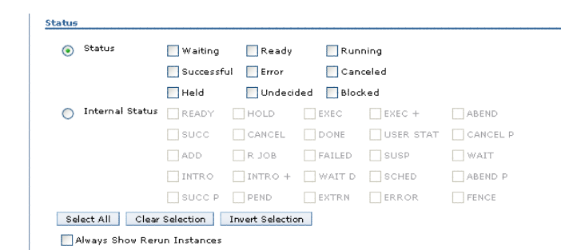

TWS User Interface

Monitor Jobs

In the Tivoli Dynamic Workload Console:
1. Click Tivoli Workload Scheduler→Workload→Monitor→Monitor Jobs
2. Select All Jobs in plan (Distributed) or another predefined task name
3. Accept the pre-populated engine name, and click OK
4. The job logs can be viewed by clicking the job log button in the right corner of job window.

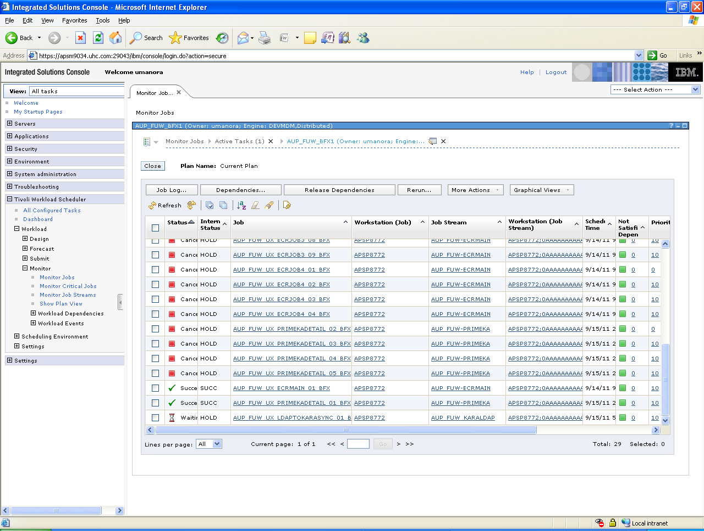

Monitor Job Streams
In the Tivoli Dynamic Workload Console:
1. Click Tivoli Workload Scheduler→Workload→Monitor→Monitor Job Streams
2. Select All Job Streams in plan (Distributed) or another predefined task name
3. Accept the pre-populated engine name, and click OK
4. The jobs inside the job streams can also be viewed by clicking the jobs button in the right corner of job stream window.
5. The job logs can be viewed by clicking the job log button in the right corner of job window.
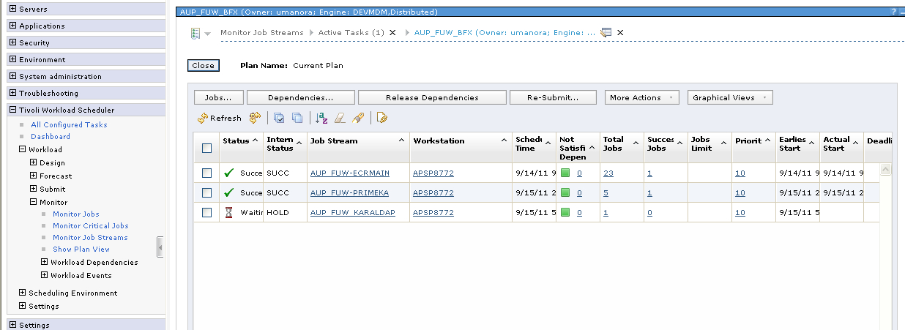

Monitor Critical Jobs
In the Tivoli Dynamic Workload Console:
1. Click Tivoli Workload Scheduler→Workload→Monitor→Monitor Critical Jobs
2. Select All Critical Jobs in plan (Distributed) or another predefined task name
3. Accept the pre-populated engine name, and click OK

Note: We can create a TASK (view) to view specific jobs/job streams of a particular Work station name, particular job family etc.

In the Tivoli Dynamic Workload Console:
1. Click Tivoli Workload Scheduler→Workload→Monitor→ Monitor Job Streams
2. Select All Job Streams in plan (Distributed) Task where all the existing job streams will be present.
3. Click on ‘Duplicate’ button .
4. Select Copy of All Job Streams in plan (Distributed) and click Task Properties button.
5. Give valid Task Name and click ‘General Filter’ link in the inner left pane.
6. Filter the job streams by Work station name, Job stream name and select all the statuses and click SAVE.

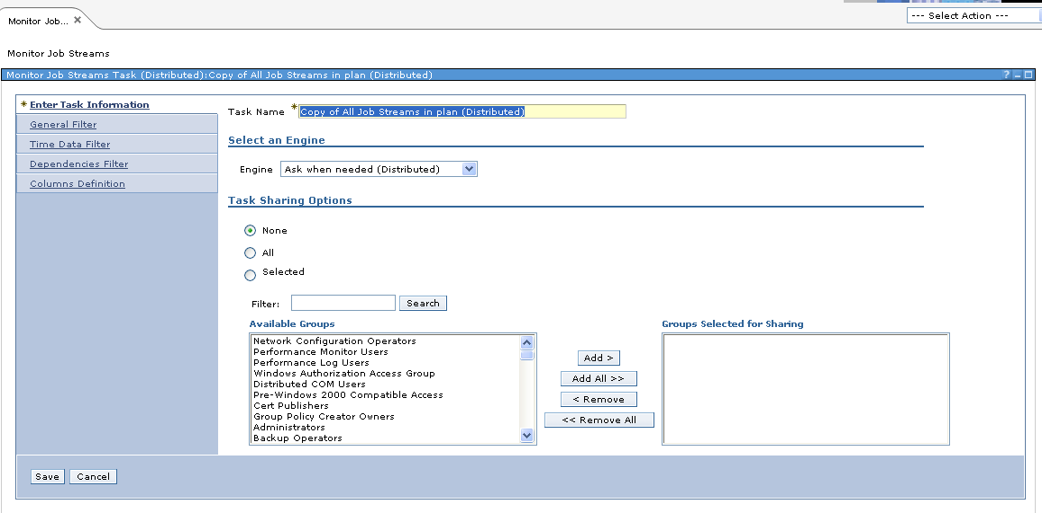

Work Load Definitions
In the Tivoli Dynamic Workload Console:
1. Click Tivoli Workload Scheduler→Workload→Design→Create Workload Definitions
2. Accept the pre-populated engine name, and click OK
3. Search for the Jobs or Job streams or another predefined task name

The job scheduling, dependencies, command to be executed, status (Active/Draft), server and the success code, all such job details can be viewed in the design section under work load definition. Both the jobs and job streams can be viewed.

Job definition
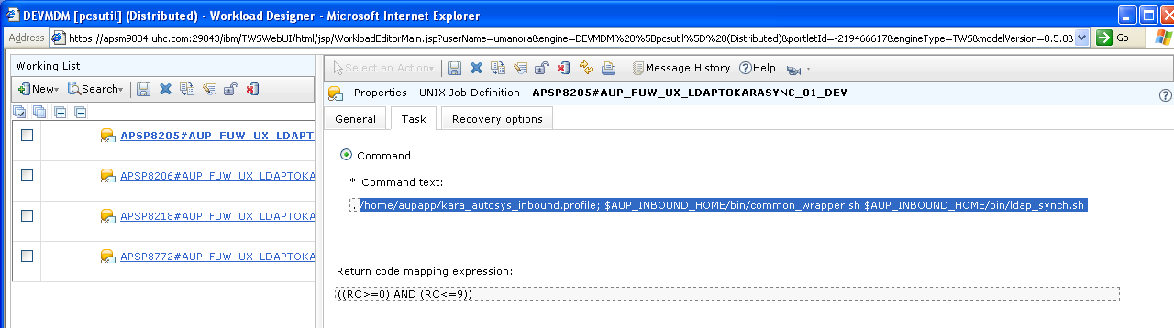
Job Stream
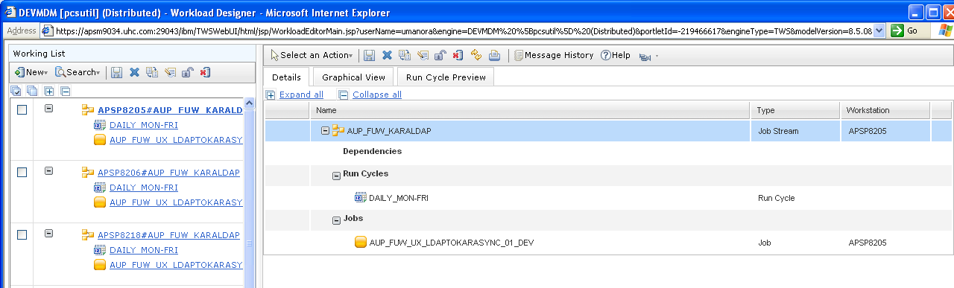

Properties: | Schedule:
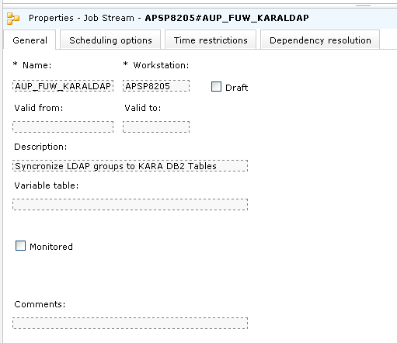 | 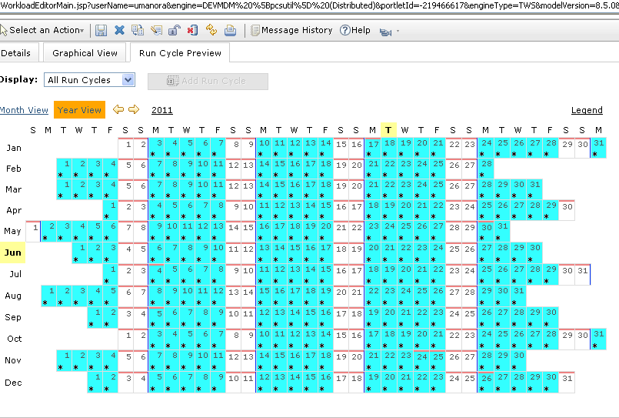

Monitor the jobs in Archived Plan:

In the Tivoli Dynamic Workload Console:
1. Click Tivoli Workload Scheduler→Workload→Forecast→List Available Plans
2. Accept the pre-populated engine name, and click Display Plans List
3. Select Archived for the date which needs to be monitored, and click Set as Active.
4. This will set the archived plan for the selected date as Active by replacing the current plan in the view created.
5. To revert this, the Current plan should be selected in the same screen and Set As Active.
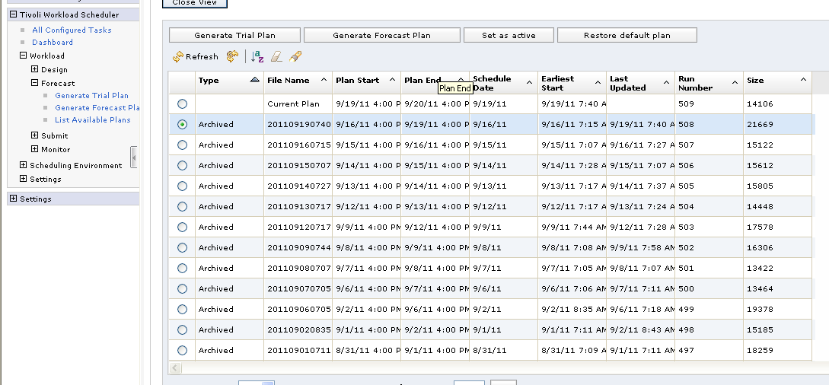

Dependencies

Dependency is defined as any condition or prerequisite that must be satisfied before a job or job stream can begin processing. The correct order of task processing is a critical aspect. There are activities that cannot start until others have completed successfully, or that must be performed at the beginning of a set sequence

In a scheduling environment, you define dependencies to establish the required processing order that best suits your business needs and optimizes your workload. Dependencies can affect jobs and job streams in terms of the time a job or job stream starts, the resources it needs to complete successfully, and on whether a human operator must intervene during the scheduling process.

Defining Dependencies

A dependency is a prerequisite that must be satisfied before processing can proceed. You can define dependencies for both jobs and job streams to ensure the correct order of processing. You can choose from four different types of dependencies:
On completion of jobs and job streams: a job or a job stream must not begin processing until other jobs and job streams have completed successfully.

Resource: a job or a job stream needs one or more resources available before it can begin to run. For more information, refer to needs.

File: a job or a job stream needs to have access to one or more files before it can begin to run. For more information, refer to opens.

Prompt: a job or a job stream needs to wait for an affirmative response to a prompt before it can begin processing. For more information, refer to prompt.

You can define up to 40 dependencies for a job or job stream. In a Tivoli Workload Scheduler network, dependencies can cross workstation boundaries. For example, you can make job1, which runs on host site1, dependent on the successful completion of job2, which runs on host site2..

File Dependencies

We use file dependencies to control job and job stream processing based on the existence of one or more files or directories. When a file dependency is specified, Tivoli Workload Scheduler checks if the specified file or directory exists before processing begins.
We can select several conditions associated to the file that must be true for processing to begin which can be used in one or more combinations.
These are:
The file exists
The file exists and is a directory
The file exists and is a regular file
The file exists and is readable
The file exists and its size is greater than zero
The file exists and is writable

Prompt Dependencies

Some jobs or job streams are so critical that they require special attention and human intervention to ensure that each task starts when all necessary conditions are fulfilled, and that it is accurately performed and monitored.

When you define prompt dependencies, you can momentarily suspend the processing of a job or job stream. A prompt identifies a textual message which is presented to an operator. The prompt requires an affirmative answer to allow processing to continue. You can also use prompts to alert an operator that a specific task was performed. In this case, an operator response is not required.

You can define three different types of prompts:
A prompt that can be used by any job or job stream in your environment
It is called a global (or named) prompt and you define it as a scheduling object. It is identified by a unique name and can be used by any job or job stream.

A prompt that is defined and used for a specific job or job stream
It is called a local or ad hoc prompt. This type of prompt is defined within a job or job stream. It does not have a name and it cannot be used by other jobs or job streams.

A prompt that alerts an operator of an error condition
It is called a recovery or abend prompt. It is a special type of prompt that you define for when a job ends abnormally. The response to this prompt determines the outcome of the job or job stream to which the job belongs. A recovery prompt can also be associated to an action and to a special type of job called a recovery job.

Resource Dependencies

We can control task processing by defining and associating resources to workstations. These resources are used as dependencies for job and job stream processing for the workstation to which they are associated.

Resources represent physical or logical scheduling resources. We define resources to introduce pauses in the logical flow of your tasks. For example, if two or more jobs require one tape unit to be available, you can define a resource called tape drive and assign it a value of 1. When you associate this resource as a dependency to one or more jobs, if both jobs request access to the resource, it is assigned to the job or job stream with the highest priority. When the job using the resource ends, the resource is released and the next job can use it. Defining resources helps you control concurrent processing.

You can also define resources to avoid shortages of limited system resources. If a job on a critical system requires a fixed amount of memory and disk space to run successfully, you can associate a logical resource dependency to that job so that no other job will run at the same time causing a memory or disk space shortage.

TWS Requests
To force start a job, to place the job ON DRAFT, to take the job OFF DRAFT, to cancel/rerun the abend job, the corresponding ITG requests need to be created.

TWS UPDATE CURRENT PLAN
This request is used to
Force start a job stream/ job.
Change the status
Change the Dependency

Description – to define the purpose of the request.
Environment – to choose the respective environment either TWS Production Distributed, TWS Stage Distributed or TWS Development Distributed.
Action Type – to choose the action type either Pre-defined Submission, Dependency change or Status Change.
Object Type – either Job or Job Stream
Job Family – to select the corresponding job family, the job is present.
Action – to select the respective action according to the action type selected.
Work Station – to select the respective workstation (optional filter)
Job/Job Stream Name – to select the exact name of job/job stream which is to be worked out with.
Notes – this can be included to brief about the request.
Action Type | Action
Pre Defined Submission | Submit  Submit On Hold
Dependency Change | Add File Dependency  Add Job Dependency  Add Job Stream Dependency  Release File Dependency  Release Job Dependency  Release Prompt Dependency  Release Job Stream Dependency
Status Change | Alter Priority  Cancel  Kill**  Take Off Hold  Place On Draft  Place On Hold  Prompt Reply  Rerun
** for Jobs alone, not for Job Streams

TWS Job Recovery
To recover the ABEND job either to cancel or to rerun the same job.

Description – to define the purpose of the request.
Environment – to choose the respective environment either TWS Production Distributed, TWS Stage Distributed or TWS Development Distributed.
Job Family – to select the corresponding job family, the job is present.
Object Name to Recover – to select the exact job name for recovery.
Current Status – the current status of the job is auto populated ‘ABEND’.
Action - to select the respective action either Cancel/Rerun.
Notes – this can be included to brief about the request.

TWS Job SCHEDULING
The TWS Job Scheduling request should be submitted for permanent batch scheduling changes in TWS.
Eg. To take the job stream OFF DRAFT ie. Active so that it can be run as per the schedule.

Description – to define the purpose of the request.
Environment – to choose the respective environment either TWS Production Distributed, TWS Stage Distributed or TWS Development Distributed.
Job Family – to select the corresponding job family, the job is present.
Is this request associated with a Project? If YES the project number needs to be provided.
Action Requested – the following are the actions that can be performed.

Action | Description
Add | To set up a new application along with the jobs include
Change | Change information on an application or job; such as scheduling, max return code, submit times, TWS work stations, resources, procedures or successors.
Delete | Deletion of application or job. It will be reviewed for successors and archived to a backup data set prior to deletion.
Distributed Variables | Use Details field to provide details.
Calendars, Periods and Dates | Use Details field to provide details
New TWS FTA Agent | Uses the FTA table to provide Details
TWS Windows ID | New ID to be used by TWSd to access and run jobs on a windows Server.
Composite Report | Use Details field to provide details
Others | Any type of scheduling request not covered above.

Pre Requisites
To test/run any job in TWS, there are some of mandatory pre requisites unless which the job fails. All those need to be checked prior to force starting the job or before it is scheduled.

On Call Repository

The Oncall Repository is a standard tool for operator instructions. It contains information including HPSM workgroup, priority, primary contact, and escalation contacts which is necessary in order for us to support the batch processing on a 24x7x365 basis.

The information is required for all production and test/dev jobs that require support from system operations. The tool is self-service and the data will be kept current by the support organization (OM). This is the single source of truth for batch support and will be the only vehicle used for such support going forward (once converted and populated).

The tool provides a common look and feel for both the operations staff, as well as the support organization (OM), regardless of the platform. The tool is robust to ensure continuous availability, and provides an audit trail for the last update to ensure accuracy. It is also secure so that only teams that are members of the HPSM workgroup can make changes.

One can view, edit, add, delete a particular job. The job which needs to be run in TWS should have been included in this repository.

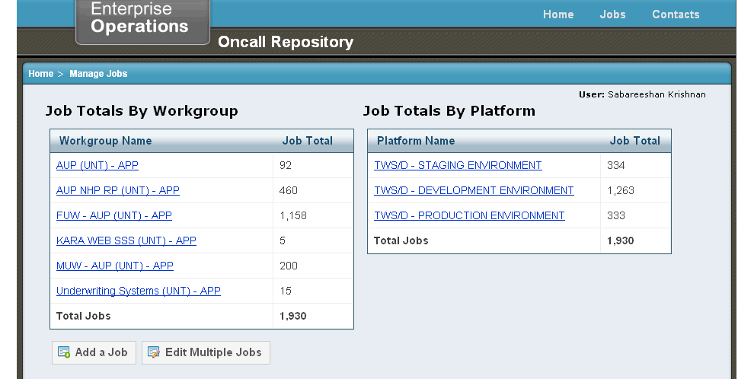

Script Files

Each and every job in the job family will call the script file in which the default variables like file name, system name, config name, script name are defined.

This provides the path where the LIB files, JAR files are present.

This also provides the class path for which java files needs to be invoked to process further.

As in Autosys, we need to have all the script files mentioned in the command to be present in the respective path and should be checked that it is executable.

Feed Files
As we know already, to process the batch job, the feed files are mandatory in the correct zone with the correct naming convention before the schedule time or before the force starting initiates.

Also we need to make sure that the environment is having sufficient space for the successful completion of job run

Other Files
All the required .xml, .profile, .log and .lib files should present in the respective locations/paths before the job stream starts running so as to avoid the failure of job.

Summary
To test/run a job in TWS, the following steps need to be followed.

- Check whether the job present in On Call Repository (sec 9.1).
- Check the status of the job in work Load Definition (sec 6.4) Active/DRAFT.
- If DRAFT, create a TWS Job Scheduling Request (sec 8.3) to take the job stream in OFF DRAFT.
- Once the request is approved, check for the Active status of Job Stream.
- Check for the pre requisites like .sh, .dat, .don, .xml, .profile, .lib and .log files for each job with the corresponding command (sec 9)
- To force start any active job stream in TWS, create TWS Update Current Plan Request (sec 8.1)
- Once the request is approved, either monitor the individual Jobs (sec 6.1) or monitor the complete Job Stream (sec 6.2)
- If any job fails in between check for the job log in the job window (sec 6.1)
- This will display the cause of failure with the Exit Code (sec 4.4)
- The status of the Job Stream will be WAITING and that of error job will be ABEND and following jobs will be HOLD. (sec 5)
- If the error is fixed, create a TWS Job Recovery request (sec 8.2)
  - either to RERUN the particular failed job so that the following jobs will be running after the completion of the same.
  - or to CANCEL the particular failed job so that the complete job stream can be force started again.
- After the successful completion of Job Stream, check for the status of both jobs and job stream as SUCCESS.

Links
ITG Request:
https://releaseservices.uhc.com/itg/dashboard/app/portal/PageView.jsp

SATS Request:
https://sats.uhc.com/sats/

On Call Repository:
http://apse0928/oncall/index.cfm

TWS_DEV:
https://apsm9034.uhc.com:29043/ibm/console/login.do?action=secure

TWS_STG:
https://apsm8067.uhc.com:29043/ibm/console/logon.jsp

TWS_PRD:
https://apsm0006.uhc.com:29043/ibm/console/logon.jsp

