**EVALUATION**

1. Quality of results (Ranking):

Score of each document is found from a query search

Ranking is based on the score i.e. the magnitude of relevance.

This is achieved by the “TopDoc” To know its efficiency, we must compare the results obtained with a benchmark.

*TopDocs cltr=schr.search(qry, 1000); //upper bound to get the actual number of hits*

**Without Preprocessing:**

**Query 1:** what similarity laws must be obeyed when constructing aeroelastic models of heated high speed aircraft .

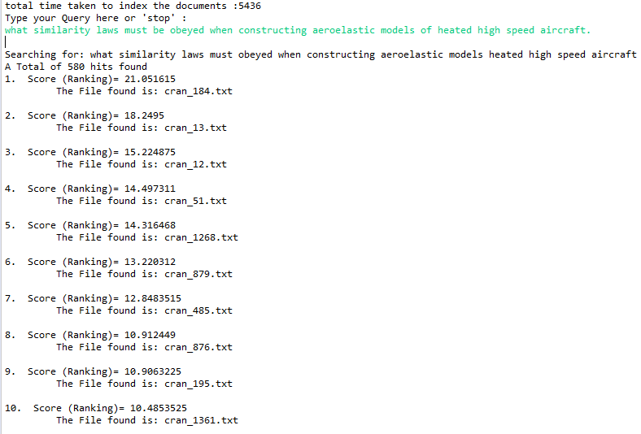

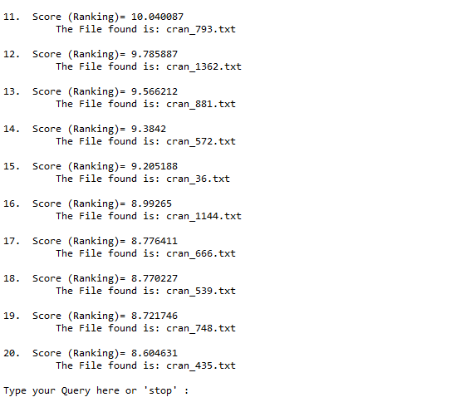

**Query 2:** how can the aerodynamic performance of channel flow ground effect machines be calculated

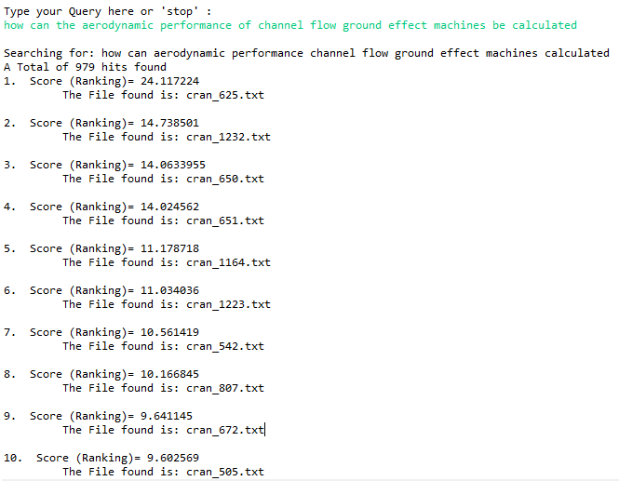

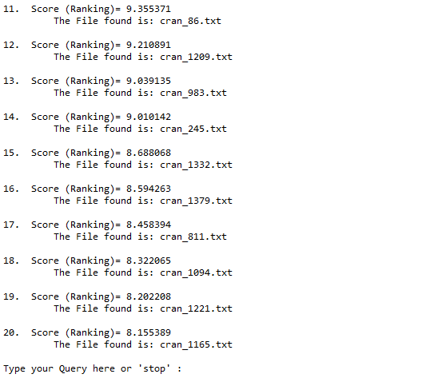

**Query 3:** what parameters can seriously influence natural transition from laminar to turbulent flow on a model in a wind tunnel

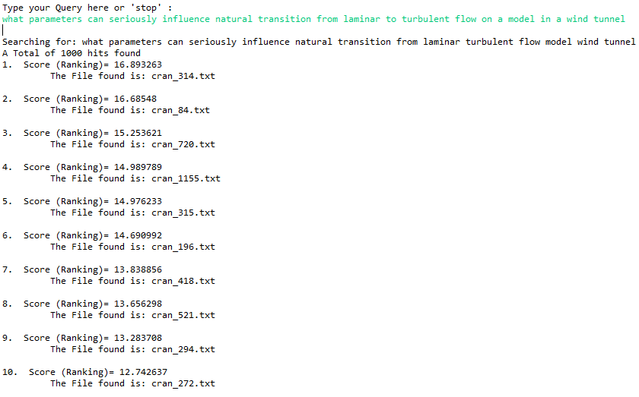

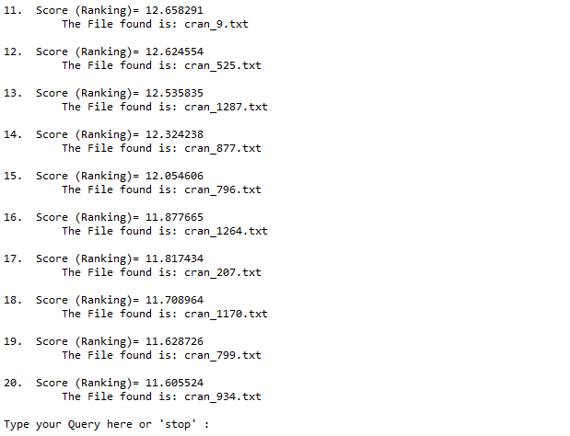

**Query 4:** in summarizing theoretical and experimental work on the behaviour of a typical aircraft structure in a noise environment is it possible to develop a design procedure

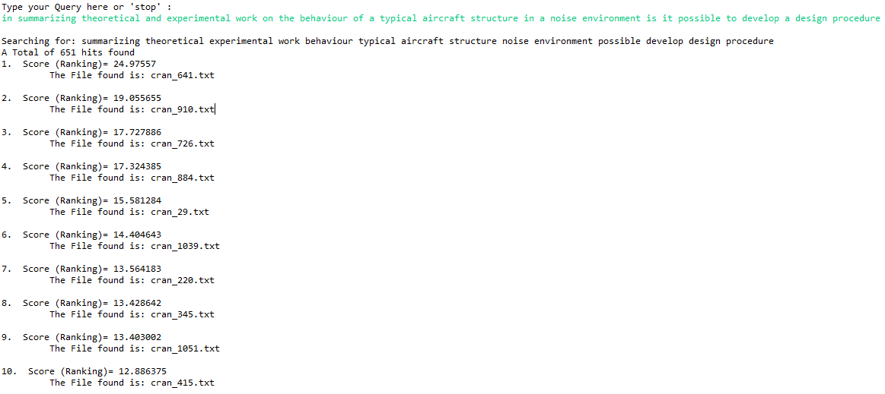

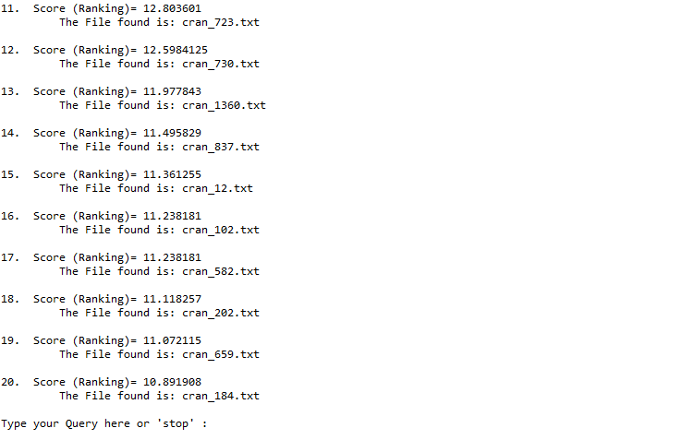

**Query 5:** theory study creep buckle

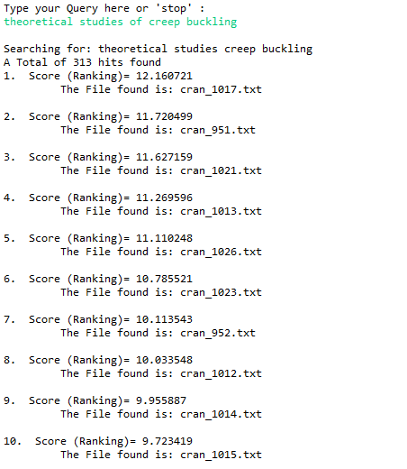

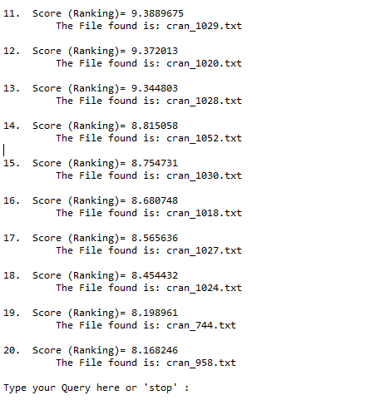

**With Preprocessing:**

**Query 1 :** what similarity law must obey when construct aeroelastic model heat high speed aircraft

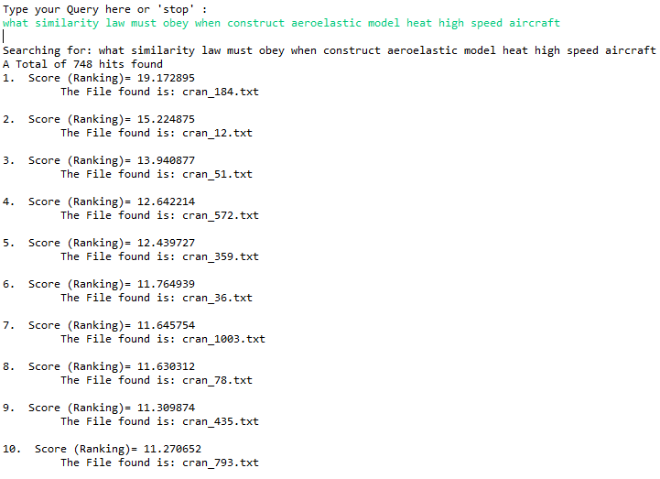

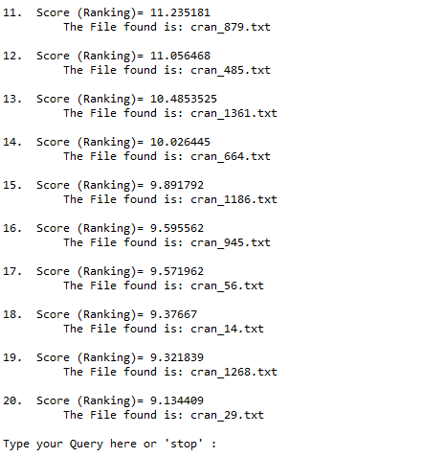

**Query 2:** how can aerodynamic performance channel flow ground effect machine calculate

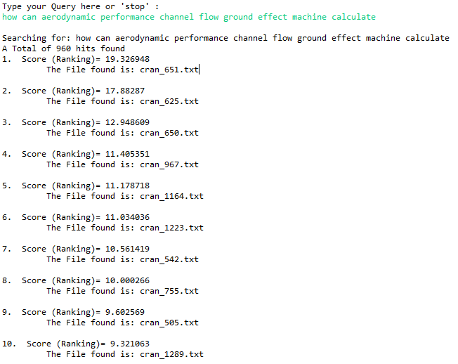

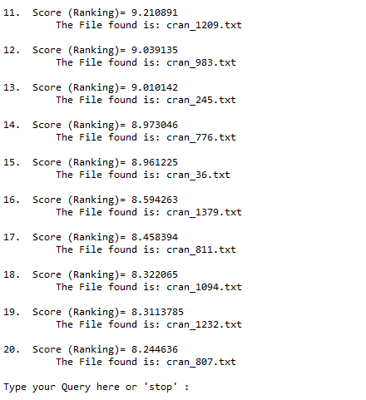

**Query 3:** what parameter can serious influence natural transition laminar turbulent flow model wind tunnel

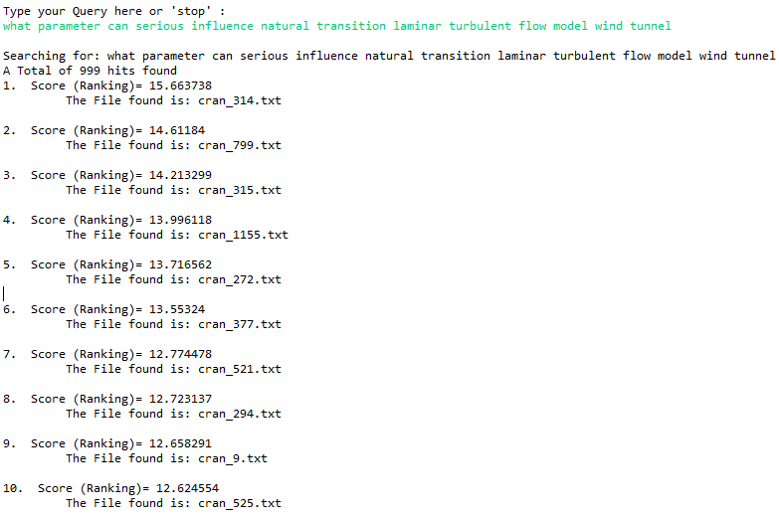

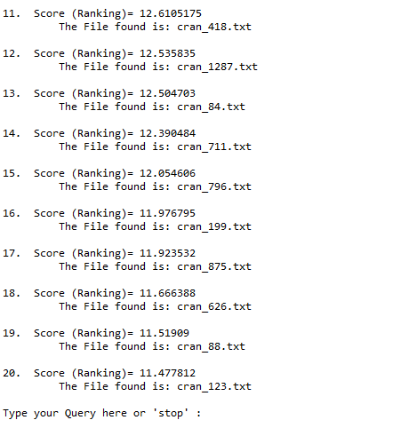

**Query 4:** summarize theoretical experimental work behavior typical aircraft structure noise environment possible develop design procedure

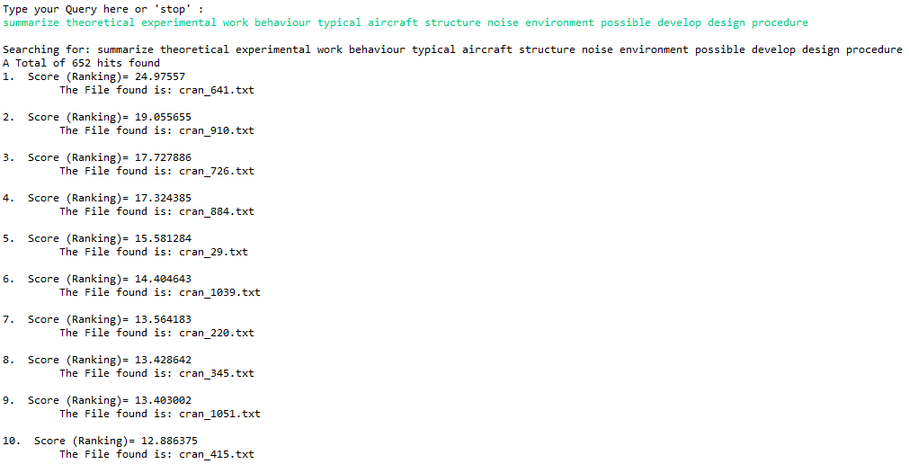

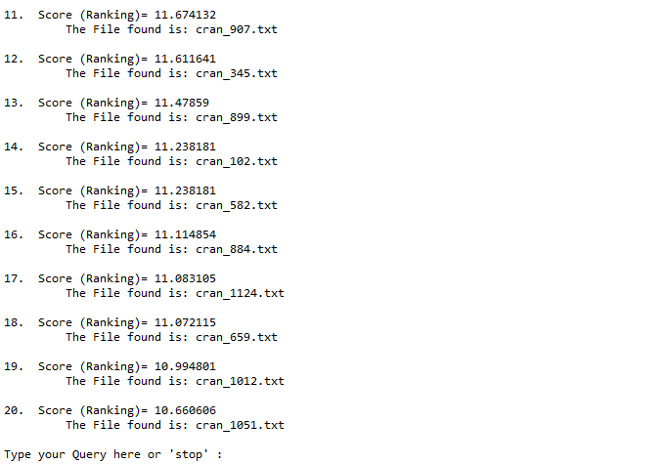

**Query 5:** theory study creep buckle

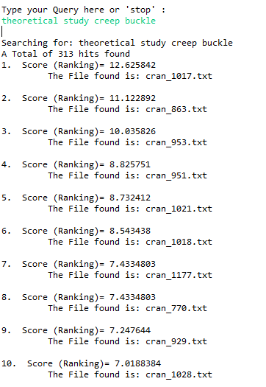

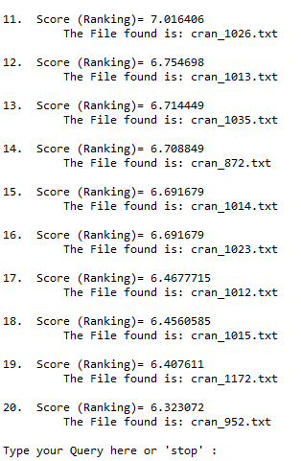

|  |  |  |
| --- | --- | --- |
|  | Without Preprocessing | With Preprocessing |
| Query 1 | 580 hits | 748 hits |
| Query 2 | 979 hits | 960 hits |
| Query 3 | 1000 hits | 999 hits |
| Query 4 | 651 hits | 652 hits |
| Query 5 | 313 hits | 313 hits |

With some preprocessing techniques like removing stop words, lemmatization, stemming the query can be nurtured better to get better search results with minimum time for retrieval.

Time taken for querying: 3234

Time taken for indexing : 3387

Index folder size is 850kb maximum.