WEEK -4
CASE STUDY ON WEB APPLICATION ACHITECTURE
INSTAGRAM

TABLE OF CONTENTS
S.no | Contents | Page number
 | Objective | 2
1 | Introduction | 2
2 | Web Server Used | 2
3 | Backend Technology | 2
4 | Why These Tools Are Used | 3
5 | Architecture Type | 3-4.
6 | Hosting & Strategy | 5
7 | Caching & CDN | 5-6.
8 | Unique Features | 6
9 | Summary Table | 7

OBJECTIVE:
The objective of this case study is to analyze the web application architecture of Instagram, focusing on the technologies it uses, how its systems are designed for performance and scalability, and the strategies that enable it to serve billions of users reliably across the world.
- INTRODUCTION:
Instagram is one of the world’s largest social media platforms with billions of monthly active users. It handles photo sharing, video delivery, messaging, and real-time interactions at massive scale. This case study explains Instagram's backend architecture, technologies used, hosting strategy, caching layers, performance optimizations, and DevOps practices that allow it to run efficiently worldwide.
- Web Server Used:
Instagram primarily uses 2 web servers. Nginx and Proxygen.
Nginx: Nginx is used at Instagram’s front-end traffic layer, where all user requests first arrive.
It acts as a reverse proxy that forwards these requests to the correct backend services.
It also acts as a load-balancer and transfer loads according to the server freeness and serves static content efficiently for faster performance.
Proxygen: Proxygen is used for Instagram’s internal microservices such as the Feed service, Messaging service, Notifications service, Ads service, and User profile service.
It handles the API communication between these backend services.
(i.e) Proxygen is used for all internal service-to-service communication inside Instagram.
- Backend Technology:
Instagram uses Python, Golang, Node.js, C++ as their programming languages and Django, GraphQL, Celery, Thrift/RPC system as their frameworks for multiple functionalities.
Category | Technologies Used | Purpose
Programming Languages | Python | Main backend language powering core services
 | Go (Golang) | High-performance microservices and concurrency-heavy tasks
 | Node.js | Real-time features like chat, notifications, and live updates
 | C++ | Used in internal Meta systems such as Proxygen
Frameworks | Django | Original main backend framework (customized at scale)
 | GraphQL | Efficient API querying across Instagram & Meta products
 | Celery | Background task processing (image processing, notifications)
 | Thrift / RPC systems | Communication between backend microservices

Note: Insta changed to microservices from monolithic Django after facebook acquired insta as their traffic got exploded.

- Why these tools are used.
Programming languages:
- Python
Chosen because it is simple, fast to develop, and easy for large teams to maintain while adding new features quickly.
- Go (Golang)
Used for performance-heavy microservices because it handles high traffic and concurrency with great efficiency.
- Node.js
Ideal for real-time features like chat and notifications due to its event-driven, non-blocking architecture.
- C++
Used inside Meta’s internal systems (like Proxygen) where very high speed and low latency are required.
FrameWorks:
- Django
Selected for its strong built-in features (security, ORM, admin panel) and because it helped Instagram scale rapidly in the early stages.
- GraphQL
Used to optimize API requests by letting clients fetch only the exact data they need, improving app performance.
- Celery
Used for background task processing (image processing, notifications) so the main application stays fast.
- Thrift / RPC systems
Used to enable fast, reliable communication between Instagram’s many backend microservices.

- Architecture Type:
Instagram uses a Multi-tier Architecture (Microservices Architecture).It originally started as a 3-tier monolithic Django app, but as it grew, it moved to a microservices-based multi-tier architecture where different services run independently and communicate through internal APIs. It is a large-scale Multi-tier Microservices architecture.
This includes layers like:
- Client Layer
Users interact with Instagram through the mobile app or website, sending requests to the backend.
- Nginx / Gateway Layer
Nginx receives all incoming traffic and forwards it to the correct backend service.
- Backend Microservices Layer
Independent services like Feed, Messaging, Stories, and Notifications process the requests.
- Database Layer
Stores user data, posts, messages, and relationships in scalable distributed databases.
- Caching Layer
Delivers frequently accessed data quickly using Redis and Memcache to reduce load.

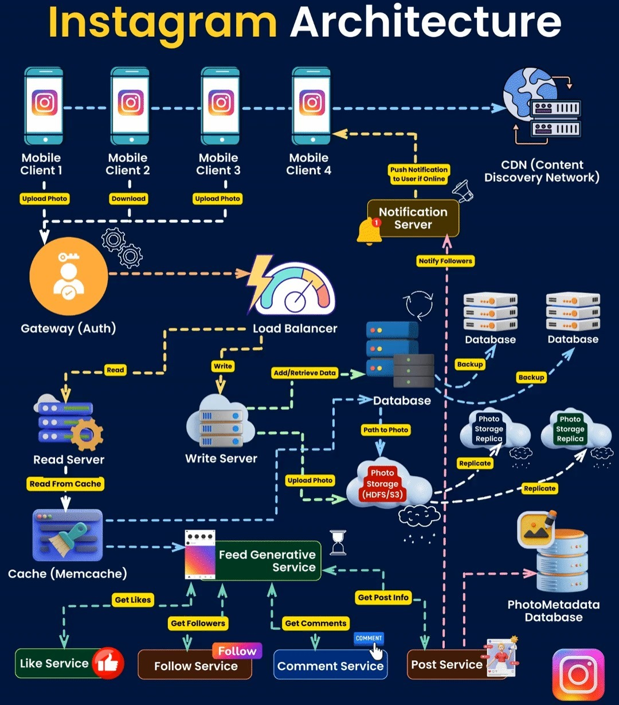

The image shows Instagram’s internal system architecture, where user requests pass through an authentication gateway, then a load balancer, and finally reach different servers like read servers, write servers, feed generation service, cache, CDN, and storage, all working together to deliver a fast and seamless experience.

- Hosting and strategy:
Instagram is not hosted on public cloud like AWS, Azure, or GCP. Instead, it runs entirely on Meta’s own private data centers around the world. These data centers are highly optimized for performance, storage, and global traffic.
- Load Balancing:
Instagram uses Nginx and Meta’s Proxygen load balancers to distribute millions of user requests across backend servers.This prevents any single server from overloading.
- Traffic management:

- Global traffic is routed through Meta’s worldwide edge infrastructure.
- CDN delivers images and videos quickly to users.
- Requests are geo-distributed to the nearest data center.

- Scaling:
Instagram uses horizontal scaling, meaning they add more servers instead of upgrading a single server. Scaling is automated based on demand:
- More servers are added during peak times.
- Microservices scale independently (Feed, Stories, Messaging, Ads, etc.).
- Caching (Redis, Memcache) reduces pressure on databases.
- High availability:

Data is replicated across multiple regions so Instagram works even if one data center fails.

- Caching &CDN:

Insta heavily uses caching to make the process fast. They uses tools like: Redis, Memcache, Edgecache for caching.

- Redis:
- Redis is an ultra-fast in-memory key-value store.
- Cache frequently accessed user data
- Store session data for logged-in users
- Reduce repeated database queries.
- Memcache:
- Memcache is one of Instagram’s oldest caching systems.
- Store temporary data
- Cache posts, comments, and user metadata
- Reduce the load on primary databases.

- Edge caching:
Instagram uses Meta’s global edge servers to cache: Image, Videos, Reels, Profile picture, Static content.

CDN: Content Delivery Network.
- Akamai CDN
  - Akamai is one of the largest CDNs in the world.
  - Deliver photos and videos extremely fast
  - Reduce load on Instagram’s core servers
  - Serve content globally with low latency
  - Akamai stores cached copies of content on thousands of servers worldwide.

- Meta’s Own CDN
  - Meta (Facebook + Instagram) also built its own large CDN infrastructure.
  - Deliver high-resolution media at large scale
  - Reduce dependency on external CDNs
  - Balance traffic between Akamai and Meta’s internal network
  - Improve reliability and speed during peak loads

- Unique features:
Instagram has many unique features in it which are admiring the world. Some of the inbuild features are listed below.
- Feed Ranking Algorithm – Personalizes each user’s feed using machine learning to show the most relevant posts.
- Stories & Reels Pipeline – Processes, compresses, and delivers photos/videos quickly for smooth viewing.
- Real-Time Messaging (Direct) – Supports instant chat, active status, and message delivery indicators.
- Distributed Storage System – Stores and retrieves billions of photos and videos reliably across regions.
- CDN & Caching System – Speeds up content delivery by serving media from the nearest server and caching frequently accessed data.

DOES INSTA READS OR MIND TO DELIVER CONTENT CORRECTLTY?
Instagram’s feed is generated using a machine learning recommendation system that analyzes signals like watch time, scroll behaviour, interaction patterns, graph connections, and device/activity data.These signals are processed through ranking models (neural networks) that predict the probability of you engaging with each post, and the feed is sorted based on that predicted score — making it feel like Instagram knows what you want.

- SUMMARY TABLE:

Topic | Summary
Web Server Used | Instagram uses Nginx as the main web server and Proxygen for fast internal microservice communication.
Backend Technology | Built mainly with Python and Django, supported by Go, Node.js, GraphQL, Celery, and Meta’s internal RPC systems.
Why These Tools? | Python and Django enable fast development; Go handles high-performance services; Node.js supports real-time features; GraphQL reduces API payload; Celery processes background tasks efficiently.
Architecture Type | Instagram uses a multi-tier microservices architecture, evolved from a monolithic Django app.
Hosting & Strategy | Hosted on Meta’s own global data centers; uses Nginx/Proxygen load balancing, horizontal scaling, distributed services, and region-based traffic management.
Caching & CDN | Uses Redis, Memcache, and edge caching to reduce latency; delivers media via Akamai CDN and Meta’s internal CDN for global speed.
Unique Features | ML-based feed ranking, optimized Stories/Reels pipeline, real-time messaging system, distributed storage, push notifications, Proxygen communication layer, AI spam detection, and A/B testing.

THANK
YOU

