Name= shaik Raakin

Class =3rd sem

Branch = cybersecurity

usn=ENG24CY0192

Roll no:64

section:A

**1Q. What is Linux Operating System (OS)? List three pros and cons of it.**

**Sol:**

Linux is an **open-source operating system** based on **Unix. (**Unix was an operating system that was developed by **AT&T’s Bell Labs** in the 1960's. **Linux** can be said as a software layer between the computers hardware such as Ram, rom ,cpu and the application layer such as chrome , firefox etc . unlike macos and windows , Linux is free and open sourced , and community driven and highly customisable and very popular ,also all of the worlds top 500 supercomputers use linux.

Pros :

1. **Open Source & Free**:

don’t need to pay for licenses like Windows . It's free and can be downloaded for free and the source code can also be changed by the user .

2.**Security & Stability:**

less vulnerable to viruses, malware, and random crashes compared to Windows since it is open source any one can find the errors in codes and fix it.

3.**Performance & Customization:**

Very lightweight and can run on very old computers. Nearly everything can be customized in linux.

**Cons:**

**1.Software Compatibility**:

Very less app support compared to macOS or windows . Apps like Photoshop, MS Office and many high-end games are not supported ,so alternatives apps will need to be used

**2.Learning Curve:**

Linux has a very steep learning curve compared to windows or macos . It's harder for people from macOS or windows to shift to linux at first .

**3.Hardware Support:**

Some hardware drivers like gpu drivers or sound drivers don’t work well with linux out of the box and have to be fixed later on after the installation.

**2Q.Differentiate between Linux, Mac, Android, and Windows OS with at least six unique features.**

**Sol:**

**Linux:**

1. It is a open source unix like os created by Linus Torvalds in 1991.
2. It is free and open source os.
3. Highly customisable and many distros like kali, ubuntu, arch, mint.
4. Very secure and less targeted by malware.
5. has many free and open source apps. Very few mainstream applications are present
6. Very light weight and can run on even very old machines.

**Mac:**

1. It is a proprietary unix based operating system created by Apple.
2. Paid but comes out of the box with a apple device.
3. Does not allow for much customisation .
4. Very highly secured apps and less targeted by malware but it is a locked ecosystem.
5. Works only on apple devices.
6. Very optimised software but resource heavy.

**Android:**

1. Android, a mobile operating systems developed by Google in 2008, is based on the Linux kernel.
2. It has the largest global market share among smartphone operating systems.
3. Android is customizable thanks to skins, launchers, and custom ROMs.
4. Android has the biggest app library through the Google Play Store.
5. Its wide usage and allowing of sideloading apps in android makes it more vulnerable to malware than iOS .
6. Android also powers tablets, TVs, cars, and IoT devices, not just phones.

**Windows:**

1. Windows is a proprietary OS developed by Microsoft since 1985.
2. It is the most widely used desktop OS in the world.
3. Windows is user-friendly with a GUI featuring the Start menu and taskbar.
4. It has the best support for software and gaming.
5. However, it is more vulnerable to viruses and malware.
6. Windows requires stronger hardware resources compared to Linux.

**3Q. Why is Linux preferred for Mainframe Servers for legacy applications? Give three out-of-the-box technical reasons.**

**Sol:**

**1. Workload Consolidation and Virtualization :**

Linux on mainframe offers significant virtualization (z/VM, KVM, LPARs) to run thousands of Linux virtual servers at the same time on a single mainframe. You can simultaneously host modern and legacy applications together without any rework. It is similar to having an enormous data center in a single box.

**2. Backward Compatibility and Open Standards:**

Many legacy applications also use legacy programming languages (e.g. COBOL, C, Fortran). The Linux environment has a strong commitment to supporting POSIX compliance, ABI compatibility, and an open-source tool-chain, which allows you to run, recompile, or wrap an older application with minimal effort, without completely rewriting it. In short, Linux provides the transition from "ancient" code to modern standards.

**3. Unmatched Reliability, Security, and Uptime :**

Mainframes are built for continuous operations with remarkably high uptime. Linux increases uptime even further with features like kernel hardening, SELinux, advanced access control, and process isolation techniques. Legacy applications that used to run on antiquated proprietary OSes receive all the security patches and stability of modern Linux without performance degradation - this is the true performance punchline for Linux.

**4Q. Explain the structure of the Linux File System with proper diagram. Note: you can use the tree command to find it out.**

**Sol:**

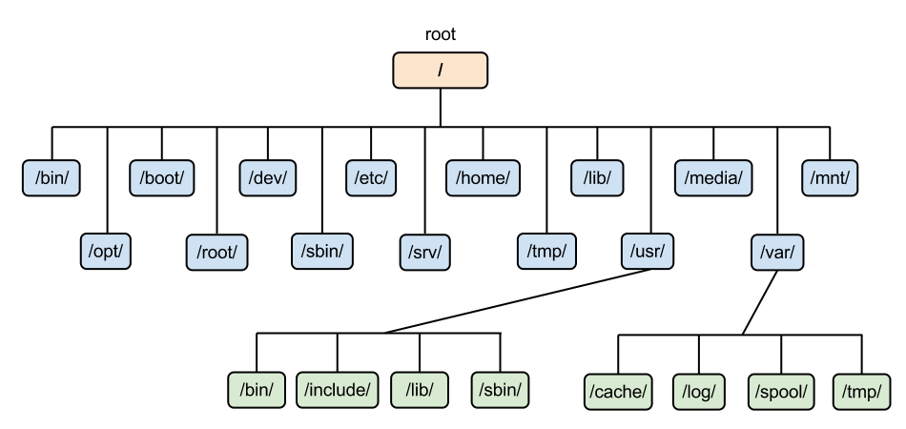

**raakin@ubuntu-25:~$ tree**

**.**

**├── a.out**

**├── client.c**

**├── Desktop**

**├── Downloads**

**│ ├── im.jpeg**

**│ └── Negus C. Linux Bible 10ed 2020Negus C. Linux Bible 10ed 2020.pdf**

**├── hi**

**├── linx**

**│ ├── demo.sh**

**│ └── sum.sh**

**├── Music**

**├── newc**

**│ ├── a.out**

**│ ├── hi.c**

**│ └── prac.c**

**├── Pictures**

**│ ├── im.jpeg**

**│ └── Screenshots**

**│ └── Screenshot From 2025-09-22 09-50-23.png**

**├── Public**

**├── Screenshot From 2025-09-22 09-50-23.png.pdf**

**├── snap**

**│ ├── firefox**

**│ │ ├── 6700**

**│ │ ├── 6738**

**│ │ ├── common**

**│ │ └── current -> 6738**

**│ ├── firmware-updater**

**│ │ ├── 167**

**│ │ ├── common**

**│ │ └── current -> 167**

**│ ├── prompting-client**

**│ │ ├── 104**

**│ │ │ ├── Desktop**

**│ │ │ ├── Documents**

**│ │ │ ├── Downloads**

**│ │ │ ├── Music**

**│ │ │ ├── Pictures**

**│ │ │ ├── Public**

**│ │ │ ├── Templates**

**│ │ │ └── Videos**

**│ │ ├── common**

**│ │ └── current -> 104**

**│ ├── snapd-desktop-integration**

**│ │ ├── 253**

**│ │ │ ├── Desktop**

**│ │ │ ├── Documents**

**│ │ │ ├── Downloads**

**│ │ │ ├── Music**

**│ │ │ ├── Pictures**

**│ │ │ ├── Public**

**│ │ │ ├── Templates**

**│ │ │ └── Videos**

**│ │ ├── 315**

**│ │ │ ├── Desktop**

**│ │ │ ├── Documents**

**│ │ │ ├── Downloads**

**│ │ │ ├── Music**

**│ │ │ ├── Pictures**

**│ │ │ ├── Public**

**│ │ │ ├── Templates**

**│ │ │ └── Videos**

**│ │ ├── common**

**│ │ └── current -> 315**

**│ ├── snap-store**

**│ │ ├── 1270**

**│ │ ├── common**

**│ │ └── current -> 1270**

**│ └── terminal-parrot**

**│ ├── 92**

**│ ├── common**

**│ └── current -> 92**

**├── tcp**

**│ ├── a.out**

**│ ├── client**

**│ ├── client.c**

**│ ├── server**

**│ └── server.c**

**├── Templates**

**└── Videos**

**63 directories, 18 files**

The linux file system is a hierarchical tree system .

the main structure:

1. **/ (Root Directory)** – The base of the file system. Every file and directory begins here.
2. **/bin** – Essential binary programs (basic commands like ls, cp, mv).
3. **/sbin** – System binaries for administrative tasks (like shutdown, mkfs).
4. **/etc** – Configuration files for the system (like network, users, services).
5. **/home** – User home directories (e.g., /home/raakin). Each user stores personal files here.
6. **/root** – Home directory of the root (superuser) account.
7. **/var** – Variable data files (logs, mail, spool, cache, temporary changing data).
8. **/tmp** – Temporary files created by programs and processes.
9. **/usr** – User-installed applications and software libraries.
10. **/lib** – Shared libraries needed for system and application programs.
11. **/dev** – Device files (like hard drives /dev/sda, USBs, printers).
12. **/proc** – Virtual directory showing process and kernel information in real time.
13. **/boot** – Bootloader files and kernel images needed for startup.
14. **/mnt and /media** – Mount points for external devices like USBs, CDs, or other partitions.

**5Q. If Linux OS is open-source, how do companies like Red Hat still making money from it? Do a market study and answer properly.**

**Sol:**

**Subscriptions and Support Services:**

The majority of Red Hat’s income is from subscriptions to RHEL that come with support, updates, patches, and lifecycle management commitments. Enterprises favor this subscription-based approach because it guarantees stability, security and backward compatibility—things that aren’t worth risking breaking on mission-critical systems.

**Enterprise-Class Guarantees & Long Lifecycle:**

In contrast to free open-source distros that can become broken with regular updates, Red Hat’s versions include stable releases, longer support windows for software, and back-ported security fixes. Once a company spends money in RHEL (staff training, infrastructure, support), changing to another distro becomes expensive, thus renewals continue the revenue flow.

**Red Hat Offers Specialized Products Apart From the OS:**

Red Hat also sells products like OpenShift, Ansible, and cloud services. These often require professional services, training, and customizations, which bring in additional high-margin revenue.

**6Q. Write the command to display today’s date and time (i.e., current System time).**

**Sol:**

The command to find todays day and time using linux is:

date

Eg:

raakin@ubuntu-25:~$ date

Mon Sep 22 03:45:42 PM UTC 2025

**7Q. Which command is used to check how long the system has been running?**

**Sol:**

The command to check how long the system has been running is

uptime.

Eg:

raakin@ubuntu-25:~$ uptime

15:47:03 up 13 min, 2 users, load average: 0.06, 0.20, 0.21

**8Q. What is the difference between shutdown -h now and halt?**

**Sol:**

**shutdown -h:**

This tells the system to safely shut down immediately.-h means *halt* after shutdown (power off).

It stops all processes, syncs disks, notifies logged-in users, and then halts the system.

**halt:**

This command directly halts the CPU.It can stop the system without properly shutting down services. It may not notify users or cleanly stop processes .

**9Q. Compare init 0 and shutdown -h. Which is safer? Why?**

**Sol:**

shutdown -h is safer than init 0.

**shutdown -h:**

it sends a warning to all logged-in users, it waits long enough for all services to save and shutdown gracefully and finally it disables new logins. This orderly shutdown will eliminate the possibility of data corruption or loss of any data that hasn't already been submitted.

**Init 0:**

This command is a more raw and immediate method of halting the system. It immediately tells the system to change to runlevel 0 (halt), forcibly stopping processes without allowing any chance for them to clean up their work or shut down gracefully.

**10Q. A system administrator accidentally powers off a Server machine without shutting it down properly. What problems can occur to the said Server?**

**Sol:**

An inappropriate shutdown can cause a number of serious issues for a server. In the context of a server, when the power is shut off suddenly without going through the appropriate shutdown instructions, this can lead to a wide array of issues anywhere from minor annoyance to critical failure.

**File System Corruption:**

The most common and critical problem is file system corruption. Operating systems constantly read and write data to the disk. A proper shutdown ensures that all pending write operations are completed and the file system is marked as "clean."

**Loss of in-flight data:** Any data that was stored in memory (in the cache) and ready to write to disk is lost and unrecoverable.

**Partially written files**: A file could have been partially updated, meaning that a loss of power could leave the file invalid and corrupted.

**Application state loss:** Any application that maintains an internal state will lose it. A web server might lose active user session data.

**Disk damage:** Older hard disk drives (HDDs) could suffer physical damage if the read/write heads didn't have time to park themselves in a safe zone.

**Brainstorming:**

**a) As Linux Kernel is open-source, can we build our own operating system?**

**b) In order to do that, what are the stoppers, hurdles, and challenges?**

**c) Is anyone in India working on this field? Find at-least three to four engineers.**

**Sol:  
a)**Yes, for sure. The reason why any person can build her/ his own OS is that the kernel is open-source. The kernel is the core of the OS that handles the essential tasks like hardware management, memory management, and process management.

**b)Creating a full-fledged OS is incredibly complex. The main hurdles are:**

* **Hardware Support:** Writing thousands of drivers for different CPUs, GPUs, and network cards.
* **Software Ecosystem:** Building everything that runs on top of the kernel, such as system utilities, a package manager, and a graphical user interface (GUI).
* **Integration & Testing:** Making all the different software components work together without bugs.
* **Maintenance & Security:** Continuously providing security patches and updates.

**c)India has a vibrant community of developers and engineers who are actively contributing to the Linux kernel and working in the field of operating systems:**

**a)K. Prasad:** A seasoned developer who has been contributing to the Linux kernel for many years.

**b)Balbir Singh:** Known for his significant work on container technology and control groups (cgroups) within the Linux kernel.

**c)Jaswinder Singh Rajput**

**d)Srivatsa S. Bhat**