AFLCMC/C3CW

Engineering Design Document for

Crew Builder Client – CBC
Bug 12767
CBC - Crew Details, MEP Error Messaging

Created By: Rahsaan Pringle
Today’s Date: 08/11/2025
Requested Push Date: TBD

1. Change Description and System Information

  - System Name and Identification
System Name: | Crew Builder Client
System Acronym: | CBC
Configuration Item Name and Acronym | Crew Builder Client – CBC
Version Number: | 1.0.24
Sprint(s): | 79
Change Description: | This change corrects the display and wording for specific error messages.
Change Purpose: | Correct incorrect display and wording for error messages.
Impact if change is not approved: | Error messages would be improperly worded and have an incorrect color scheme.

  - Required Firewall Modifications:
N/A
1.3 Personally Identifiable Information
N/A
- Network
2.1 External Interfaces
Domain/Network | Interfaces | Information Description | Information Exchange Attributes
N/A | N/A | N/A | N/A

2.2 IP address
Device Name | Private IP Address | System Name | Additional Information
N/A | N/A |  | N/A

2.3 Internal Interfaces
Container / Module / Code Base | Internal Interfaces | Information Description | Information Exchange Attributes
N/A | N/A | N/A | N/A

2.4 IP Address
Device Name | Private IP Address | System Name | Additional Information
SGBP-WS-02P | 131.7.1.131 | PEX | DL360 Gen 9, Windows Server 2016, GOTS Application ePEX, Web servers
SGBP-WS-EPEX03P | 131.7.1.132 | PEX | DL360 Gen 9, Windows Server 2016, GOTS Application ePEX, Web servers
SGBP-WS-EPEX04P | 131.7.1.133 | PEX | DL360 Gen 9, Windows Server 2016, GOTS Application ePEX, Web servers
SGBP-WS-EPEX05P | 131.7.1.134 | PEX | DL360 Gen 9, Windows Server 2016, GOTS Application ePEX, Web servers
SGBP-WS-EPEX07P | 131.7.1.136 | PEX | DL360 Gen 9, Windows Server 2016, GOTS Application ePEX, Web servers
SGBP-WS-EPEX08P | 131.7.1.137 | PEX | DL360 Gen 9, Windows Server 2016, GOTS Application ePEX, Web servers
SGBP-WS-EPEX10P | 131.7.1.139 | PEX | DL360 Gen 9, Windows Server 2016, GOTS Application ePEX, Web servers
SGBP-WS-EPEX11P | 131.7.1.142 | PEX | DL360 Gen 9, Windows Server 2016, GOTS Application ePEX, Web servers
BXCR-AS-SRV51P | 214.27.220.51 | PEX | DL360 Gen 9, Windows Server 2016, GOTS Application ePEX, Web servers
BXCR-AS-SRV52P | 214.27.220.52 | PEX | DL360 Gen 9, Windows Server 2016, GOTS Application ePEX, Web servers

- Hardware and Software Lists

  - Hardware List
Hardware | Manufacturer  Model | COTS/ GOTS  Operating Sys | Function | Hardware
SGBP-WS-EPEX02P | DL360 Gen9 | COTS  Windows Server 2016 | OMNI Production Web Server | SGBP-WS-EPEX02P
SGBP-WS-EPEX03P | DL360 Gen9 | COTS  Windows Server 2016 | OMNI Production Web Server | SGBP-WS-EPEX03P
SGBP-WS-EPEX04P | DL360 Gen9 | COTS  Windows Server 2016 | OMNI Production Web Server | SGBP-WS-EPEX04P
SGBP-WS-EPEX05P | DL360 Gen9 | COTS  Windows Server 2016 | OMNI Production Web Server | SGBP-WS-EPEX05P
SGBP-WS-EPEX06P | DL360 Gen9 | COTS  Windows Server 2016 | OMNI Production Web Server | SGBP-WS-EPEX06P
SGBP-WS-EPEX07P | DL360 Gen9 | COTS  Windows Server 2016 | OMNI Production Web Server | SGBP-WS-EPEX07P
SGBP-WS-EPEX08P | DL360 Gen9 | COTS  Windows Server 2016 | OMNI Production Web Server | SGBP-WS-EPEX08P
SGBP-WS-EPEX10P | DL360 Gen9 | COTS  Windows Server 2016 | OMNI Staging Web Server | SGBP-WS-EPEX10P
SGBP-WS-EPEX11P | DL360 Gen9 | COTS  Windows Server 2016 | OMNI Production Web Server | SGBP-WS-EPEX11P

  - Software List
Component | Language | Version | Function
PR Link | TypeScript | V5.4.5 | Pull request 1796

3.3 Languages
TypeScript v.5.4.5

- Security Scans, Testing & Help Documents

  - Send security scans in POAM format
Attachment provided:

Fortify Scan Results:
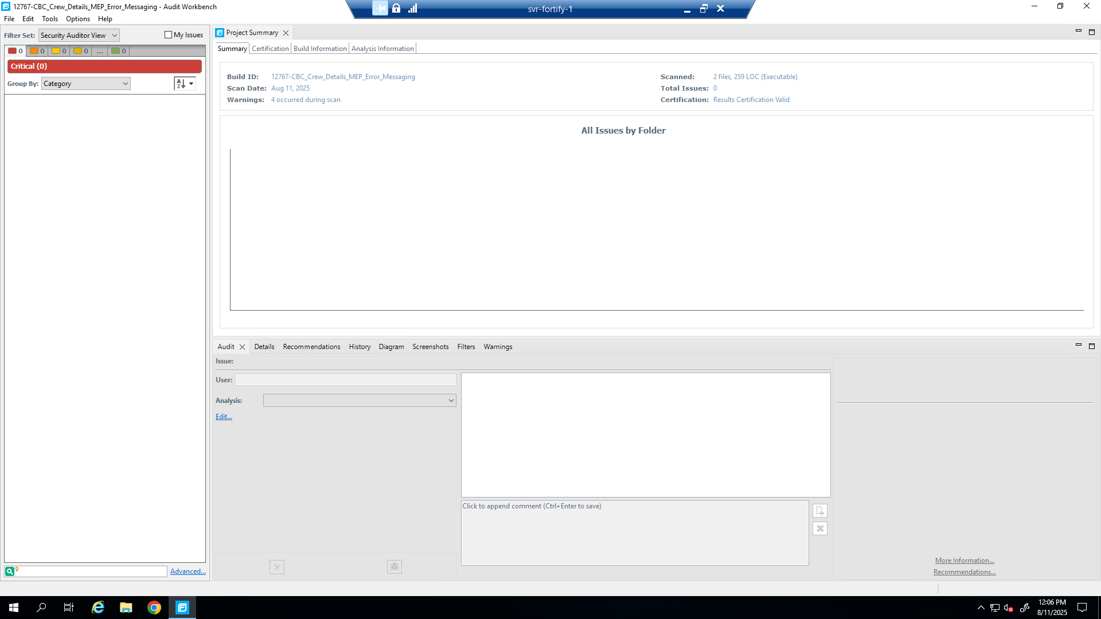

4.2 Describe all testing:
Test Cases: David Feathers
- Test Case 12988 Updated MEP Message

- Log into PEX with permissions to Flying Schedule
- Load the sortie filter
- Select Crew Builder for a sortie with multiple crew members
- Select the Crew Details for the sortie
- Select 2 crew members to be “Flight Lead”
- Select 2 crew members to be “Deputy Lead”

4.3 Is there a Help File? No.

- Code/Change Review
    - Pull request 1796
  - Reviewer Names:
    - Code Reviewed By: TBD
    - EDD Reviewed By: Phillip Hassoun
  - Does the change require UX Team validation? No.
  - Review code for
Readability: There are no redundant comments.
Security: There are no security risks.
Test coverage: No more test cases required.
Architecture: This code makes use of a design pattern for encapsulation, modularization, and containerization.
Reusability: This change does not involve the need for reusable components.

- Data Flow Diagram
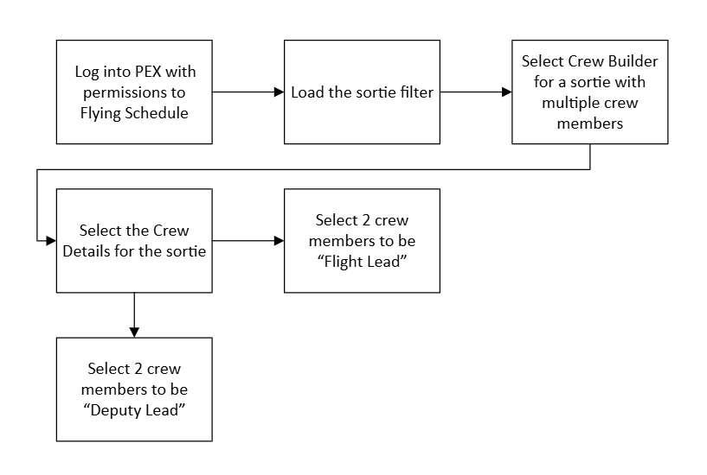

- Logical Connection Diagram