AFLCMC/C3CW

Engineering Design Document for

OMNI_PEX

Crew Builder Client - CBC

Bug 12467 CBC - Responsive Mission Scroller

Created By: Rahsaan Pringle
Today’s Date: 07/24/2025
Requested Push Date: TBD

1. Change Description and System Information

  - System Name and Identification
System Name: | Crew Builder Client
System Acronym: | CBC
Configuration Item Name and Acronym | Crew Builder Client – CBC
Version Number: | 1.0.23
Sprint(s): | 78
Change Description: | This change corrects some incorrect spacing and sizing in the header.
Change Purpose: | Correct incorrect spacing and sizing in the header.
Impact if change is not approved: | The header would have incorrect spacing and sizing.

  - Required Firewall Modifications:

1.3 Personally Identifiable Information

- Network
2.1 External Interfaces
Domain/Network | Interfaces | Information Description | Information Exchange Attributes
N/A | N/A | N/A | N/A

2.2 IP address
Device Name | Private IP Address | System Name | Additional Information
N/A | N/A |  | N/A

2.3 Internal Interfaces
Container / Module / Code Base | Internal Interfaces | Information Description | Information Exchange Attributes
N/A | N/A | N/A | N/A

2.4 IP Address
Device Name | Private IP Address | System Name | Additional Information
SGBP-WS-02P | 131.7.1.131 | PEX | DL360 Gen 9, Windows Server 2016, GOTS Application ePEX, Web servers
SGBP-WS-EPEX03P | 131.7.1.132 | PEX | DL360 Gen 9, Windows Server 2016, GOTS Application ePEX, Web servers
SGBP-WS-EPEX04P | 131.7.1.133 | PEX | DL360 Gen 9, Windows Server 2016, GOTS Application ePEX, Web servers
SGBP-WS-EPEX05P | 131.7.1.134 | PEX | DL360 Gen 9, Windows Server 2016, GOTS Application ePEX, Web servers
SGBP-WS-EPEX07P | 131.7.1.136 | PEX | DL360 Gen 9, Windows Server 2016, GOTS Application ePEX, Web servers
SGBP-WS-EPEX08P | 131.7.1.137 | PEX | DL360 Gen 9, Windows Server 2016, GOTS Application ePEX, Web servers
SGBP-WS-EPEX10P | 131.7.1.139 | PEX | DL360 Gen 9, Windows Server 2016, GOTS Application ePEX, Web servers
SGBP-WS-EPEX11P | 131.7.1.142 | PEX | DL360 Gen 9, Windows Server 2016, GOTS Application ePEX, Web servers
BXCR-AS-SRV51P | 214.27.220.51 | PEX | DL360 Gen 9, Windows Server 2016, GOTS Application ePEX, Web servers
BXCR-AS-SRV52P | 214.27.220.52 | PEX | DL360 Gen 9, Windows Server 2016, GOTS Application ePEX, Web servers

- Hardware and Software Lists

  - Hardware List
Hardware | Manufacturer  Model | COTS/ GOTS  Operating Sys | Function | Hardware
SGBP-WS-EPEX02P | DL360 Gen9 | COTS  Windows Server 2016 | OMNI Production Web Server | SGBP-WS-EPEX02P
SGBP-WS-EPEX03P | DL360 Gen9 | COTS  Windows Server 2016 | OMNI Production Web Server | SGBP-WS-EPEX03P
SGBP-WS-EPEX04P | DL360 Gen9 | COTS  Windows Server 2016 | OMNI Production Web Server | SGBP-WS-EPEX04P
SGBP-WS-EPEX05P | DL360 Gen9 | COTS  Windows Server 2016 | OMNI Production Web Server | SGBP-WS-EPEX05P
SGBP-WS-EPEX06P | DL360 Gen9 | COTS  Windows Server 2016 | OMNI Production Web Server | SGBP-WS-EPEX06P
SGBP-WS-EPEX07P | DL360 Gen9 | COTS  Windows Server 2016 | OMNI Production Web Server | SGBP-WS-EPEX07P
SGBP-WS-EPEX08P | DL360 Gen9 | COTS  Windows Server 2016 | OMNI Production Web Server | SGBP-WS-EPEX08P
SGBP-WS-EPEX10P | DL360 Gen9 | COTS  Windows Server 2016 | OMNI Staging Web Server | SGBP-WS-EPEX10P
SGBP-WS-EPEX11P | DL360 Gen9 | COTS  Windows Server 2016 | OMNI Production Web Server | SGBP-WS-EPEX11P

  - Software List
Component | Language | Version | Function
 | TypeScript | V5.4.5
 | TypeScript | V5.4.5

3.3 Languages
TypeScript v.5.4.5

- Security Scans, Testing & Help Documents

  - Send security scans in POAM format
Attachment provided:

Fortify Scan Results:
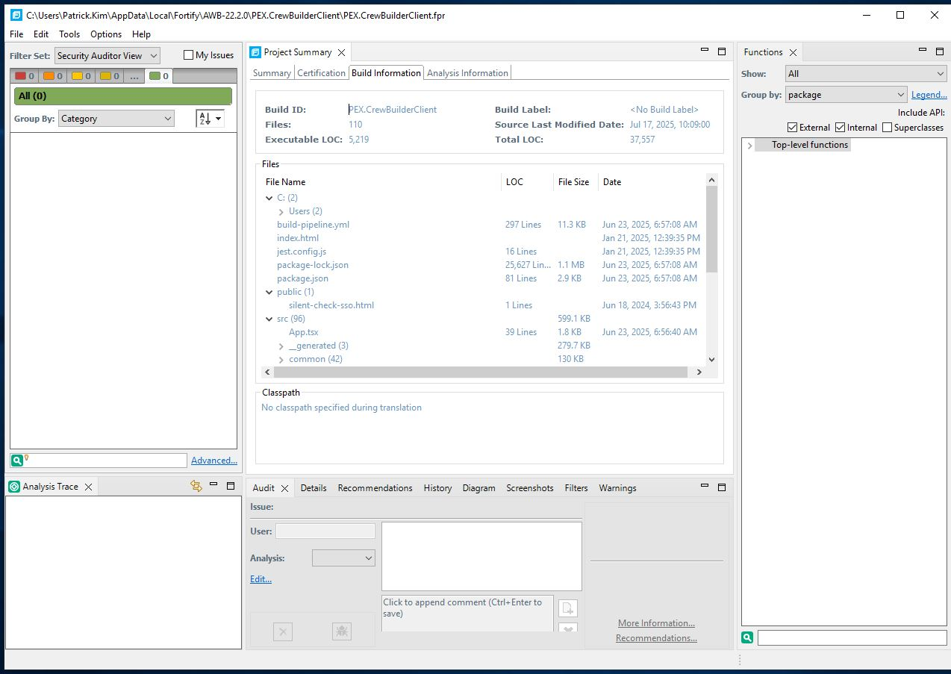

4.2 Describe all testing:
Test Cases: Justin Coop
- Test Case: 11905

- Navigate to Flying Schedule
- Create a Mission with multiple sorties
- Click on the Crew Builder Client icon on one of the sorties
- Choose a sortie and click + Add Crew
- Delete one or more of the crew members.
- Verify that the progress bar appears while loading instead of the circular spinner

4.3 Is there a Help File? No.

- Code/Change Review
  - Reviewer Names:
    - Code Reviewed By: JJ Escandor, Rahsaan Pringle
    - EDD Reviewed By: Phillip Hassoun
  - Review code for
Readability: There are no redundant comments.
Security: There are no security risks.
Test coverage: No more test cases required.
Architecture: This code makes use of a design pattern for encapsulation, modularization, and containerization.
Reusability: The code makes use of proper reusable data grid component.

- Data Flow Diagram
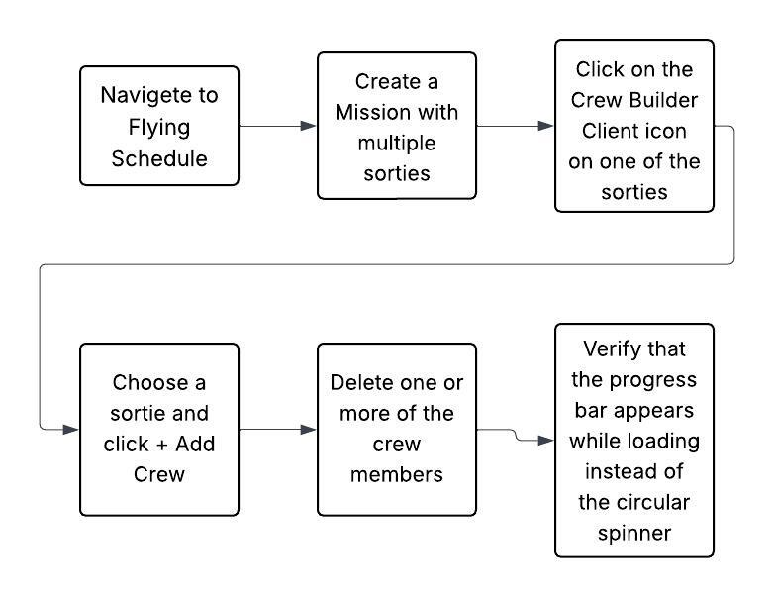
- Logical Connection Diagram