Synthesis Schematics

# Introduction

This document presents the schematics from synthesizing the Liasion System in the Term Assignment[1] from the course TFE4140 Modelling and Analysis of Digital Systems. As part of the project, the system that is implemented using VHDL is synthesized in  
 Synplicity Synplify Pro C-2009.06.

The schematics from the RTL view are presented first, then the schematics from the Technology view. The modules are both presented in the following order: Liasion, Onebit-voter, controller, registers and ECC.

# RTL view Schematics

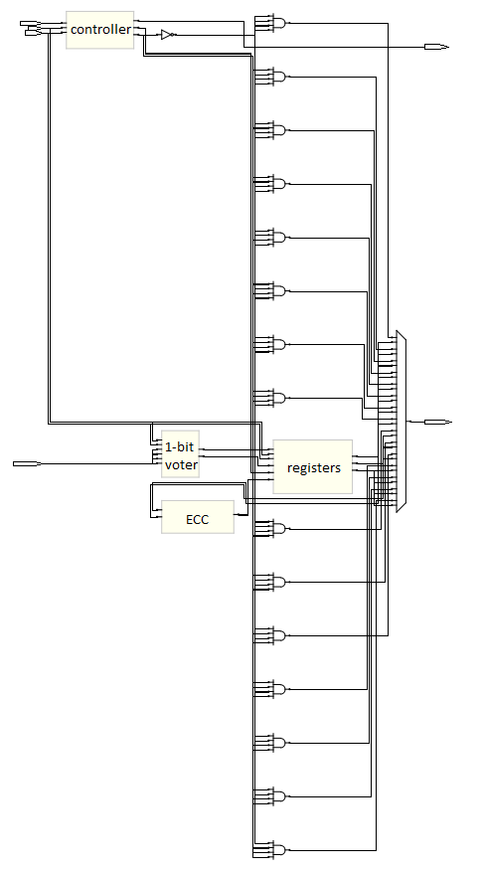

Figure 1 – Liaison (RTL)

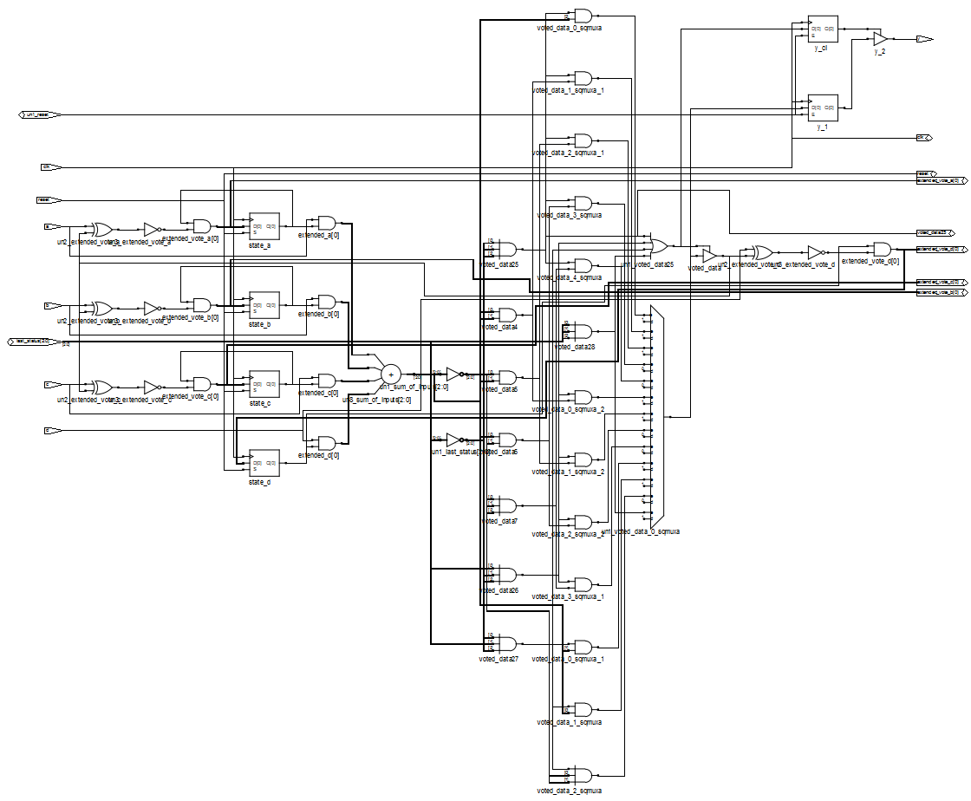

Figure 2 - 1-Bit Voter (RTL)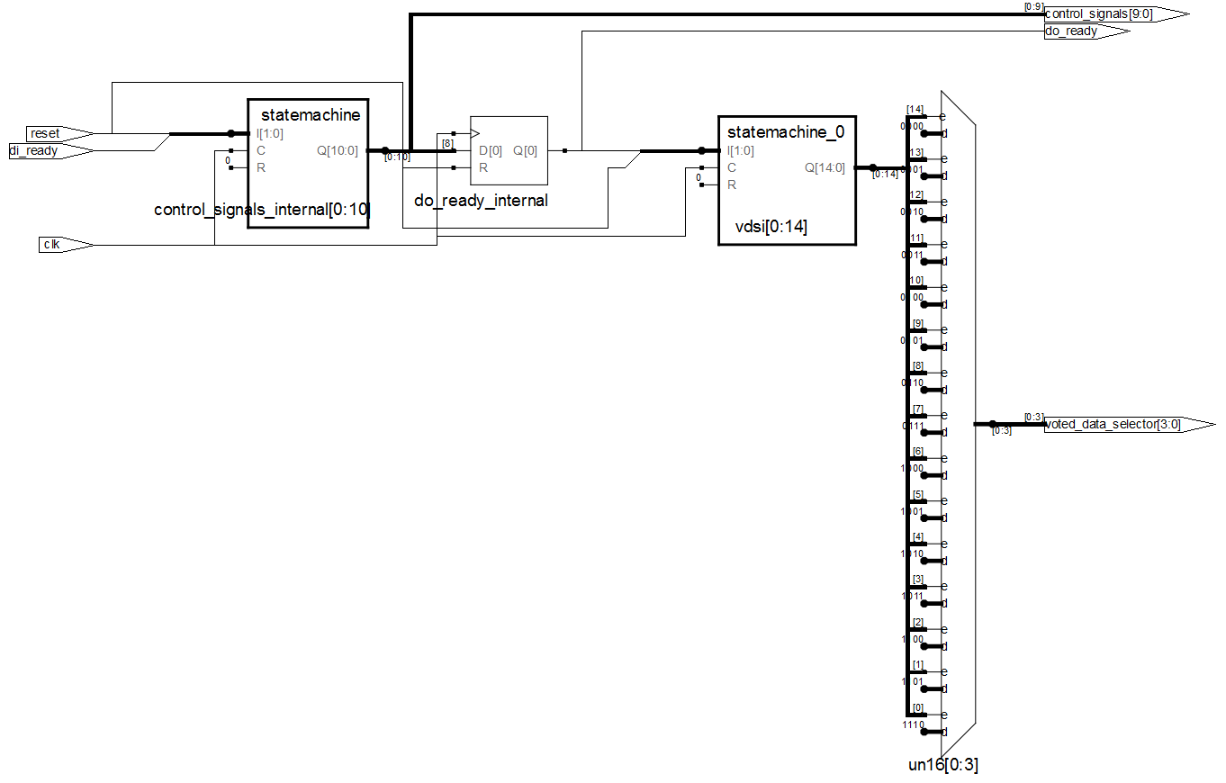

Figure 3 – Controller (RTL)

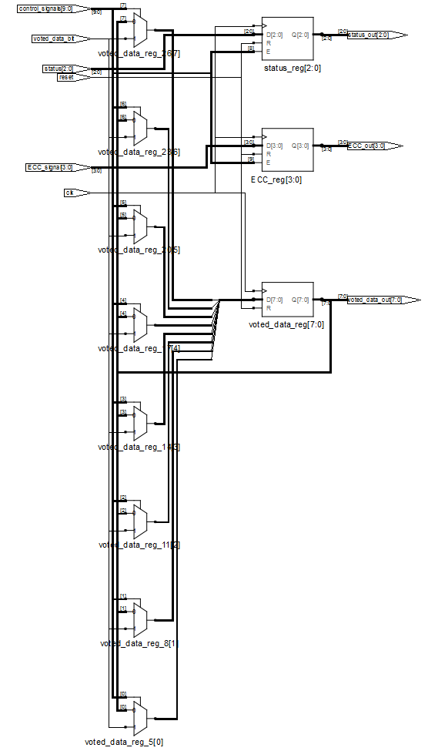

Figure 4 – Registers (RTL)

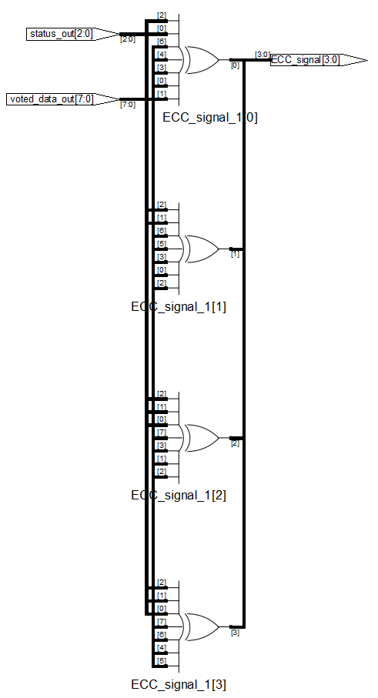

Figure 5 – ECC (RTL)

# Technology-view Schematics

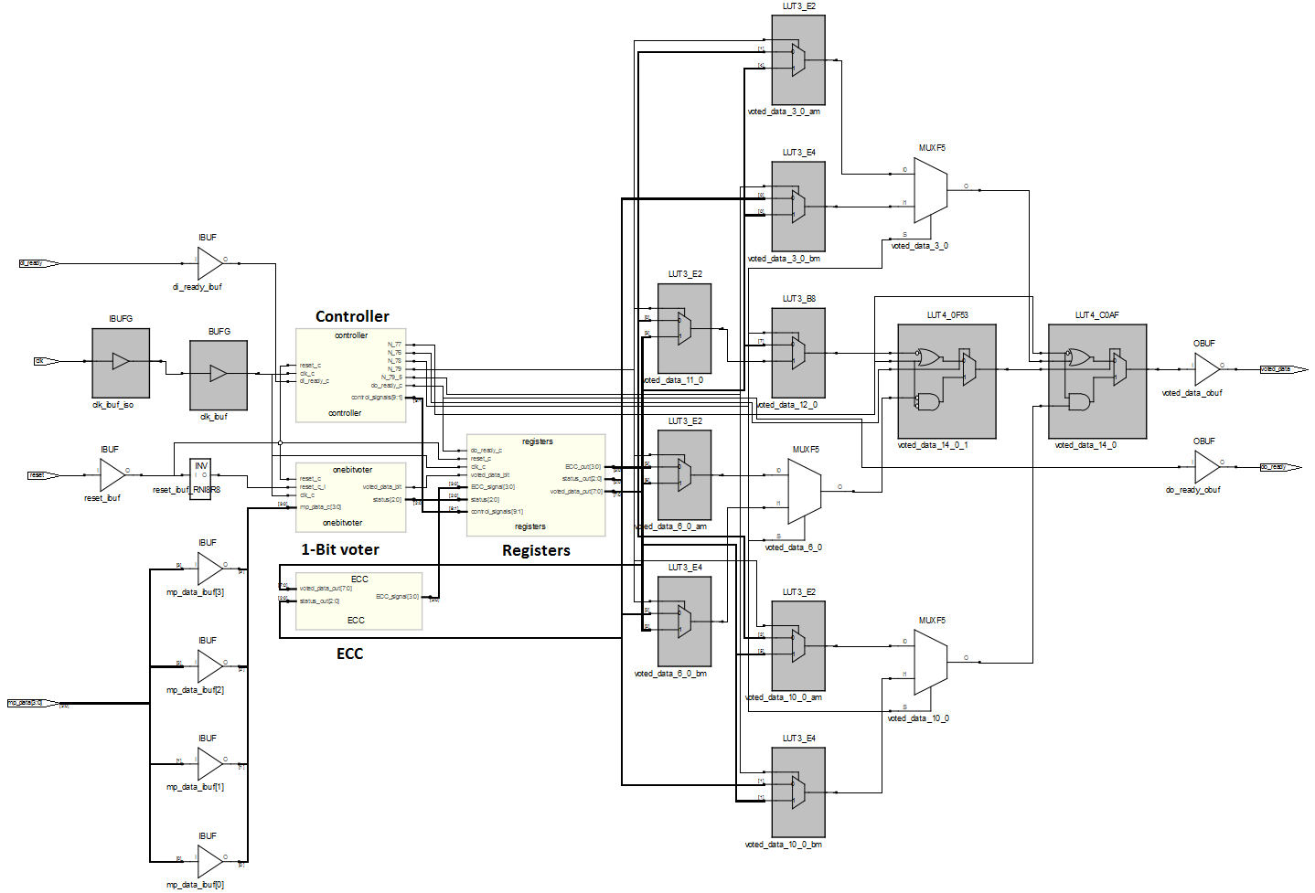Figure 6 – Liaison (Technology)

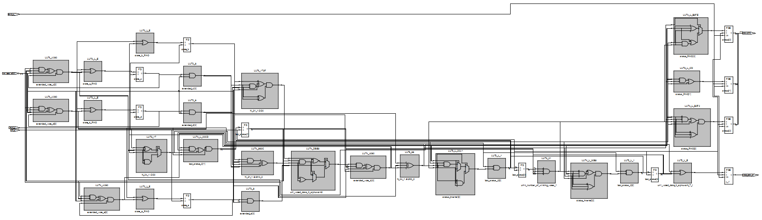

Figure 7 – 1-Bit Voter (Technology)

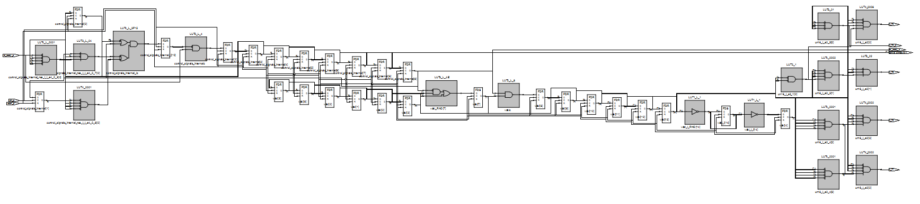

Figure 8 – Controller (Technology)

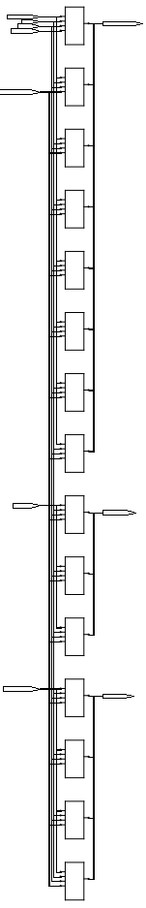

Figure 9 - Registers (Technology)

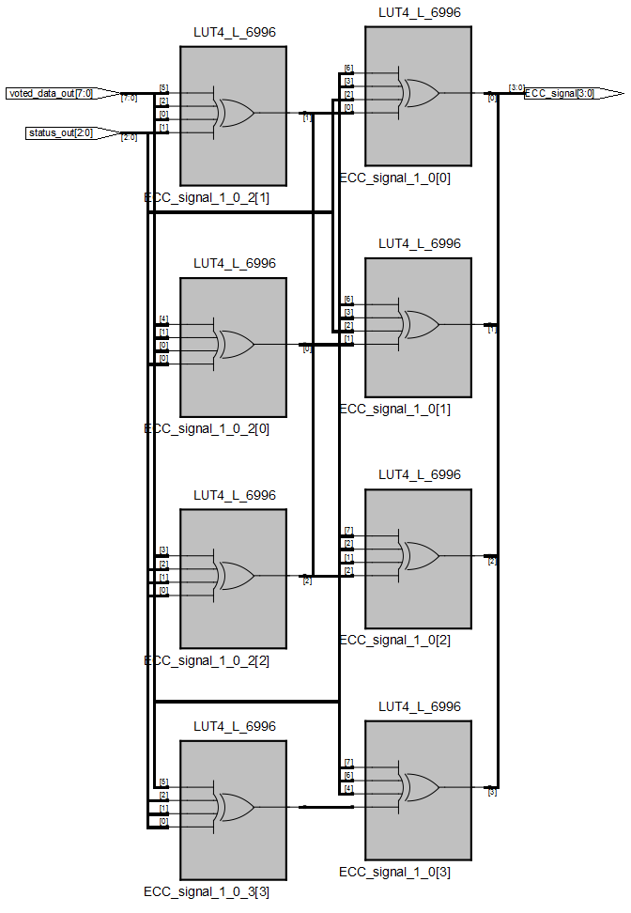

Figure 10 - ECC (Technology)

# Figure list

Figure 1 – Liaison (RTL) 1

Figure 2 - 1-Bit Voter (RTL) 2

Figure 3 – Controller (RTL) 2

Figure 4 – Registers (RTL) 3

Figure 5 – ECC (RTL) 4

Figure 6 – Liaison (Technology) 5

Figure 7 – 1-Bit Voter (Technology) 5

Figure 8 – Controller (Technology) 5

Figure 9 - Registers (Technology) 6

Figure 10 - ECC (Technology) 7

# Sources:

[1] TFE4140 Modelling and Analysis of Digital Systems Term Assignment 2014