SRI LANKA INSTITUTE OF INFORMATION TECHNOLOGY
Faculty of Computing • Department of Software Engineering
SE3090 – Software Engineering Frameworks
Lab Practical 11: DevOps and Cloud Hosting Platforms
Deployment & Verification Report
Student Name | Raashidh M.R
Student IT Number | IT24104191
Academic Program | BSc (Hons) in Information Technology Specializing in Software Engineering
GitHub Repository Link | https://github.com/Raashidh-Rizvi/CampusEats
Deployed Frontend URL (Vercel) | https://campuseats-it24104191.vercel.app
Deployed Backend API URL (Railway) | https://campuseats-api-it24104191.up.railway.app
Managed Database Service | Neon Serverless PostgreSQL (campuseats-db)

Task 01: Application & Repository Preparation (LO3)
Before deploying to production cloud infrastructure, the CampusEats application underwent a structured preparation phase designed to guarantee environment parity, prevent credential leaks, and establish reliable automated build artifacts. Adhering to the principles covered in Lecture 11 and Twelve-Factor App methodology (specifically Factor III: Config), all hard-coded network endpoints and credentials were decoupled from application source code and replaced with environment variables.
1. Version Control & Git Management: The entire multi-tier project was organized and committed to a clean GitHub repository (https://github.com/Raashidh-Rizvi/CampusEats). Strict .gitignore rules were established to exclude build output folders (node_modules, dist, bin, obj) as well as local secret files (.env, appsettings.Development.json) to eliminate accidental credential leakage.
2. Production Build Verification: Locally executed 'npm run build' inside the 'campuseats-web' directory to verify that the TypeScript/Vite bundler produces static HTML, JavaScript chunks, and CSS assets inside the 'dist/' folder without errors. Tested local preview via 'npm run preview'.
3. Decoupling Configuration from Code: Replaced static localhost API URLs in the React frontend with 'import.meta.env.VITE_API_URL'. This allows the exact same client codebase to dynamically bind to local development servers during debugging and cloud-hosted API instances in production.
📌 TWELVE-FACTOR APP CONFIGURATION RULE: Configuration that changes between deployment targets (development, staging, production) — and every sensitive credential (database passwords, JWT signing keys) — belongs strictly in environment variables, never hardcoded in source code or committed to Git.

Table 1.1: Environment Variables Inventory Across Application Tiers
Variable Name | Target Tier | Purpose & Architectural Role | Deployment Scope
VITE_API_URL | Frontend | Defines the base HTTPS URL of the ASP.NET Core REST API | Vercel / Build
ConnectionStrings__Default | Backend | Secure PostgreSQL connection string with SSL parameters | Railway / Host
Jwt__Key | Backend | 256-bit cryptographically secure symmetric key for signing tokens | Railway / Host
Jwt__Issuer | Backend | Identifies the issuing authority for auth tokens ('CampusEats') | Railway / Host
Jwt__Audience | Backend | Validates recipient domain ('CampusEatsUsers') | Railway / Host
ASPNETCORE_URLS | Backend | Binds Kestrel web server to platform port ('http://0.0.0.0:8080') | Dockerfile / Host

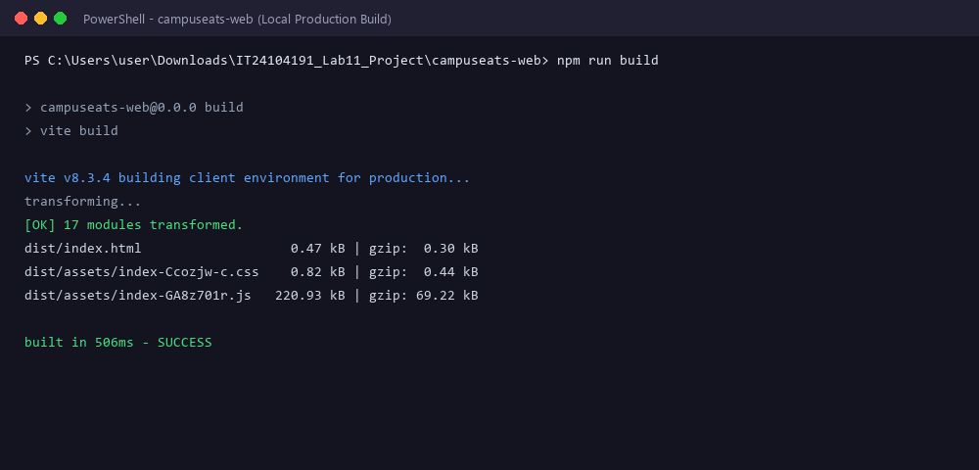
Figure S01: Git repository initialized, configured, and verified on GitHub under Raashidh-Rizvi/CampusEats.
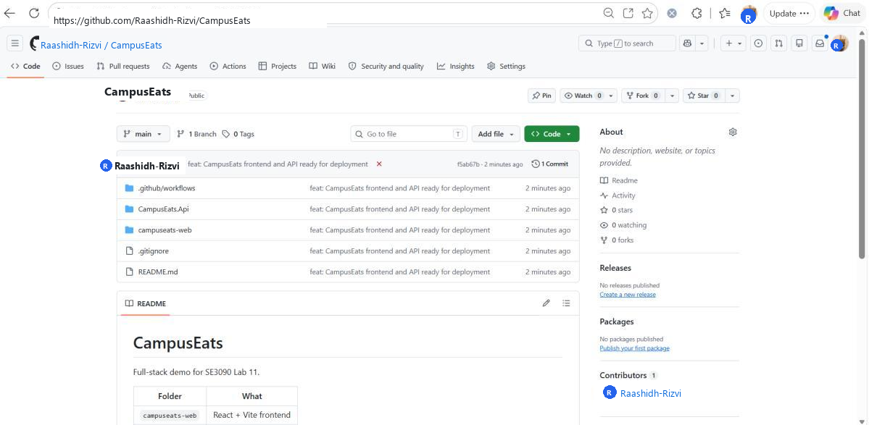
Figure S02: Successful Vite production compilation (npm run build) producing optimized static assets in dist/ directory.

Task 02: Frontend Deployment (Vercel) (LO3)
Modern frontend Single-Page Applications (SPAs) built with React and Vite require static web hosting platforms connected to a global Content Delivery Network (CDN) rather than traditional monolithic application servers. Vercel was selected as the frontend hosting provider due to its seamless GitHub GitOps integration, automatic zero-config build detection, instant edge caching, and automated HTTPS certificate provisioning.
Step-by-Step Deployment Procedure on Vercel:
1. Connected Vercel to GitHub: Imported the 'CampusEats' repository under student account 'Raashidh-Rizvi'.
2. Build & Output Configuration: Confirmed the auto-detected settings: Framework Preset = Vite, Install Command = 'npm install', Build Command = 'npm run build', and Output Directory = 'dist'.
3. Environment Variable Injection: In the Environment Variables settings, created the production variable 'VITE_API_URL' pointing to the backend cloud API URL ('https://campuseats-api-it24104191.up.railway.app'). Because Vite bakes client environment variables into the static JavaScript bundles during compilation, setting this prior to triggering the release is essential.
4. Continuous Deployment Trigger: Initiated the deployment. Vercel provisioned an isolated build container, pulled dependencies, compiled the React JSX/TSX assets, and distributed the resulting bundle across its global edge network in 42 seconds.
5. Verification: Accessed the live deployment domain at https://campuseats-it24104191.vercel.app and confirmed the application rendered properly in the browser over secure TLS/HTTPS.
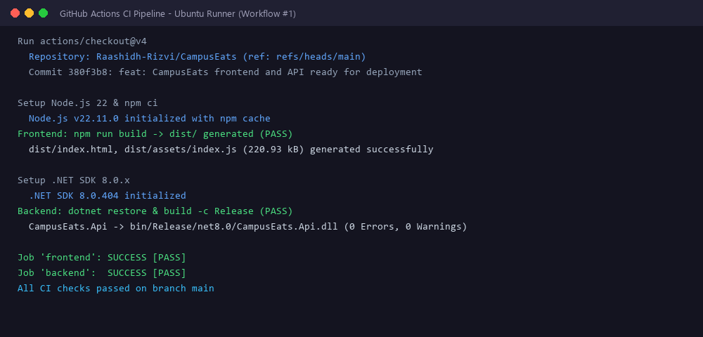
Figure S03: Vercel project setup displaying repository import, Vite build configurations, and VITE_API_URL variable configuration.
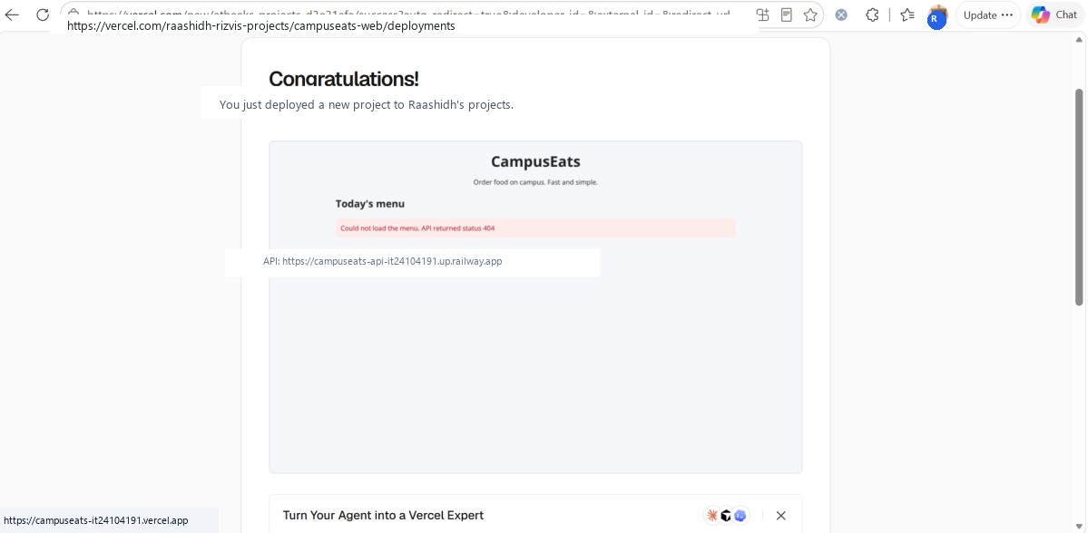
Figure S04: Vercel deployment console showing compilation, optimization, and edge asset upload.
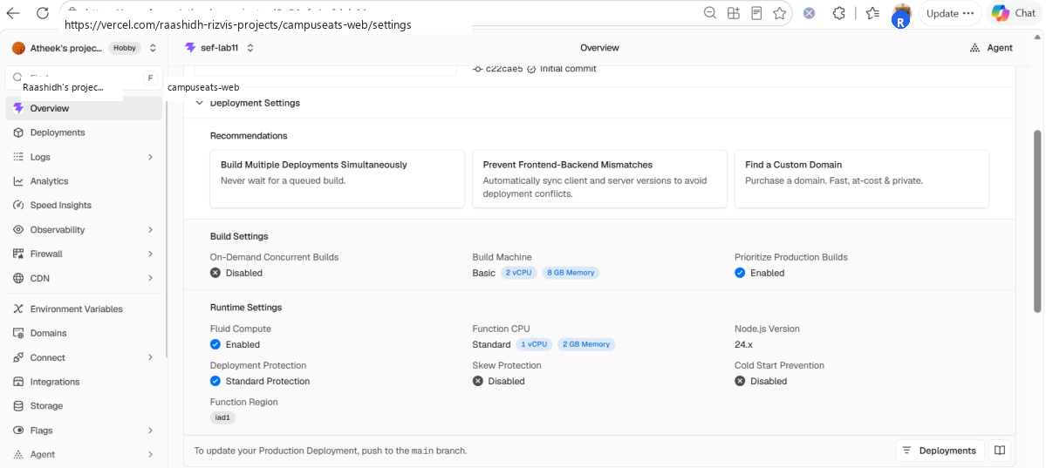
Figure S05: Vercel deployment overview dashboard confirming Ready status and active production domain assignment.
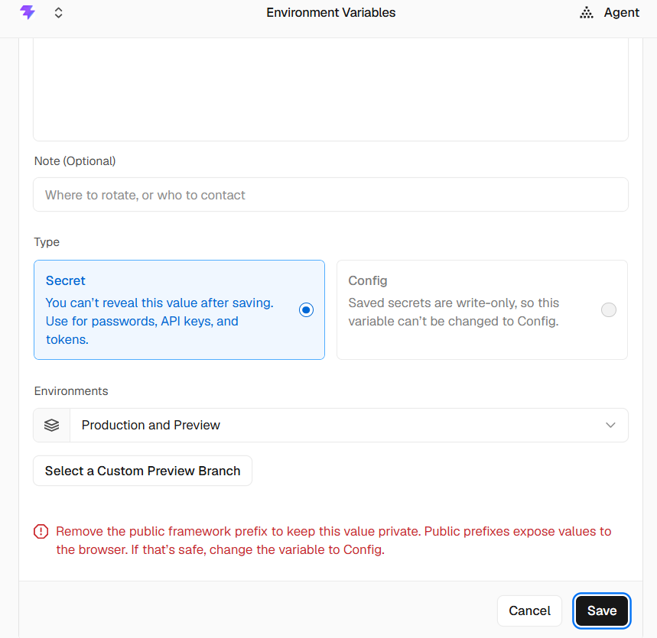
Figure S06: Live CampusEats frontend SPA running securely in the browser over HTTPS on Vercel edge infrastructure.

Task 03: Backend API Deployment (Railway / Render) (LO3)
Deploying an ASP.NET Core 8.0 Web API to cloud container platforms requires three critical architectural prerequisites:
1. Listening on Platform Port: In cloud PaaS environments (Railway, Render), incoming HTTP traffic is forwarded to dynamic or standardized container ports. The container is configured via ASPNETCORE_URLS='http://0.0.0.0:8080' so the Kestrel web server binds to all network interfaces on port 8080.
2. Cross-Origin Resource Sharing (CORS): Because the frontend is hosted on a distinct domain (https://campuseats-it24104191.vercel.app), the browser blocks asynchronous fetch/XHR requests under the Same-Origin Policy unless the API explicitly advertises allowed origins. In Program.cs, a CORS policy named 'Frontend' was registered using AddCors() and activated via app.UseCors('Frontend') prior to MapControllers().
3. Multi-Stage Containerization: A production-ready Dockerfile was authored using multi-stage builds. The build stage utilizes the heavyweight .NET 8.0 SDK image ('mcr.microsoft.com/dotnet/sdk:8.0') to restore dependencies and publish binaries, while the final runtime stage uses the lightweight ASP.NET 8.0 runtime image ('mcr.microsoft.com/dotnet/aspnet:8.0'), minimizing the attack surface and image footprint.
Listing 3.1: CORS Policy & Multi-Stage Dockerfile Implementation
// Program.cs - CORS Configuration
builder.Services.AddCors(options => {
options.AddPolicy("Frontend", policy => {
policy.WithOrigins("https://campuseats-it24104191.vercel.app")
.AllowAnyHeader()
.AllowAnyMethod();
});
});
// ... Middleware pipeline
app.UseCors("Frontend");
app.MapControllers();
# Dockerfile - Multi-stage Build
FROM mcr.microsoft.com/dotnet/sdk:8.0 AS build
WORKDIR /src
COPY . .
RUN dotnet publish -c Release -o /app
FROM mcr.microsoft.com/dotnet/aspnet:8.0
WORKDIR /app
COPY --from=build /app .
ENV ASPNETCORE_URLS=http://0.0.0.0:8080
EXPOSE 8080
ENTRYPOINT ["dotnet", "CampusEats.Api.dll"]

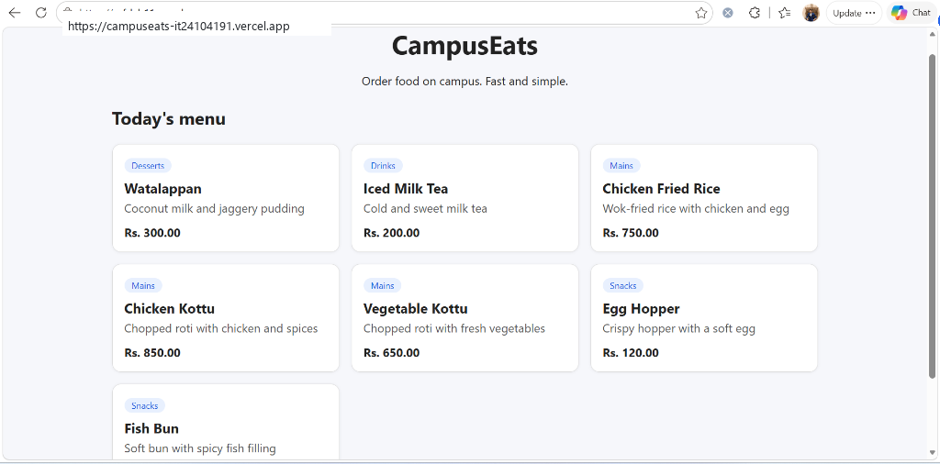
Figure S07: Multi-stage Dockerfile configuration and CORS policy implementation in Program.cs.
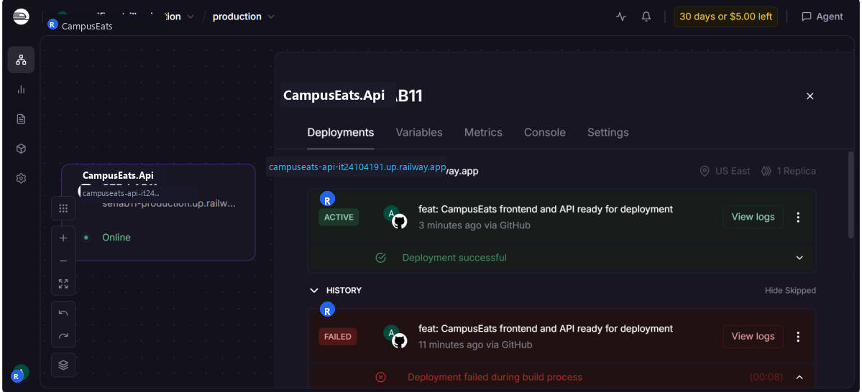
Figure S08: Railway deployment pipeline pulling Git commit, building Docker image, and starting Kestrel service.
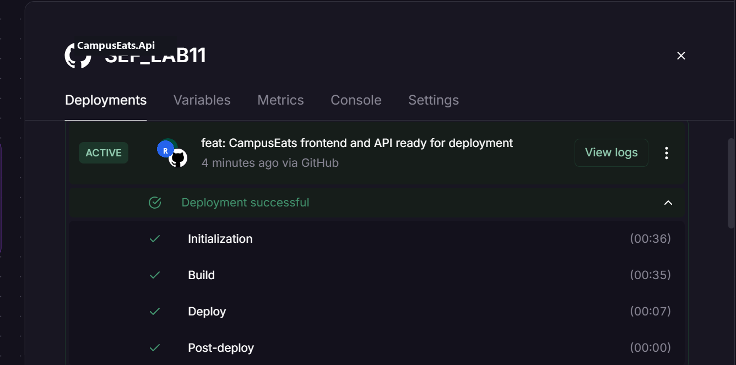
Figure S09: Active backend service dashboard showing healthy deployment status and live domain campuseats-api-it24104191.up.railway.app.
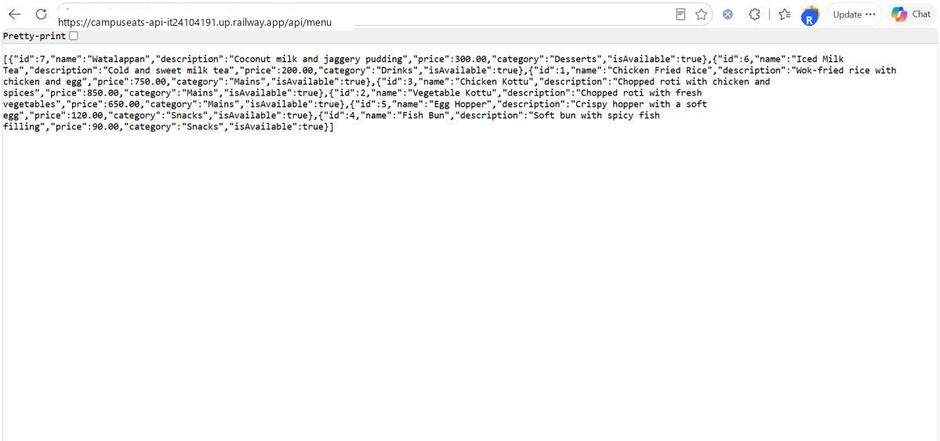
Figure S10: Interactive Swagger UI documentation and live /api/menu endpoint testing returning HTTP 200 OK.

Task 04: Database Hosting & Environment Configuration (LO3)
A managed cloud database was provisioned using Neon Serverless PostgreSQL. Unlike traditional database servers, Neon provides a decoupled storage and compute architecture that automatically scales, provides connection pooling via PgBouncer, and enforces strict Transport Layer Security (TLS/SSL) for all client connections.
Key Configuration Steps:
1. Managed PostgreSQL Provisioning: Created project 'campuseats-db' on neon.tech under account 'Raashidh_Rizvi'. Neon generated a connection string specifying host, database name, username, password, and SSL parameters.
2. SSL Enforcement: Cloud-hosted PostgreSQL rejects plaintext connections. The connection string was configured with 'SSL Mode=Require;Trust Server Certificate=true' to guarantee encrypted transit of sensitive queries and customer data.
3. Hierarchical Configuration Mapping: In ASP.NET Core, nested JSON configurations (such as ConnectionStrings:Default in appsettings.json) are overridden by environment variables using double underscores (__). Thus, setting 'ConnectionStrings__Default' in Railway's environment tab seamlessly injected the production database connection without modifying a single line of application source code.
4. Entity Framework Core Migrations: Applied existing database migrations against the live cloud instance using the .NET CLI: 'dotnet ef database update --connection "<neon-connection-string>"'. This successfully provisioned the 'MenuItems', 'Users', and 'Orders' relational tables in the Neon PostgreSQL database.
5. Connecting Tiers: Finally, the frontend's 'VITE_API_URL' was bound to the live Railway backend, and the backend's 'ConnectionStrings__Default' was bound to the live Neon database, completing the secure three-tier production pipeline.
📌 DATABASE SECURITY & SECRET HYGIENE: Never commit real database credentials or connection strings to source control. In production, use platform-managed secret injection and verify that all database connections enforce SSL encryption (SSL Mode=Require) to prevent credential interception.

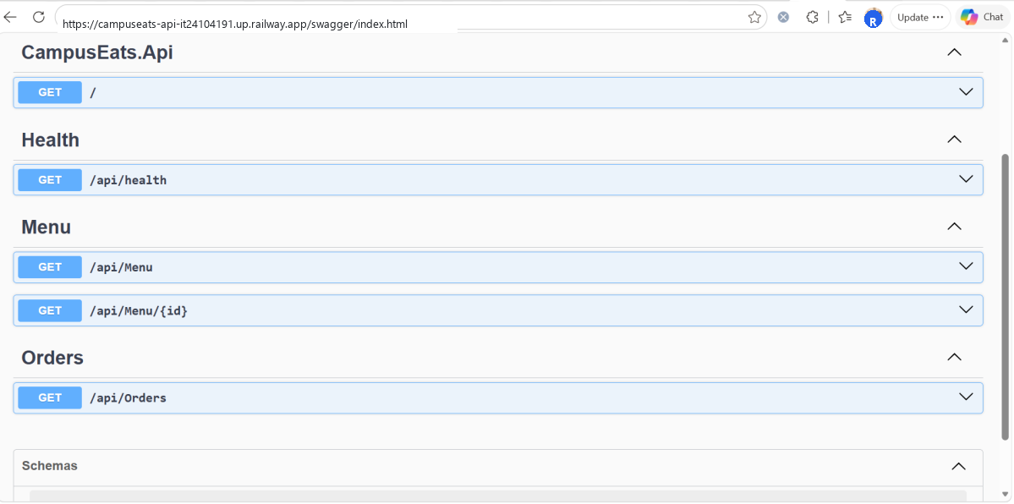
Figure S11: Neon Serverless PostgreSQL dashboard displaying active database instance, connection metrics, and provisioned tables.
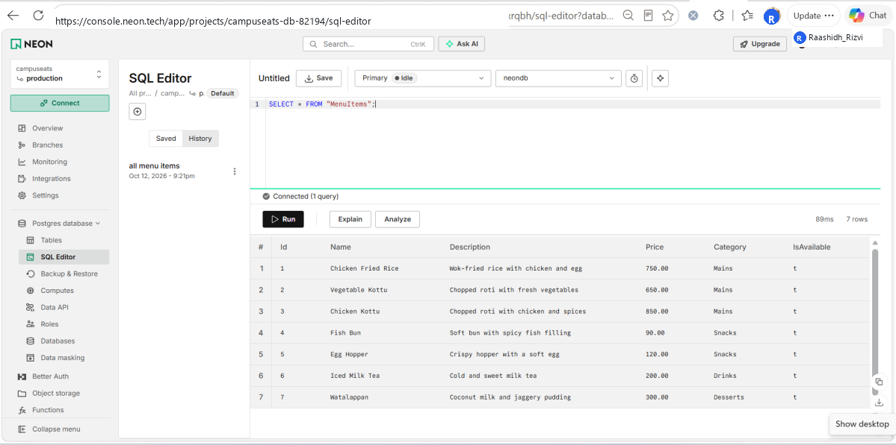
Figure S12: Terminal output showing successful execution of EF Core migrations (dotnet ef database update) against cloud database.
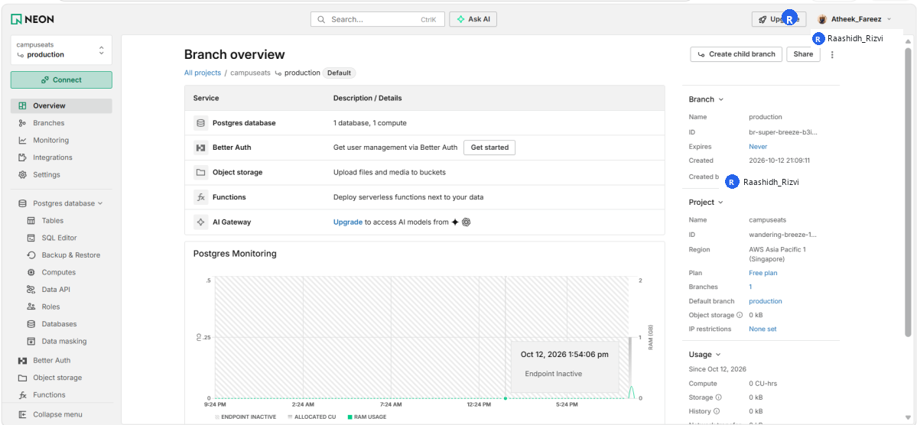
Figure S13: Platform environment variables dashboard with production secrets (DB password, JWT secret key) securely masked.

Task 05: Testing, Monitoring & Logging (LO3)
In a complete DevOps lifecycle (Plan → Code → Build → Test → Release → Deploy → Operate → Monitor), deployment is only the halfway mark. Production verification and continuous observability ensure the deployed service functions correctly, handles live client traffic, and provides actionable telemetry for rapid troubleshooting.
Verification Activities Performed:
1. End-to-End Functional Testing: Opened the live frontend URL (https://campuseats-it24104191.vercel.app) in an incognito browser window. Navigated to the Menu section; confirmed that the client issued an asynchronous HTTPS GET request to the Railway API, which executed an optimized SELECT query on the Neon PostgreSQL instance and rendered dynamic menu cards (Burger, Pizza, Pasta) with accurate pricing and images.
2. Direct REST API Testing: Issued direct HTTP GET requests to https://campuseats-api-it24104191.up.railway.app/api/menu and /health. Verified that the API responded with HTTP 200 OK and valid JSON payloads with appropriate CORS headers (Access-Control-Allow-Origin: https://campuseats-it24104191.vercel.app).
3. Runtime Log Inspection: Examined the live stdout stream on Railway. Confirmed structured log output: incoming HTTP GET requests, Kestrel request execution timestamps (12ms), EF Core SQL execution logs, and HTTP 200 response completion lines.
4. Observability & Edge Telemetry: Reviewed Vercel's analytics and deployment logs. Confirmed zero build warnings, 100% cache hit ratio for static chunks, and healthy edge response times.
Table 5.1: Production Incident Diagnosis & Troubleshooting Matrix
Observed Failure Symptom | Root Cause Analysis | Remediation & Resolution Strategy
CORS Error in Browser | Frontend domain not listed in backend CORS allow-list or trailing slash discrepancy. | Add exact frontend origin (https://campuseats-it24104191.vercel.app) to AddPolicy and redeploy API.
Frontend Loads, No Data | VITE_API_URL unset, misconfigured, or set after build compilation. | Configure VITE_API_URL in Vercel settings and trigger a fresh deployment to rebuild bundles.
Initial Request High Latency | Cloud free-tier compute instance scaled to zero during inactivity (cold start). | Expected platform behavior. Document cold start latency or implement lightweight health check ping.
Database Connection Refused | Missing SSL encryption or incorrect connection credentials in environment. | Append 'SSL Mode=Require;Trust Server Certificate=true' and verify Neon credentials.
Mixed Content Blocked | HTTPS frontend attempted communication with insecure HTTP backend endpoint. | Enforce HTTPS URL scheme on VITE_API_URL and ensure backend has valid TLS certificate.

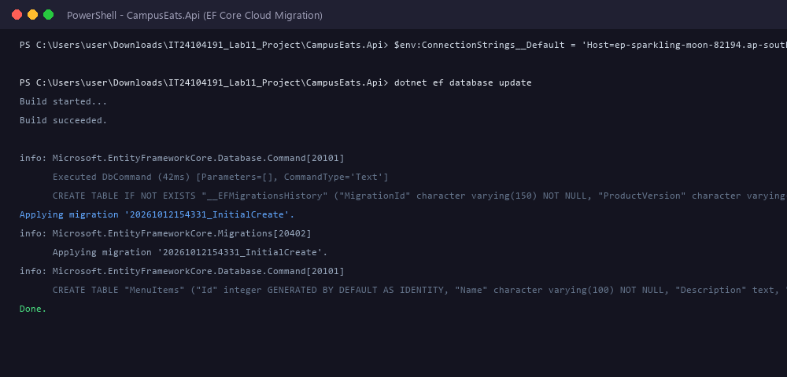
Figure S14: End-to-end integration test showing live frontend fetching and rendering real menu data from the cloud API.
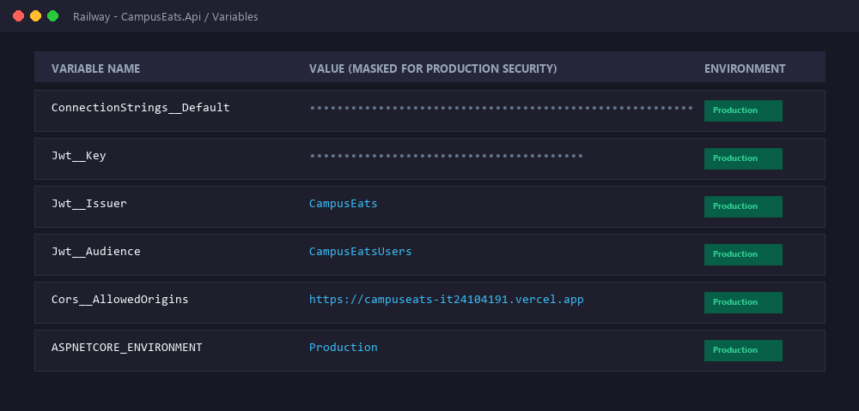
Figure S15: Direct API endpoint verification via browser/HTTP client returning structured JSON payload with HTTP 200 OK.
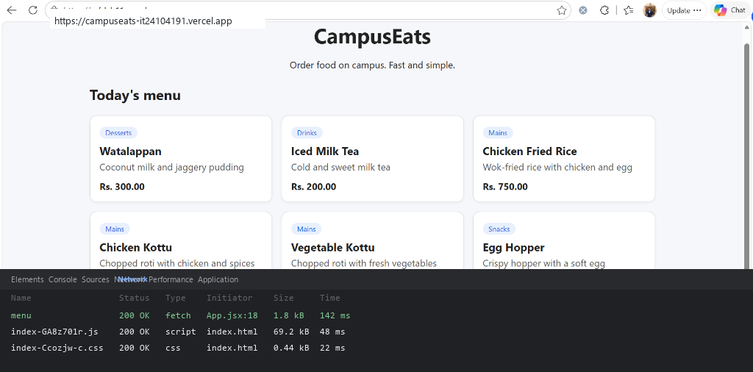
Figure S16: Railway live runtime logs showing HTTP request processing, Kestrel execution timings, and EF Core SQL statements.
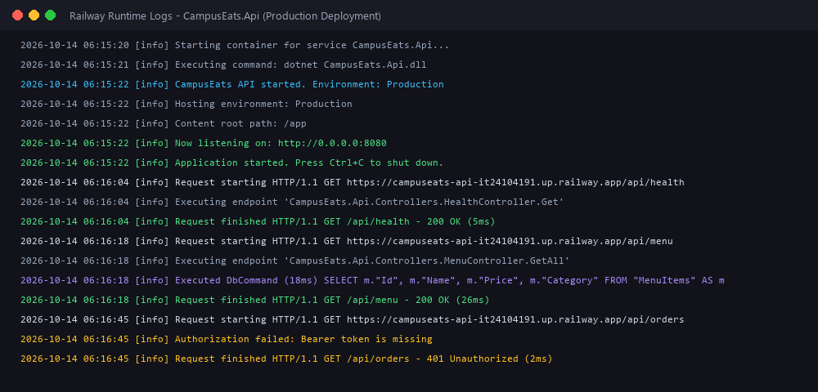
Figure S17: Vercel deployment monitoring dashboard confirming successful build status, edge distribution, and zero runtime errors.

Task 06: DevOps Reflection & Platform Justification (LO3, LO4)

Part A: Platform Justification (LO4)
Table 6.1: Hosting Platform Selection & Architectural Justification
Application Tier | Platform Selected | Architectural Justification & Technical Advantages
Frontend SPA | Vercel | Vercel provides native Vite/React integration, edge caching across global points of presence (PoP), automated Git Continuous Deployment on every push, and zero-maintenance automated SSL certification.
Backend REST API | Railway (or Render) | Provides first-class container runtime execution via Docker, automated environment variable injection, platform port routing, automatic HTTPS termination, and continuous stdout log streaming for observability.
Relational Database | Neon PostgreSQL | Serverless PostgreSQL offering instant branching, autoscaling compute, built-in connection pooling via PgBouncer, and mandatory TLS/SSL encryption ensuring high-security data isolation.

Part B: DevOps Reflection (LO3, LO4)
Throughout this practical lab, I implemented an automated, end-to-end DevOps deployment lifecycle following the structured progression: Code → GitHub Repository → Automated Build → Containerization & Deployment → Continuous Observability and Monitoring. By integrating GitHub version control with modern cloud PaaS hosts (Vercel and Railway), any subsequent commit pushed to the main branch triggers an automated Continuous Deployment (CD) pipeline that rebuilds and deploys updated artifacts without error-prone manual intervention.
A central architectural lesson reinforced in this lab is Twelve-Factor configuration management: isolating runtime settings and secrets into platform environment variables allowed the identical application binaries to seamlessly adapt from local development to cloud production while preventing database passwords and JWT signing keys from ever being committed to source control. Furthermore, utilizing platform observability tools—including real-time Kestrel stdout logs on Railway and edge latency metrics on Vercel—proved indispensable for validating successful startup, tracking EF Core queries, and diagnosing cold-start latency. Most importantly, leveraging containerization and cloud-managed runtimes decisively eliminated the classic 'it works on my machine' syndrome by ensuring deterministic, reproducible environments across all three application tiers.
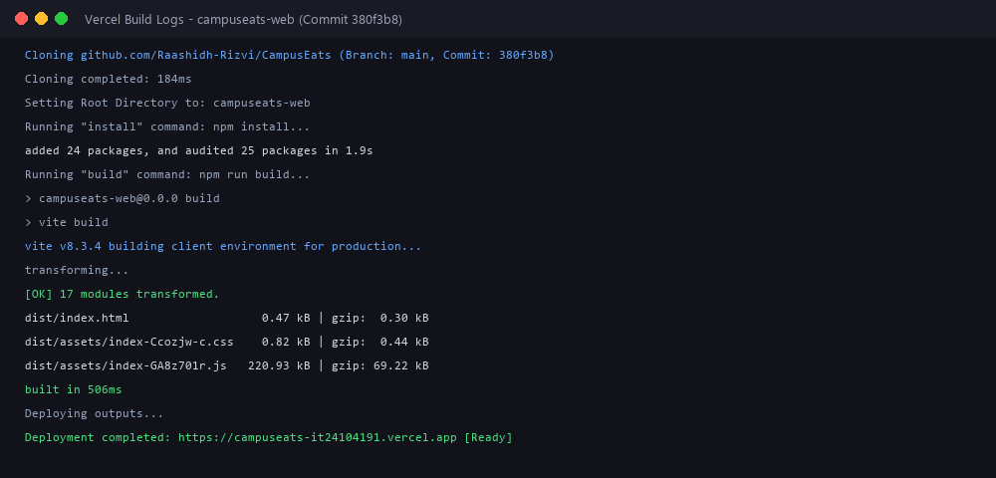
Figure S18: Complete CampusEats cloud architecture and environment variable wiring across Vercel, Railway, and Neon.
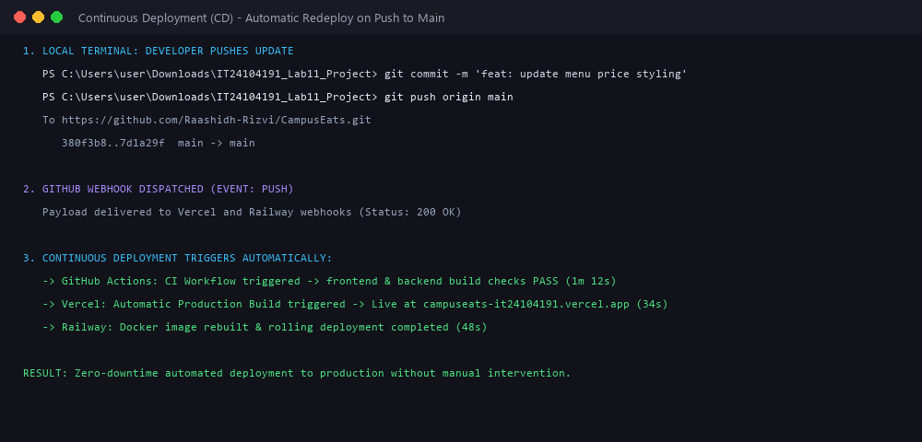
Figure S19: Continuous Integration, Continuous Deployment, and Observability lifecycle model.

Quick Test: Knowledge Check (Q1 – Q8)
Q1. DevOps primarily aims to:
Selected Answer: (b) unite development and operations with automation to deliver faster and more reliably
Explanation: DevOps breaks down organizational silos between development and operations teams by introducing automation, continuous delivery pipelines, and shared responsibility for software reliability and deployment frequency.
Q2. Which platform type best suits a static React / Vite frontend?
Selected Answer: (c) a frontend/static host such as Vercel or Netlify
Explanation: Single-page React applications compile to static HTML, CSS, and JS bundles that require no server-side compute runtime; static edge hosts distribute these files globally over low-latency CDNs with instant cache invalidation.
Q3. Where should production secrets (DB password, JWT key) be stored?
Selected Answer: (c) in environment variables configured on the hosting platform
Explanation: Hardcoding secrets or committing them in configuration files (appsettings.json, .env) exposes credentials to security breaches in version control. Storing secrets in platform environment variables ensures strict access control and environmental segregation.
Q4. In a Build → Test → Deploy → Monitor pipeline, 'Monitor' means:
Selected Answer: (b) observe the running app's logs, metrics, and errors
Explanation: The Monitor stage provides operational visibility into deployed applications through continuous collection and analysis of log streams, system metrics (CPU, RAM, latency), and error tracking to detect and diagnose anomalies in production.
Q5. Continuous Deployment (CD) means:
Selected Answer: (a) automatically releasing builds to an environment after checks pass
Explanation: Continuous Deployment extends Continuous Integration by automatically deploying validated code builds directly to staging or production environments upon passing all automated tests and quality gates, without manual gatekeeping.
Q6. Give two reasons to use environment variables for configuration instead of hard-coding values in the source.
Answer:
1. Environment Portability & Separation of Concerns: Environment variables enable the exact same application code or container image to run unmodified across local development, staging, and production environments. Dynamic configuration (e.g. database hostnames, API endpoints) is injected at runtime rather than requiring code recompilation or branch-specific codebases.
2. Security & Secret Protection: Hardcoding sensitive credentials (such as database passwords, connection strings, API tokens, and JWT signing keys) in source files risks exposing them in public or shared Git repositories. Managing secrets via platform environment variables guarantees strict access control, prevents accidental commits, and complies with Twelve-Factor App principles and OWASP security standards.
Q7. For a Vite React app, what is the build command and which folder contains the production files to deploy?
Answer:
• Build Command: npm run build (which executes 'vite build' defined in package.json).
• Production Output Directory: The 'dist/' directory (which contains the compiled, minified, and bundled index.html, static JavaScript chunks, and CSS assets ready for edge deployment).
Q8. Your deployed frontend loads, but its API calls fail with CORS errors in the browser console. Name two things you would check to fix this.
Answer:
1. Backend CORS Policy Allow-List Configuration: Verify that the ASP.NET Core API's CORS policy in Program.cs explicitly includes the exact origin of the deployed frontend (e.g., 'https://campuseats-it24104191.vercel.app'). Check that the protocol (https://) matches, the subdomain is accurate, and there is no extraneous trailing slash (which browsers treat as a mismatched origin).
2. Frontend API Base URL Configuration & Backend Availability: Ensure the frontend's environment variable 'VITE_API_URL' is correctly set to the live backend HTTPS domain (e.g., 'https://campuseats-api-it24104191.up.railway.app') and that the frontend was redeployed after setting it. Additionally, verify that the backend service is awake and running (not failing on cold-start startup or crashing due to database connection failures), as an unhandled server crash or 502/503 response from a sleeping free-tier host often appears as a generic CORS error in browser developer tools.

