The Chronicles of Higher Education
Community Data Lab Project Report:
Developed by:
Raasikh Naveed
Wichita State University

In association with:
Fujian Yan, Wichita State University
Jimmy Aschkar, Wichita State University

Dec 12, 2024
Contents
Summary 2
Introduction 2
Preparation 3
Analysis 5
Results 7
Recommendations 18
Conclusion 19
References 20
Appendices -

Summary
This report analyzes trends in university waitlist admissions over the past five years, with a particular focus on the impact of the COVID-19 pandemic. The study reveals a significant increase in waitlist activity during Fall 2020 compared to Fall 2019, as institutions adapted to enrollment uncertainties. Specifically, there was a 22.8% increase in students offered a place on the waitlist and a 55.1% increase in students admitted from the waitlist.
The analysis employed various modeling techniques, including LSTM, ARIMA, and SARIMA, to forecast trends and identify patterns. The results highlighted the limitations of linear models like ARIMA and SARIMA in capturing non-linear trends and high variability in the dataset. On the other hand, the LSTM model provided more accurate predictions by effectively capturing complex relationships in the data. These findings underscore the importance of selecting appropriate analytical tools for understanding dynamic and institution-specific factors in university admissions.
The insights generated in this report provide actionable recommendations for both universities and prospective students, aiming to enhance decision-making processes in higher education.
Introduction
Many students apply to numerous universities, hoping to increase their chances of getting into their dream school. Universities have specific enrolment criteria, admitting some students directly while placing others on a waiting list.
The waitlist benefits both students and universities. Instead of facing outright rejection, students are given a glimmer of hope with the possibility of being selected. It is then up to them to decide whether to enroll. The waitlist is an effective way for universities to meet their enrollment targets.

Preparation
I cleaned the dataset and performed a linear regression task. While the model had a fairly good R-squared value, the predictions were quite off from the actual values. I tried different techniques but couldn't achieve predictions significantly closer to the actual values. Then, Professor Fujian suggested a new approach: dividing the dataset into five separate subsets, each corresponding to one of the five years I am focusing on.
One of the classification tasks my professor suggested was using an LSTM model, as it was well-suited for this dataset, which exhibited a non-linear relationship and a varied distribution of time across different ranges. Initially, when I used the model for predictions, I lacked a proper understanding of the dataset’s nature, leading to unsatisfactory results with significant differences between predicted and actual values.
Upon analyzing the dataset more closely, I realized discrepancies arose, especially in the year 2022, where some skewed values distort the data, thus affecting the predictions. To address this, I applied a capping method that reduced the impact of the outliers without eliminating the data. After implementing this method, the error dropped significantly. Moreover, by adjusting the epoch count and batch size, I was able to further reduce the error, allowing for more accurate predictions for the next four years. With these improvements, the gap between actual and predicted values decreased substantially.

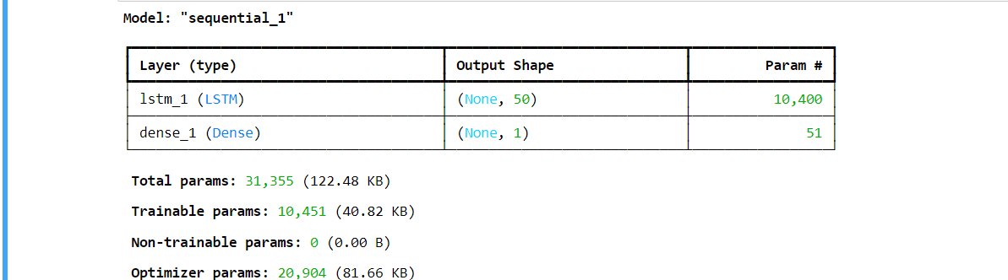
Fig-1
The model is structured as a sequential architecture, identified as "sequential_1," which indicates it is composed of a linear stack of layers. In the summary, each layer of the model is listed alongside its type, output shape, and the number of parameters.
The first layer is an LSTM layer with an output shape of (batch_size, 50), where the 'None' signifies that the batch size can vary. This LSTM layer contains 10,400 parameters, which include weights and biases. LSTM layers traditionally have a higher number of parameters due to their inherent complexity; they consist of weights for input connections, recurrent connections, and respective biases. Following the LSTM layer is a Dense layer that produces a single output value for each input sequence, which is typical in regression tasks. The Dense layer has 51 parameters, comprising the weights connecting the LSTM output to the Dense output, along with a bias term. Overall, the model includes a total of 31,355 trainable parameters. This total accounts for the parameters from both the LSTM and Dense layers. Notably, all 10,451 parameters in the model are trainable, meaning they can be updated during training; there are no parameters within the model that are non-trainable.
Additionally, there are 20,904 parameters associated with the optimizer itself. While these parameters do not directly contribute to the model's predictions, they play a critical role in updating the model's weights throughout the training process.

When exploring the dataset for modeling with ARIMA, we started by addressing the critical requirement of stationarity, as ARIMA assumes that the input time series is stationary (i.e., its statistical properties such as mean, variance, and autocorrelation remain constant over time). This is a crucial step because a non-stationary dataset would lead to biased or inaccurate results in ARIMA modeling.
To determine stationarity, we implemented the Augmented Dickey-Fuller (ADF) Test. The ADF test evaluates whether a time series is stationary by statistically testing the null hypothesis that the series is non-stationary. Upon applying the ADF test to our dataset, the test statistics yielded an ADF Statistic of -7.45 and a p-value of 5.63×10−11. As the p-value was significantly lower than the threshold of 0.05, we rejected the null hypothesis and concluded that the dataset was stationary. Consequently, we determined that no differencing operations were required, and we set the d parameter to 0.
With the data confirmed to be stationary, we moved forward to identify appropriate values for the p (autoregressive order) and q (moving average order) parameters. To determine these, we analyzed the Autocorrelation Function (ACF) and Partial Autocorrelation Function (PACF) plots:
The ACF plot showed significant spikes up to lag 5, suggesting that autocorrelation persists for about 5 lags. This observation led us to set q = 5.
The PACF plot exhibited a strong spike at lag 1 and smaller spikes up to lag 3. This indicated the presence of autoregressive relationships, leading us to test values of p between 1 and 3.

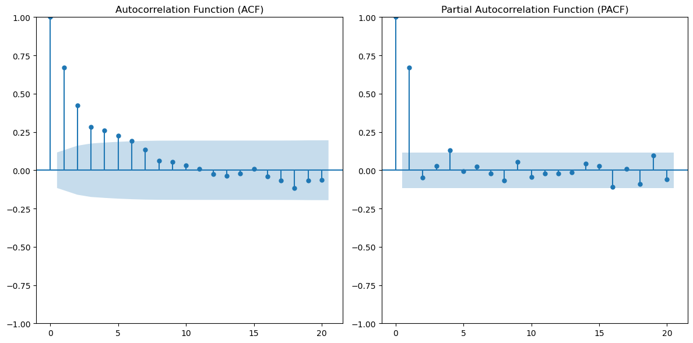
Fig- 2
After selecting the ARIMA parameters (p,d,q)(p, d, q)(p,d,q), we trained the model and evaluated its performance. The model produced predictions; however, the results revealed several concerns:
The Mean Squared Error (MSE) and Mean Absolute Error (MAE) were high, suggesting that the predictions were not highly accurate and required further refinement.
The ARIMA model's predictions failed to match the variability seen in the test data. This discrepancy highlighted the challenges of capturing the dynamics of the dataset using linear models. One of the main issues with ARIMA was its tendency to produce relatively constant predictions, resulting from the model's inherent over-smoothing. ARIMA forecasts future values using a linear combination of present and past values, making it less effective for datasets with high variability or complex patterns. The lack of strong autoregressive patterns in the data further limited ARIMA's effectiveness. We concluded that ARIMA struggled to handle the complexities and non-linear trends in the dataset, making it unsuitable for our data's behavior and patterns.
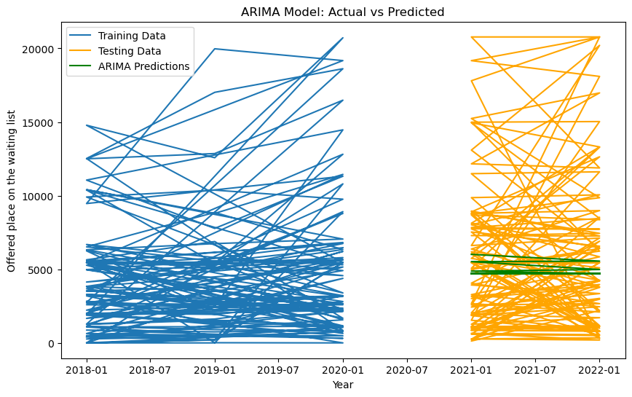
Fig-3
SARIMA Model and Its Performance
Following the challenges with ARIMA, we extended our analysis by using SARIMA (Seasonal ARIMA), which incorporates seasonal components into the ARIMA framework. SARIMA is particularly useful for datasets with periodic or repeating seasonal patterns, as it models both linear and non-linear trends.
We analyzed the data for consistent patterns over time to identify potential seasonality in the dataset. However, the dataset did not exhibit clear and consistent seasonality. Despite this, we proceeded with SARIMA by testing various combinations of seasonal parameters, including (p,d,q)(P, D, Q, s) where s represents the seasonal period (e.g., yearly or quarterly).
The SARIMA model produced results, but several limitations became evident:
Similar to ARIMA, SARIMA produced smoother predictions that failed to capture the high variability seen in the test data. The model could not adequately handle the significant differences in values between institutions or across years.
The absence of clear seasonality in the dataset weakened SARIMA's ability to accurately capture patterns, as the seasonal components could not significantly contribute to the model.
The confidence intervals for SARIMA predictions were wide, indicating a high degree of uncertainty in the forecasted values. As a result, the SARIMA model, like ARIMA, struggled to capture the non-linear trends and high variability in the dataset. While SARIMA is effective for datasets with strong seasonal patterns, its performance is limited when applied to datasets without periodic behaviors.
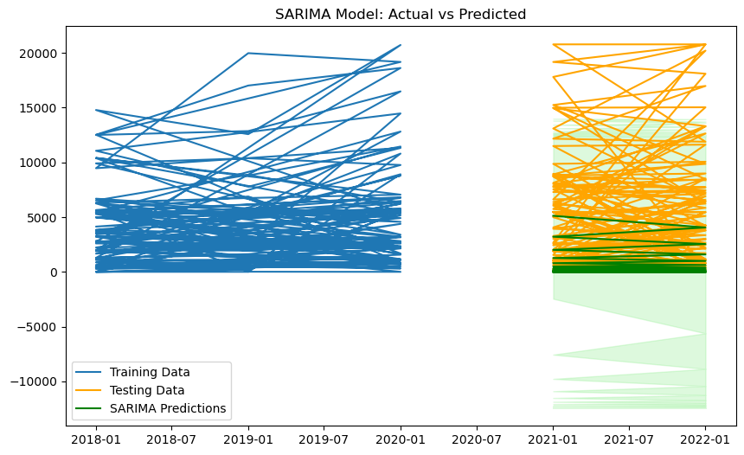
Fig- 4

Analysis
Some of the initial goals of this project were to find the following:

- The percentage of the total applicant pool offered a place on the waiting list.

- Percentage of applicants who accepted a place on the waiting list.

- Percentage of applicants admitted from the waiting list.

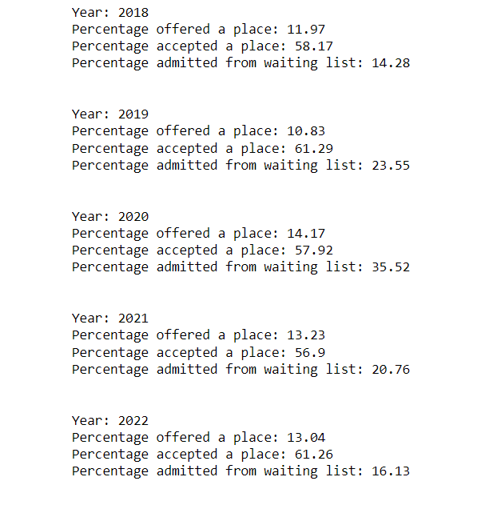
Fig-5

- Analyze the data to determine if there was an increase in the number of students offered a place on the waiting list, and those accepted from the waitlist, for 2020 compared to 2019

Total Students Offered a Place on the Waiting List:
Fall 2019: 243,036
Fall 2020: 314,788
Increase: 71,752
Percent Increase: 22.8%
Total Students Admitted from the Waiting List:
Fall 2019: 25374
Fall 2020: 56577
Increase: 31203
Percent Increase: 55.1%
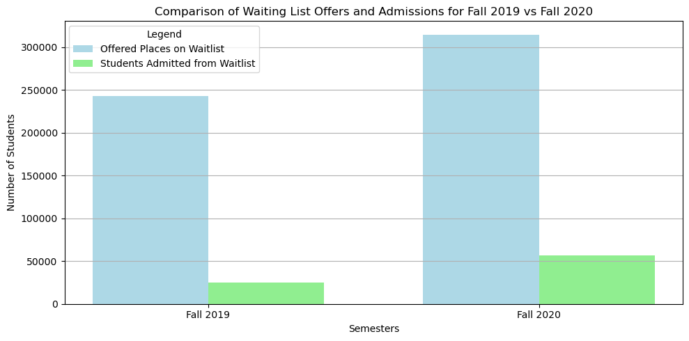
Fig-6
We then delved into classification tasks, aiming to forecast values for the next four years. However, before proceeding, we needed to establish the credibility of our predictions by evaluating our model. Initially, we attempted to train the model using data from the first four years and test it on the fifth year. Unfortunately, the results did not meet our expectations.
As a result, we decided to utilize an LSTM model, where we trained it on the first three years of data and used the subsequent two years for testing and prediction. Before this, we planned to visualize the data to gain a better understanding of our model and identify any uncertainties in the data that might require preprocessing techniques.
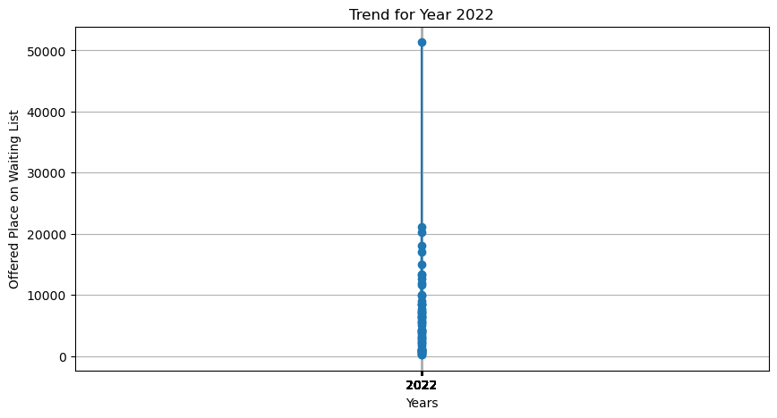
Fig-7
Upon visualizing the data, we identified an outlier that was skewing our results. To address this, we employed a capping method that handles the outlier without eliminating it. We applied the 99th percentile for our capping approach.

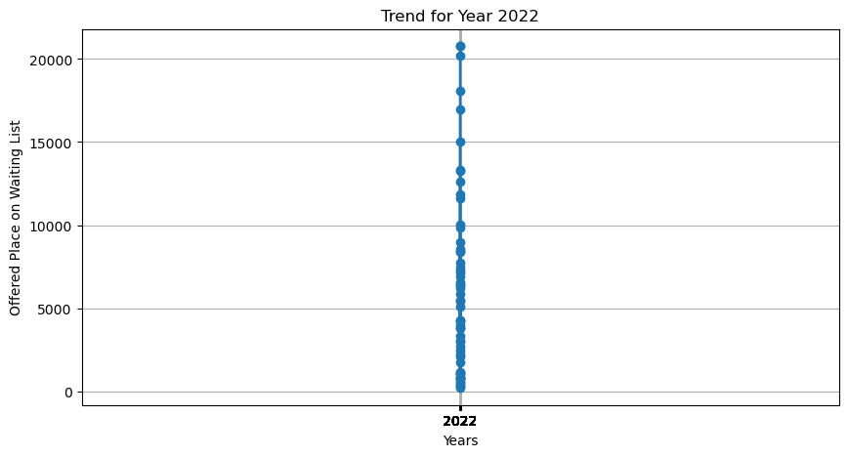
Fig-8
As observed in the results, there is a decline in the trend of waitlist activity. To help students choose the right university, the following steps can be taken
One of the key factors that can assist students in making informed decisions about universities is understanding the specific courses and programs offered. Having clarity on the courses provided by different universities allows students to better align their preferences and career goals with the institution's offerings. Universities often design their majors and programs with unique approaches tailored to specific domains.
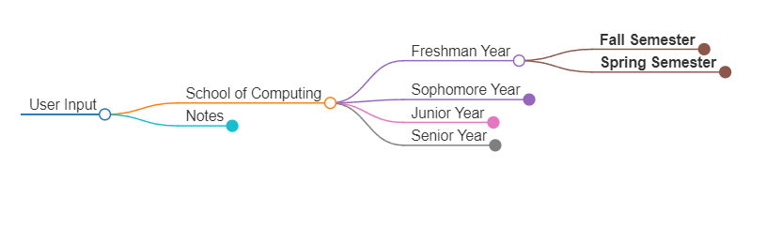
Fig- 9
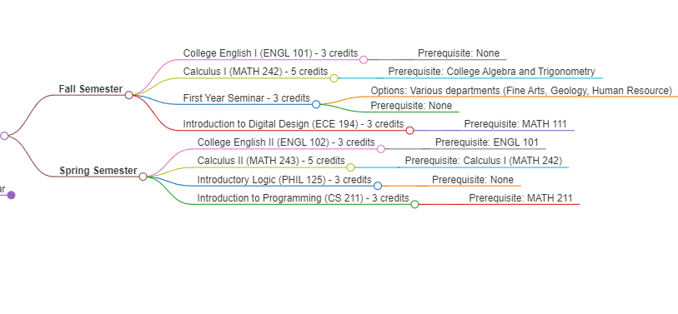
Fig-10
By exploring the structure, focus, and specializations within the programs, students can identify which universities offer the most suitable courses for their academic and professional aspirations.
This insight not only helps students choose universities that match their interests but also empowers them to make well-informed decisions about their future.
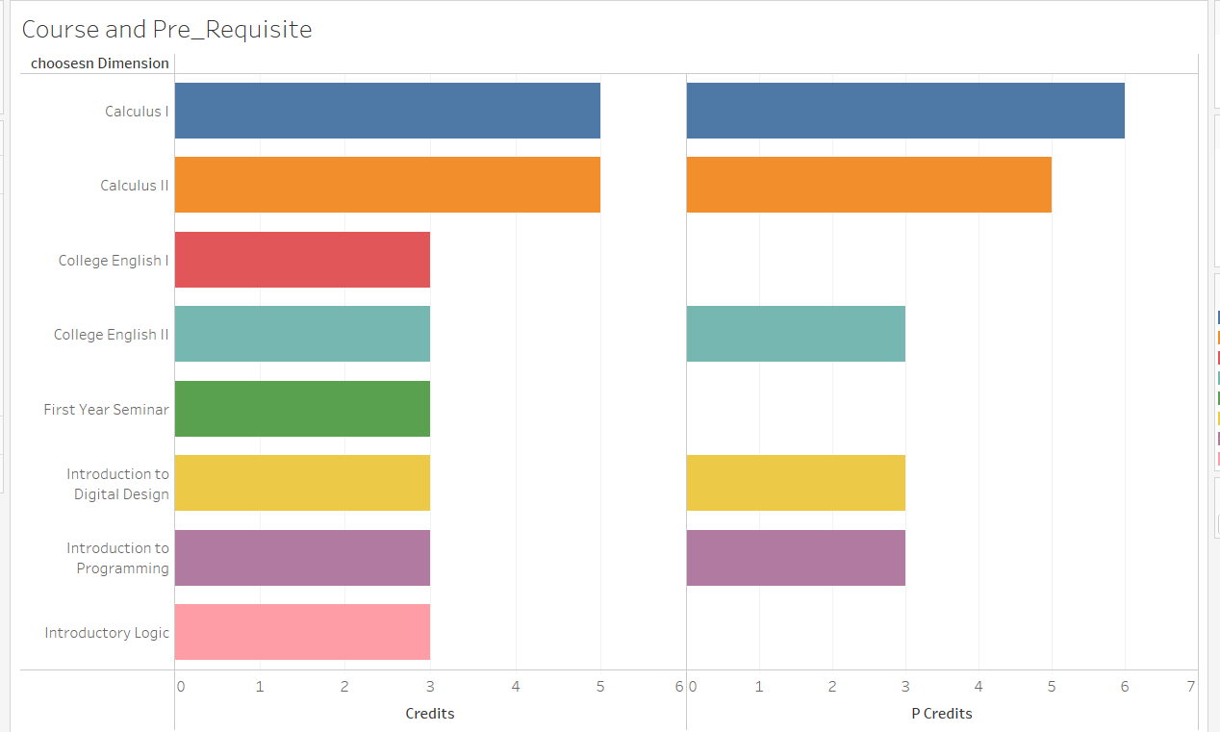
Fig- 11

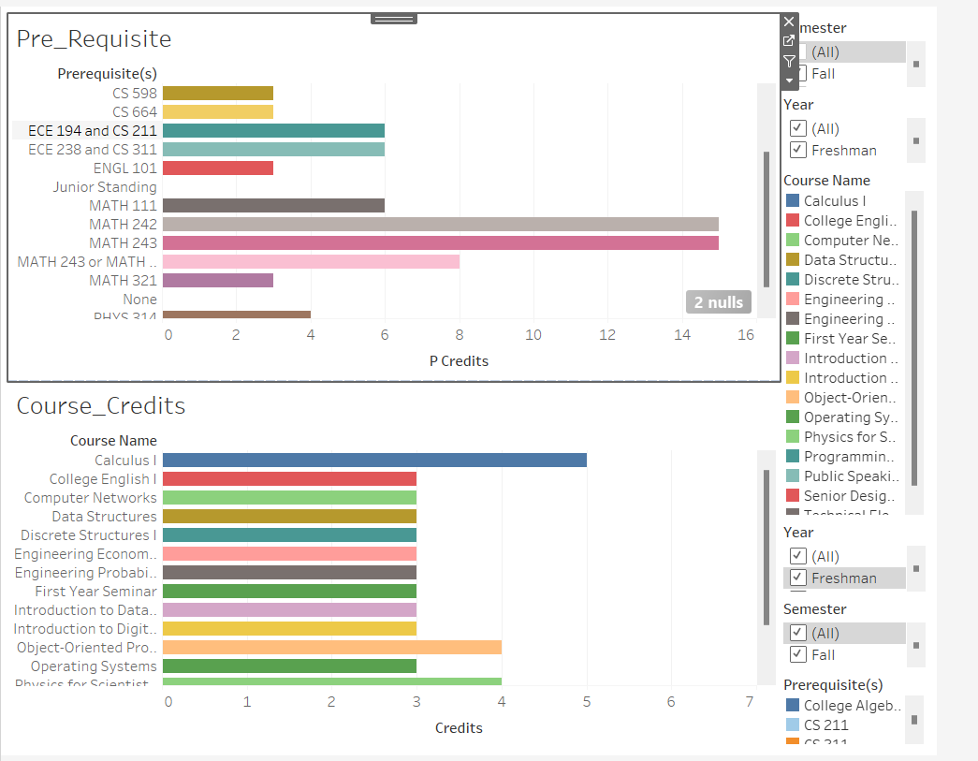
Fig -12

Now, after students take these important steps, universities must maintain transparency. The increase or decrease in waitlist admissions is a significant phenomenon influenced by various factors, including:
The selection of students from the waitlist often depends significantly on the specific university departments. Universities expanding certain departments may admit more students from their waitlists to accommodate increased capacity or to fill positions in newly funded programs. Budget cuts or reduced funding in specific departments can result in fewer admissions, decreasing waitlist offers for those programs.

Some examples of R1 universities are
- University of Michigan:
The expansion of engineering and computer science programs has led to the strategic use of waitlists to ensure diverse and qualified cohorts.
- University of California, Berkeley:
Budget cuts to humanities departments led to fewer spots and limited movement on those programs’ waitlists, while STEM programs saw increased offers.
- Carnegie Mellon University:
A strong focus on computer science and AI resulted in higher waitlist pull rates for those departments to keep pace with industry trends and demand.
Results
Training the first 3 years and then testing for 2 years we got significantly better results. Iterated with different epoch and batch size to get best results.
We ran our model for 100 epochs and a batch size of 64
Actual value for 2022: 5456
Predicted value for 2022: 5484.5
The loss decreases significantly, from 0.0927 in epoch 1 to around 0.029 by epoch 83.
This shows that the model is learning and adjusting weights well over time. It indicates that the LSTM can capture patterns in the data and gradually improve its predictions.
Predicted value for 2023: 5484.5234375
Predicted value for 2024: 5290.125
Predicted value for 2025: 5140.3701171875
Predicted value for 2026: 4992.00927734375

Challenges with ARIMA and SARIMA:
Both models are inherently linear and rely on stationarity assumptions. While this is suitable for datasets with smoother or linear trends, our dataset exhibited complex non-linear relationships and significant variability, which neither ARIMA nor SARIMA could fully address.
The predictions generated by both models were overly smooth, failing to account for the large fluctuations seen in the actual data. This was particularly evident in the test data, where institutional differences and year-to-year variations were prominent.
The absence of consistent seasonal patterns in the data hindered SARIMA's performance. Seasonal components did not significantly enhance the model's predictive accuracy, as the dataset did not exhibit periodic trends.
The dataset's behavior was influenced by non-linear factors, which ARIMA and SARIMA, being linear models, are ill-equipped to handle. This limitation resulted in predictions that could not match the dataset's real-world complexity.
Based on the analysis, neither ARIMA nor SARIMA is a suitable model for this dataset due to the following reasons:
- The high variability and non-linear trends in the data.
- The absence of strong autoregressive patterns or seasonality.
- The models' inability to account for institution-specific differences and dynamic behaviors.

Recommendations
For Universities:
Enhance Transparency: Universities should make detailed waitlist data publicly available, including program-specific trends and historical statistics. This transparency will enable prospective students to make more informed decisions and reduce anxiety about the admissions process.
Optimize Admissions Strategies: Universities should leverage advanced predictive models, such as LSTM, to forecast enrollment patterns and manage waitlists more effectively. These models can help identify trends, optimize resource allocation, and enhance decision-making processes.
Align Programs with Industry Trends: Institutions should monitor demand for specific programs, such as STEM fields, and adjust admissions strategies accordingly. For example, expanding departments like computer science and engineering may require higher waitlist admissions to meet industry demand.
Consideration of Equity: Implement policies to ensure equitable admissions practices, particularly for underrepresented groups, by analyzing and addressing disparities in waitlist offers and admissions.
For Prospective Students:
Research Program-Specific Trends: Students should investigate the waitlist trends for their desired programs and institutions. Understanding program capacities, admission probabilities, and historical data will help align expectations.
Engage with University Admissions Offices: Communicating with admissions offices can provide clarity on waitlist positions and timelines, enabling better planning for alternate options.
Plan for Multiple Scenarios: Students should develop contingency plans in case they are not admitted from the waitlist. This includes exploring alternative universities or deferring admission for a year if necessary.
By implementing these recommendations, universities can improve their admissions processes while students can make more informed decisions about their academic futures. This collaborative effort will contribute to a more transparent, efficient, and equitable higher education system.

Conclusion
This project provides a comprehensive analysis of trends in university waitlist admissions over the past five years, focusing on the impact of the COVID-19 pandemic. The data revealed a sharp increase in waitlist activity during 2020, driven by enrollment uncertainties and the pandemic's influence on student decisions. However, the subsequent years show a return to pre-pandemic patterns, indicating improved predictability in university admissions processes
It highlights the importance of transparent university data and offers actionable insights for universities and prospective students. Universities can optimize their admissions strategies, while students can make more informed choices based on program-specific trends. This analysis underscores the evolving dynamics of university admissions and sets the stage for more data-driven decision-making in higher education.
References

- Hao, C. (2022) Students frustrated with long waitlists for upper-level computer science classes, The Michigan Daily. Available at: https://www.michigandaily.com/news/academics/students-discuss-frustrations-long-waitlists-upper-level-computer-science-classes/ (Accessed: 12 December 2024).

- DiPierro, A. (2024) Budget cuts begin to surface at California State University, EdSource. Available at: https://edsource.org/2024/budget-cuts-begin-to-surface-at-california-state-university/718699 (Accessed: 12 December 2024).

- Carnegie Mellon University master of science in artificial intelligence and innovation (no date) Carnegie Mellon University - Master of Science in Artificial Intelligence and Innovation. Available at: https://msaii.cs.cmu.edu/ (Accessed: 12 December 2024).

