Email

|  |  |  |  |  |
| --- | --- | --- | --- | --- |
| Sl. No | Author | Date | Version | Action |
| 1 | Abhishek | 10/02/2021 | 1.0 | Draft |
| 2 | Abhishek | 11/02/2021 | 1.0a | Added Architecture design diagram, ERD and modified some sentences |
|  |  |  |  |  |

Table of Contents:

1. Purpose: 4

2. Architectural Design: 4

3. Database Design: 4

4. Email API’s: 5

1. AddEmailPool(): 5

2. AddEmailProvider(): 6

3. AddEmailChannel(): 7

4. AddEmailTemplate(): 8

5. GetEmailChannelByKey(): 9

6. GetEmailProvidersByPool(): 10

7. GetEmailHistories(): 11

8. SendEmail(): 12

## Purpose:

Email is used to send emails to recipients and maintain the email histories in the database.

## Architectural Design:

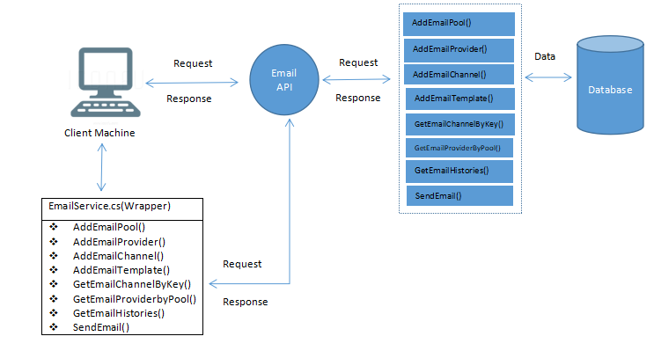

## Database Design:

Creates six new tables “**EmailHistory**”, “**EmailChannel**”, “**EmailQuota**”, “**EmailTemplate**”, “**EmailProviderSettings**” and “**EmailPool”** in the database for the connection string if not found.

Before the application can send emails and insert entries into the Email History table, it’s Pool name must first be registered into the “**EmailPool**” table. Once registered, provider settings, channel and template must be inserted against the inserted pool name in the “**EmailProviderSettings**”, “**EmailChannel**” and “**EmailTemplate**” tables respectively. Once this is done, the application can send emails to the recipients and store the email history into the database

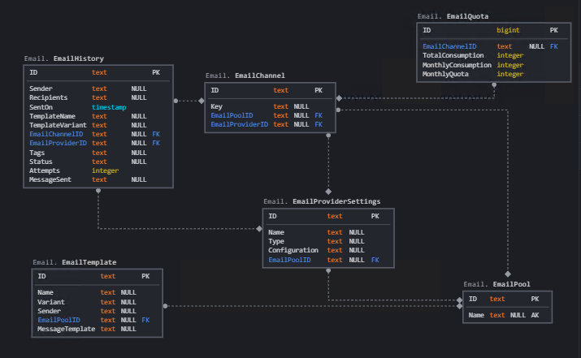

## Email API’s:

### AddEmailPool():

This API is called when an application’s pool should be registered into the database.

|  |  |
| --- | --- |
| Method Type | POST |
| API Format | {domain}/API/Email/AddEmailPool |
| Example | http://email.novigodemo.com/API/Email/AddEmailPool |

**Request Parameters:**

|  |  |  |  |
| --- | --- | --- | --- |
| Type | Parameter Name | Data Type | Comment |
| Body | **poolInput** | object | Model as mentioned below. |

**poolInput** is as follows:

|  |  |  |
| --- | --- | --- |
| Parameter Name | Data Type | Comment |
| ID | string |  |
| Name | string | Application Pool Name |

**Response Parameters:**

|  |  |  |
| --- | --- | --- |
| Parameter Name | Data Type | Comment |
| Message | string | Message |

### AddEmailProvider():

This API is called to add the email provider settings into the database.

|  |  |
| --- | --- |
| Method Type | POST |
| API Format | {domain}/API/email/AddEmailProvider |
| Example | http://email.novigodemo.com/API/email/AddEmailProvider |

**Request Parameters:**

|  |  |  |  |
| --- | --- | --- | --- |
| Type | Parameter Name | Data Type | Comment |
| Body | **providerInput** | object | Model as below |

**providerInput** is as follows:

|  |  |  |
| --- | --- | --- |
| Parameter Name | Data Type | Comment |
| ID | string |  |
| Name | string | Name of the provider settings |
| Type | string | Provider settings type (Smtp or NewGrid) |
| Configuration | string | SMTP or NewGrid Configuration |
| EmailPoolName | string | Application Pool Name |
| EmailPoolID | string |  |

**Response Parameters:**

|  |  |  |
| --- | --- | --- |
| Parameter Name | Data Type | Comment |
| Message | string | Message |

### AddEmailChannel():

This API is called to add the email channel into the database.

|  |  |
| --- | --- |
| Method Type | POST |
| API Format | {domain}/API/Email/AddEmailChannel |
| Example | http://email.novigodemo.com/API/Email/AddEmailChannel |

**Request Parameters:**

|  |  |  |  |
| --- | --- | --- | --- |
| Type | Parameter Name | Data Type | Comment |
| Body | **channelInput** | Object | Model as mentioned below |

**channelInput** is as follows:

|  |  |  |
| --- | --- | --- |
| Parameter Name | Data Type | Comment |
| ID | string |  |
| Key | string | Channel Key |
| EmailPoolName | string | Application Pool name |
| EmailPoolID | string |  |
| EmailProviderName | string | Name of the provider settings |
| EmailProviderId | string |  |

**Response Parameters:**

|  |  |  |
| --- | --- | --- |
| Parameter Name | Data Type | Comment |
| Message | string | Message |

### AddEmailTemplate():

This API is called to add the email template into the database.

|  |  |
| --- | --- |
| Method Type | POST |
| API Format | {domain}/API/Email/AddEmailTemplate |
| Example | http://email.novigodemo.com/API/Email/AddEmailTemplate |

**Request Parameters:**

|  |  |  |  |
| --- | --- | --- | --- |
| Type | Parameter Name | Data Type | Comment |
| Body | **templateInput** | object | Model as below |

**templateInput** is as follows:

|  |  |  |
| --- | --- | --- |
| Parameter Name | Data Type | Comment |
| ID | string |  |
| Name | string | Template Name |
| Variant | int | Variant name |
| Sender | string | Sender email address |
| EmailPoolID | string |  |
| EmailPoolName | bool | Application pool name |
| MessageTemplate | string | Email Template |

**Response Parameters:**

|  |  |  |
| --- | --- | --- |
| Parameter Name | Data Type | Comment |
| Message | string | Message |

### GetEmailChannelByKey():

This API is called to get the Email Channel details for the given Channel Key.

|  |  |
| --- | --- |
| Method Type | GET |
| API Format | {domain}/API/Email/GetEmailChannelByKey/{channelKey} |
| Example | http://email.novigodemo.com/API/Email/GetEmailChannelByKey/{channelKey} |

**Request Parameters:**

|  |  |  |  |
| --- | --- | --- | --- |
| Type | Parameter Name | Data Type | Comment |
| Route | channelKey | string | Channel Key |

**Response Parameters:**

|  |  |  |
| --- | --- | --- |
| Parameter Name | Data Type | Comment |
| **EmailChannelDto** | object | Model as mentioned below |

**EmailChannelDto** is as below:

|  |  |  |
| --- | --- | --- |
| Parameter Name | Data Type | Comment |
| ID | string | Email Channel ID |
| Key | string | Channel Key |
| EmailPoolName | string | Application Pool name |
| EmailPoolID | string | Email Pool ID |
| EmailProviderName | string | Name of the provider settings |
| EmailProviderId | string | Email Provider Settings ID |

### GetEmailProvidersByPool():

This API is called to get email provider settings by pool name and provider settings name.

|  |  |
| --- | --- |
| Method Type | GET |
| API Format | {domain}/API/Email/GetEmailProvidersByPool/{poolName}/{providerName} |
| Example | http://email.novigodemo.com/API/Email/GetEmailProvidersByPool/{poolName}/{providerName} |

**Request Parameters:**

|  |  |  |  |
| --- | --- | --- | --- |
| Type | Parameter Name | Data Type | Comment |
| Route | poolName | string | Application Pool name |
| Route | providerName | string | Email Provider Settings name |

**Response Parameters:**

|  |  |  |
| --- | --- | --- |
| Parameter Name | Data Type | Comment |
| **EmailProviderSettingsDto** | object | Model as mentioned below |

**EmailProviderSettingsDto** is as below:

|  |  |  |
| --- | --- | --- |
| Parameter Name | Data Type | Comment |
| ID | string | Email Provider Settings ID |
| Name | string | Name of the provider settings |
| Type | string | Provider settings type (Smtp or NewGrid) |
| Configuration | string | SMTP or NewGrid Configuration |
| EmailPoolName | string | Application Pool Name |
| EmailPoolID | string | Email Pool ID |

### GetEmailHistories():

This API is called to get email histories for a given channel key and a tag.

|  |  |
| --- | --- |
| Method Type | GET |
| API Format | {domain}/API/Email/GetEmailHistories/{channelKey}/{tag} |
| Example | http://email.novigodemo.com/API/Email/GetEmailHistories/{channelKey}/{tag} |

**Request Parameters:**

|  |  |  |  |
| --- | --- | --- | --- |
| Type | Parameter Name | Data Type | Comment |
| Route | channelKey | string | Channel Key |
| Route | tag | string | Tag name, Optional |

**Response Parameters:**

|  |  |  |
| --- | --- | --- |
| Parameter Name | Data Type | Comment |
| **EmailHistoryDto** | List<object> | List of Model as mentioned below |

**EmailHistoryDto** is as below:

|  |  |  |
| --- | --- | --- |
| Parameter Name | Data Type | Comment |
| ID | string | Email History ID |
| MessageSent | string | Email Body |
| Sender | string | Email sender |
| Recipients | string | Email Recipients |
| SentOn | DateTime | Datetime of the mail that was sent |
| TemplateName | string | Name of the template |
| TemplateVariant | string | Variant name |
| EmailChannelID | string | Email Channel ID |
| ChannelKey | string | Channel key |
| EmailProviderID | string | Email Provider Settings ID |
| ProviderName | string | Email Provider settings Name |
| Tags | string | Tags |
| Status | string | Whether email was sent or not |
| Attempts | int | Number of Attempts |

### SendEmail():

This API is called to send the email and store the email data into the database.

|  |  |
| --- | --- |
| Method Type | POST |
| API Format | {domain}/API/Email/SendEmail |
| Example | http://email.novigodemo.com/API/Email/SendEmail |

**Request Parameters:**

|  |  |  |  |
| --- | --- | --- | --- |
| Type | Parameter Name | Data Type | Comment |
| Body | **emailInputs** | object | Model as mentioned below |

**emailInputs** is as below:

|  |  |  |
| --- | --- | --- |
| Parameter Name | Data Type | Comment |
| ChannelKey | string | Channel Key |
| TemplateName | string | Template Name |
| Sender | string | Sender Email address |
| Variant | string | Variant |
| Recipients | string | Email Recipients |
| Subject | string | Email Subject |
| Body | string | Email Body |
| Username | string | Username |
| Tag | string | Tag |

**Response Parameters:**

|  |  |  |
| --- | --- | --- |
| Parameter Name | Data Type | Comment |
| **Message** | string | Message |