SMS

|  |  |  |  |  |
| --- | --- | --- | --- | --- |
| Sl. No | Author | Date | Version | Action |
| 1 | Abhishek | 11/02/2021 | 1.0 | Draft |
|  |  |  |  |  |

Table of Contents:

1. Purpose: 4

2. Architectural Design: 4

3. Database Design: 4

4. SMS API’s: 5

1. AddSMSPool(): 5

2. AddSMSProvider(): 6

3. AddSMSChannel(): 7

4. AddSMSTemplate(): 8

5. GetSMSChannelByKey(): 9

6. GetSMSProvidersByPool(): 10

7. GetSMSHistories(): 11

8. SendSMS(): 12

## Purpose:

SMS is used to send text messages to recipients and maintain the SMS histories in the database.

## Architectural Design:

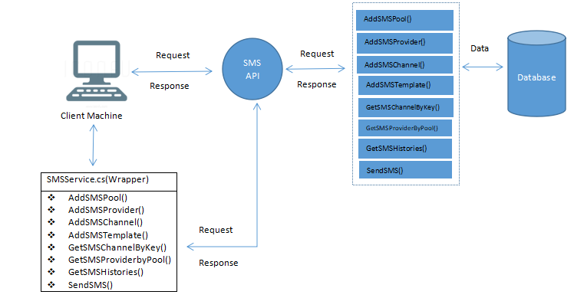

## Database Design:

Creates six new tables “**SMSHistory**”, “**SMSChannel**”, “**SMSQuota**”, “**SMSTemplate**”, “**SMSProviderSettings**” and “**SMSPool”** in the database for the connection string if not found.

Before the application can send text messages and insert entries into the SMS History table, it’s Pool name must first be registered into the “**SMSPool**” table. Once registered, provider settings, channel and template must be inserted against the inserted pool name in the “**SMSProviderSettings**”, “**SMSChannel**” and “**SMSTemplate**” tables respectively. Once this is done, the application can send text messages to the recipients and store the SMS history into the database

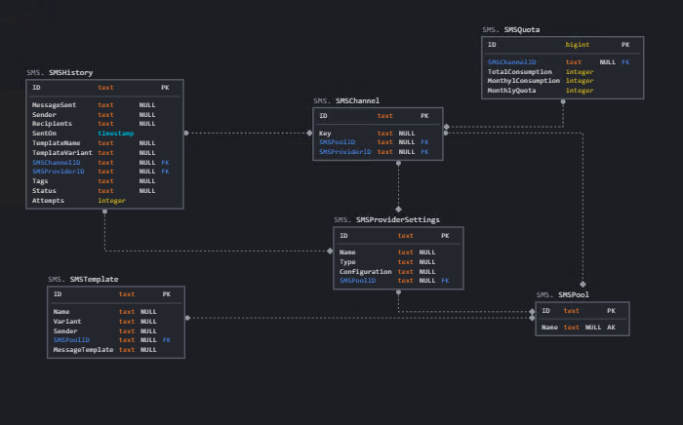

## SMS API’s:

### AddSMSPool():

This API is called when an application’s pool should be registered into the database.

|  |  |
| --- | --- |
| Method Type | POST |
| API Format | {domain}/API/SMS/AddSMSPool |
| Example | http://sms.novigodemo.com/API/SMS/AddSMSPool |

**Request Parameters:**

|  |  |  |  |
| --- | --- | --- | --- |
| Type | Parameter Name | Data Type | Comment |
| Body | **poolInput** | object | Model as mentioned below. |

**poolInput** is as follows:

|  |  |  |
| --- | --- | --- |
| Parameter Name | Data Type | Comment |
| ID | string |  |
| Name | string | Application Pool Name |

**Response Parameters:**

|  |  |  |
| --- | --- | --- |
| Parameter Name | Data Type | Comment |
| Message | string | Message |

### AddSMSProvider():

This API is called to add the SMS provider settings into the database.

|  |  |
| --- | --- |
| Method Type | POST |
| API Format | {domain}/API/SMS/AddSMSProvider |
| Example | http://sms.novigodemo.com/API/SMS/AddSMSProvider |

**Request Parameters:**

|  |  |  |  |
| --- | --- | --- | --- |
| Type | Parameter Name | Data Type | Comment |
| Body | **providerInput** | object | Model as below |

**providerInput** is as follows:

|  |  |  |
| --- | --- | --- |
| Parameter Name | Data Type | Comment |
| ID | string |  |
| Name | string | Name of the provider settings |
| Type | string | Provider settings type |
| Configuration | string | Configuration |
| SMSPoolName | string | Application Pool Name |
| SMSPoolID | string |  |

**Response Parameters:**

|  |  |  |
| --- | --- | --- |
| Parameter Name | Data Type | Comment |
| Message | string | Message |

### AddSMSChannel():

This API is called to add the SMS channel into the database.

|  |  |
| --- | --- |
| Method Type | POST |
| API Format | {domain}/API/SMS/AddSMSChannel |
| Example | http://sms.novigodemo.com/API/SMS/AddSMSChannel |

**Request Parameters:**

|  |  |  |  |
| --- | --- | --- | --- |
| Type | Parameter Name | Data Type | Comment |
| Body | **channelInput** | Object | Model as mentioned below |

**channelInput** is as follows:

|  |  |  |
| --- | --- | --- |
| Parameter Name | Data Type | Comment |
| ID | string |  |
| Key | string | Channel Key |
| SMSPoolName | string | Application Pool name |
| SMSPoolID | string |  |
| SMSProviderName | string | Name of the provider settings |
| SMSProviderId | string |  |

**Response Parameters:**

|  |  |  |
| --- | --- | --- |
| Parameter Name | Data Type | Comment |
| Message | string | Message |

### AddSMSTemplate():

This API is called to add the SMS template into the database.

|  |  |
| --- | --- |
| Method Type | POST |
| API Format | {domain}/API/SMS/AddSMSTemplate |
| Example | http://sms.novigodemo.com/API/SMS/AddSMSTemplate |

**Request Parameters:**

|  |  |  |  |
| --- | --- | --- | --- |
| Type | Parameter Name | Data Type | Comment |
| Body | **templateInput** | object | Model as below |

**templateInput** is as follows:

|  |  |  |
| --- | --- | --- |
| Parameter Name | Data Type | Comment |
| ID | string |  |
| Name | string | Template Name |
| Variant | int | Variant name |
| Sender | string | Sender |
| SMSPoolID | string |  |
| SMSPoolName | bool | Application pool name |
| MessageTemplate | string | SMS template |

**Response Parameters:**

|  |  |  |
| --- | --- | --- |
| Parameter Name | Data Type | Comment |
| Message | string | Message |

### GetSMSChannelByKey():

This API is called to get the SMS Channel details for the given Channel Key.

|  |  |
| --- | --- |
| Method Type | GET |
| API Format | {domain}/API/SMS/GetSMSChannelByKey?channelKey={channelKey} |
| Example | http://sms.novigodemo.com/API/SMS/GetSMSChannelByKey?channelKey={channelKey} |

**Request Parameters:**

|  |  |  |  |
| --- | --- | --- | --- |
| Type | Parameter Name | Data Type | Comment |
| QueryString | channelKey | string | Channel Key |

**Response Parameters:**

|  |  |  |
| --- | --- | --- |
| Parameter Name | Data Type | Comment |
| **SmsChannelDto** | object | Model as mentioned below |

**SmsChannelDto** is as below:

|  |  |  |
| --- | --- | --- |
| Parameter Name | Data Type | Comment |
| ID | string | Email Channel ID |
| Key | string | Channel Key |
| SMSPoolName | string | Application Pool name |
| SMSPoolID | string | SMS Pool ID |
| SMSProviderName | string | Name of the provider settings |
| SMSProviderId | string | SMS Provider Settings ID |

### GetSMSProvidersByPool():

This API is called to get SMS provider settings by pool name and provider settings name.

|  |  |
| --- | --- |
| Method Type | GET |
| API Format | {domain}/API/SMS/GetSMSProvidersByPool?poolName={poolName}&providerName={providerName} |
| Example | http://sms.novigodemo.com/API/SMS/GetSMSProvidersByPool?poolName={poolName}&providerName={providerName} |

**Request Parameters:**

|  |  |  |  |
| --- | --- | --- | --- |
| Type | Parameter Name | Data Type | Comment |
| QueryString | poolName | string | Application Pool name |
| QueryString | providerName | string | SMS Provider Settings name |

**Response Parameters:**

|  |  |  |
| --- | --- | --- |
| Parameter Name | Data Type | Comment |
| **SMSProviderSettingsDto** | object | Model as mentioned below |

**SMSProviderSettingsDto** is as below:

|  |  |  |
| --- | --- | --- |
| Parameter Name | Data Type | Comment |
| ID | string | SMS Provider Settings ID |
| Name | string | Name of the provider settings |
| Type | string | Provider settings type |
| Configuration | string | Configuration |
| SMSPoolName | string | Application Pool Name |
| SMSPoolID | string | SMS Pool ID |

### GetSMSHistories():

This API is called to get SMS histories for a given channel key and a tag.

|  |  |
| --- | --- |
| Method Type | GET |
| API Format | {domain}/API/SMS/GetSMSHistories?channelKey={channelKey}&tag={tag} |
| Example | http://sms.novigodemo.com/API/SMS/GetSMSHistories?channelKey={channelKey}&tag={tag} |

**Request Parameters:**

|  |  |  |  |
| --- | --- | --- | --- |
| Type | Parameter Name | Data Type | Comment |
| QueryString | channelKey | string | Channel Key |
| QueryString | tag | string | Tag name |

**Response Parameters:**

|  |  |  |
| --- | --- | --- |
| Parameter Name | Data Type | Comment |
| **SMSHistoryDto** | List<object> | List of Model as mentioned below |

**SMSHistoryDto** is as below:

|  |  |  |
| --- | --- | --- |
| Parameter Name | Data Type | Comment |
| ID | string | SMS History ID |
| MessageSent | string | SMS Message |
| Sender | string | SMS sender |
| Recipients | string | SMS Recipients |
| SentOn | DateTime | Datetime of the SMS that was sent |
| TemplateName | string | Name of the template |
| TemplateVariant | string | Variant name |
| SMSChannelID | string | SMS Channel ID |
| ChannelKey | string | Channel key |
| SMSProviderID | string | SMS Provider Settings ID |
| ProviderName | string | SMS Provider settings Name |
| Tags | string | Tags |
| Status | string | Whether SMS was sent or not |
| Attempts | int | Number of Attempts |

### SendSMS():

This API is called to send the text messages and store the SMS data into the database.

|  |  |
| --- | --- |
| Method Type | POST |
| API Format | {domain}/API/SMS/SendSMS |
| Example | http://sms.novigodemo.com/API/SMS/SendSMS |

**Request Parameters:**

|  |  |  |  |
| --- | --- | --- | --- |
| Type | Parameter Name | Data Type | Comment |
| Body | **smsInputs** | object | Model as mentioned below |

**smsInputs** is as below:

|  |  |  |
| --- | --- | --- |
| Parameter Name | Data Type | Comment |
| ChannelKey | string | Channel Key |
| TemplateName | string | Template Name |
| Sender | string | Sender |
| Variant | string | Variant |
| Recipients | string | SMS Recipients |
| Content | string | SMS Content |
| Username | string | Username |
| Tag | string | Tag |

**Response Parameters:**

|  |  |  |
| --- | --- | --- |
| Parameter Name | Data Type | Comment |
| **Message** | string | Message |