EXPERIMENT- 1
Q] Sum of Integers from 1 to n
Aim-
To write a Prolog program to find the sum of integers from 1 to N..
Algorithm-
- Read the value of N.
- If N = 0, return 0.
- Otherwise, recursively find the sum of N-1.
- Add N to the previous sum.
- Display the result.
Program-
sum(0,0).

sum(N,S) :-
N > 0,
N1 is N-1,
sum(N1,S1),
S is S1 + N.
Sample Input-
?- sum(5,S).

Sample Output-
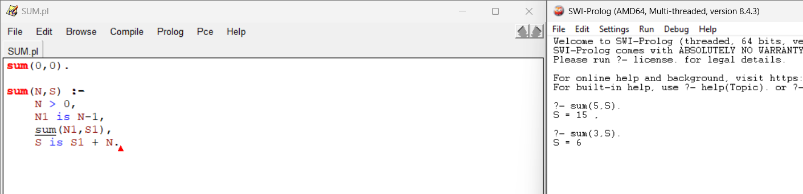

Result-
Thus, the Prolog program to find the sum of integers from 1 to N was executed successfully.

