EXPERIMENT- 2
Q] Database with Name and DOB.
Aim-
To write a Prolog program to create a database containing Name and Date of Birth (DOB).
Algorithm-
- Create facts for person name and DOB.
- Store each record in the database.
- Query the database using name or DOB.
- Display the matching result.
Program-
person(rupa,'08-03-2007').
person(rahul,'15-06-2005').
person(priya,'21-10-2006').
Sample Input-
?- person(rupa,DOB).
Sample Output-
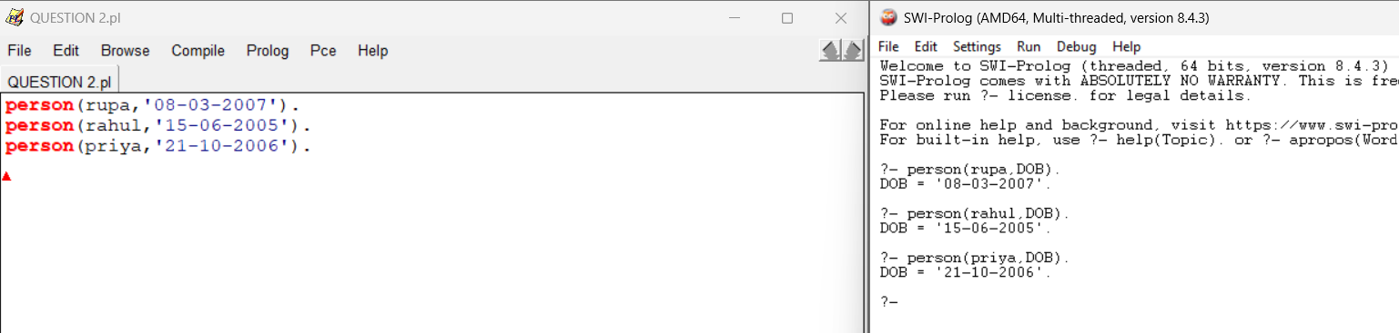

Result-
Thus, the Prolog program for a Name and DOB database was executed successfully.

