EXPERIMENT- 3
Q] Student–Teacher–Subject Code Database.
Aim-
To write a Prolog program to create a database containing Student, Teacher, and Subject Code details.
Algorithm-
- Create facts for students, teachers, and subjects.
- Assign subject codes.
- Define which teacher teaches which subject.
- Define which student studies which subject.
- Query the database to retrieve the required information.
Program-
student(rupa).
student(rahul).
teacher(anil).
teacher(suma).
subject(ai,101).
subject(java,102).
teaches(anil,ai).
teaches(suma,java).
studies(rupa,ai).
studies(rahul,java).
Sample Input-
?- subject(ai,Code).
Sample Output-
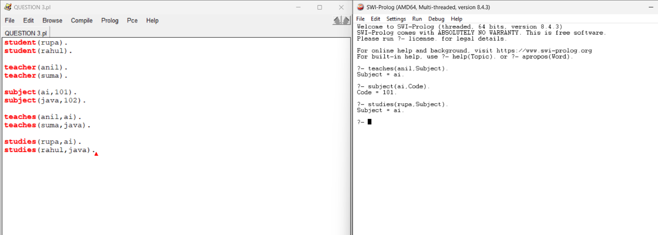

Result-
Thus, the Prolog program for the Student–Teacher–Subject Code database was executed successfully.

