EXPERIMENT- 4
Q] Planets Database.
Aim-
To write a Prolog program to create a database of the eight planets in the solar system.
Algorithm-
- Create facts for each planet.
- Store the planet names in the database.
- Query the database.
- Display the required planet details.
Program-
planet(mercury).
planet(venus).
planet(earth).
planet(mars).
planet(jupiter).
planet(saturn).
planet(uranus).
planet(neptune).
Sample Input-
?- planet(X).

Sample Output-
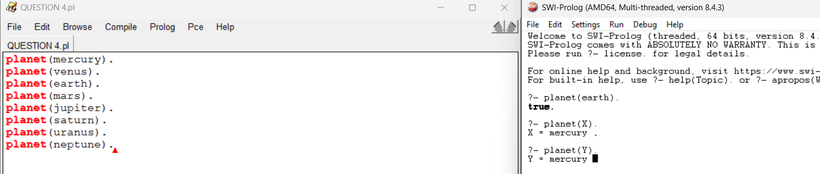

Result-
Thus, the Prolog program for the Planets database was executed successfully.

