**Leadership**

Table of Contents

**Chapter 1. Developing Societies Leaders** 3

**Section A. Are Leaders Born or Made?** 3

Animation 1: Are Leaders Born or Made? What Makes a Democratic Leader? 3

**Section B. Political Parties Develop Tomorrow’s Leaders** 3

**Section C. Leadership is Choice** 4

Quiz 1. 5

**Chapter 2. What Makes Democratic Leader** 5

**Section A. Leadership** 5

**Section B. Democratic Leadership** 6

**Section C. How a Democratic Leader Operates** 7

Infographic 1: Democratic Leader 8

Quiz 2 8

**Chapter 3. Political Leadership** 8

**Section A. Political Leadership** 8

**Section B. Ethical Leadership** 10

**Section C. Critical Thinking** 11

**Section D. Communication Skills** 13

**Section E. Organizational Skills** 13

Infographic 2: Key traits of a political leader 14

Quiz 3 14

**Chapter 4. Developing a Career Plan** 14

**Section A. Develop a Plan** 14

**Section B. Mission Statement** 15

Infographic 3: Drafting a Mission Statement 16

**Section C. Self-Assessment** 16

**Section D. Professional Development** 18

**Section E. Benchmarks** 19

Quiz 4 20

**Chapter 5. Strategic Communication** 21

**Section A. Communication Road Map** 21

Infographic 4: Steps of a Personal Strategic Communication Plan 21

**Section B. Story Telling** 21

**Section C. Your Personal Brand** 22

Quiz 5 24

**Chapter 6. Public Speaking Skills** 24

**Section A. Public Speaking** 24

Animation 2: How is Public Speaking use in politics? Useful tips of Public Speaking. Dos and Don’ts of Public Speaking. 24

**Section B. The Speech Communication Process** 25

**Section C. Non-Verbal Communication** 26

Infographic 5: Nonverbal Communication 28

**Section D. Speech Construction** 28

**Section E. Persuasion - Making the Pitch** 29

**Section F. Preparation** 30

Quiz 6. 31

**Chapter 7. Networking Skills** 31

**Section A. Political Networks** 31

**Section B. Where to Grow your Network** 32

Quiz 7. 33

**Chapter 8. Media Engagement** 33

**Section A. Cultivate Relationships** 33

**Section B. Interviews - Preparation** 34

**Section C. TV and Radio Interviews.** 35

Infographic 6: Dos and Don’ts of TV interviews. 36

**Section D. Print Media** 36

Quiz 8 37

**Chapter 9. Social Media** 37

**Section A. Social Media Page** 37

**Section B. Don’ts of Social Media** 38

Infographic 7: Dos and Don’ts of Social Media 39

Quiz 9 39

Final Exam 40

# **Chapter 1. Developing Societies Leaders**

## **Section A. Are Leaders Born or Made?**

### Animation 1: Are Leaders Born or Made? What Makes a Democratic Leader?

Ethical and effective leadership are a fundamental element of a democratic society. Leaders must understand the important issues facing a country, hear all sides and perspectives, account for all available resources, and ultimately make decisions in the best interest of everyone. Leadership is an essential necessity for a society to function.

**Are Leaders Born or Made?**

In choosing its leaders, democracies must answer the age-old question, “are leaders born or made?” Throughout history, every civilization has attempted to answer this question. Social scientists have conducted many academic studies to find a conclusive answer. While research has discovered interesting information, it has yet to produce a conclusive answer.

Democracies operate under the assumption that yes; **leaders can be made**. While certain individuals may be ***born*** with unique leadership characteristics, a democratic society will choose its leaders based on who it believes can best serve the people, regardless of their personal backgrounds.

Two key points support the idea that leaders can be made:

## **Section B. Political Parties Develop Tomorrow’s Leaders**

Identifying and developing new leaders is one of the most important roles of political parties in a democratic society. Political parties provide a mechanism to identify individuals with potential for leadership and provide the necessary opportunities to develop their capacities.

Parties help develop leaders in the following 3 ways:

## **Section C. Leadership is Choice**

While leadership skills and experience can be developed over time, aspiring leaders need to do the hard work to improve these skills. Leadership is a great responsibility that brings both the challenge and opportunity.

Common Challenges of Leadership include:

**Leadership is a Choice!**

These examples only outline a few of the potential challenges leaders face. While the act of leadership is a noble service that provides extensive rewards, it also comes with great responsibility. Individuals need to choose to take on this responsibility, including both the good and the bad. There are many people that want to be leaders, but only few willing to lead.

**Parties Must Develop Leaders**.

While throughout history, heroic individuals have emerged from the shadows to lead people through crises and to bigger and better circumstances, a society does not have the luxury to depend on this scenario. One of the main purposes of a democratic society is create structures that select leaders and guide their decision-making process in ways that best serve everyone. Political Parties are critical part of these structures that help develop and support national leaders.

### Quiz 1.

1. Democracies assume that Leaders are_______.
   1. Tall
   2. Born
   3. **Made**
   4. Decided by God.
   5. Wealthy
2. Political parties can do _______ to develop leaders.
   1. Create a Support System.
   2. Provide Skills Training
   3. Provide Gradual Experience.
   4. **All the above**.
3. True or **False**: Experience is never as an effective teacher as textbook learning.
4. Success is not given, a delicate balance of interests, responsible for consequences, acquiring difficult skills, and managing stress are_______.
   1. **Challenges leaders face.**
   2. Thing leaders should ignore.
   3. Reason leaders are born.
   4. None of the above.

# **Chapter 2. What Makes Democratic Leader**

## **Section A. Leadership**

The concept of leadership is not easily defined. Leadership means different things to different people, and different things in different situations. A simple definition is ***“the action of leading a group of people or an organization”***. While this is true in a basic since, in practice e it is not easy to define.

A helpful way to understand leadership is to identify what ***is not***.

* Leadership has nothing to do with seniority or one’s position in a hierarchy.
* Leadership has nothing to do with titles.
* Leadership has nothing to do with personal attributes.
* Leadership is nothing to do with gender.
* Leadership is not management.

Prominent historical figures have provided their own views of leadership. A few popular examples include:

In short, the definition of leadership has nothing to do with the hierarchy or position of anyone; it has nothing to do with imposing views. ***Leadership is the attitude assumed by those looking for something different, who are committed to achieving a goal and whose conviction they manage to transmit to others through enthusiasm and optimism to reach a common goal***. Leadership is the lifting of people’s vision to a higher sight, the raising of their performance to a higher standard, the building of their personality beyond its normal limitations.

## **Section B. Democratic Leadership**

Leadership in a democracy offers its own unique challenges. While elected leaders may be responsible for making final decisions, they do not make these decisions unilaterally. Democracies create a process that divides decision making responsibilities among different bodies. The process is designed in a way that balances the interests of all aspects of society in decision making.

To be effective in a democratic system, ***leaders must focus as much on the process of decision making as they do on the eventual outcomes of the decision***. Leaders must balance the need for assertiveness, good judgment, and vision with the need to be collaborative, inclusive, and consensus minded. Democratic leaders need to guide a process that results in the right decision being made on behalf the people.

The 5 most important characteristics of a Democratic Leader include:

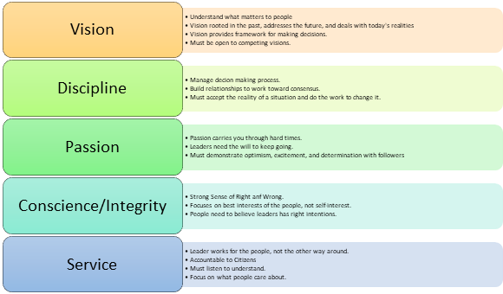

## **Section C. How a Democratic Leader Operates**

While vision, discipline, passion, conscious, and a sense of service or the key personal traits that guide a democratic leader, on a functional level the leader must be collaborative.

To create a collaborative process, a democratic leader will do the following:

### Infographic 1: Democratic Leader

### Quiz 2

1. True or **False:** Leadership is a result of hierarchy and position.
2. Vision, Discipline, ________, Conscience, and Service.
   1. Wealth
   2. Status
   3. **Passion**
   4. None of the above.
3. **True** or False: Democratic Leaders proactively seek the perspective of others.
4. True or **False**: Democratic Leaders only focus on making final decisions and leave managing the decision-making process to others.

# **Chapter 3. Political Leadership**

## **Section A. Political Leadership**

*Democratic Leaders* push for a bold vision for the betterment of society, work toward that vision in an inclusive manner, and steer collective efforts in the service of citizens. Unfortunately, very few societies are perfect, and aspiring leaders need to balance the ideal process with political realities. ***Political Leadership*** focuses on the practical realities of leading in politics.

Political leaders need to navigate the conflicting pressures of citizen expectations, competing parties, passionate interest groups, and an often-aggressive media to articulate a vision, gain power, and eventually govern.

Political leadership often means:

* Leading more through *softer skills* like persuasion.
* Leading diverse coalitions toward policy goals.
* Organizing efforts of volunteers.
* Maintaining support of cynical and skeptical voters.
* Responding to crises in the moment, without the luxury of sticking to an established plan.

Political leaders come in different shapes and sizes. They can include:

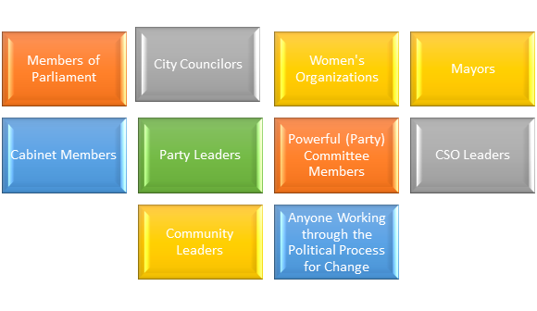

The personal characteristics necessary to be an effective political leader largely depend on the person and circumstances. There are some traits that are universal, and immensely important to any political leader.

The main traits of a Political Leaders fit into these 4 categories.

## **Section B. Ethical Leadership**

Ethical leadership is as important in practice as it is in principle. It provides the framework collaboration and making decisions. Political leaders need to constantly balance conflicting interests and negotiate compromise. People on all sides will need to sacrifice. If someone believes that you are operating from an ethical foundation, they will be more likely to work with you even if they do not agree with everything you are proposing.

There are multiple ways to define ethics. The most common definition of ethics is***“a set of standards of right and wrong that guide what people in a society should and should not do”****.* A common understanding of right and wrong is critical for a democracy to function. Ethics are central to ensuring citizens possess a shared sense of collective good.

Ethical Leadership is leadership respects the values, dignity, and rights of others. Ethical leaders internalize and practice moral concepts such as honesty, justice, care, and respect for people.

Ethical leaders typically possess the following traits.

​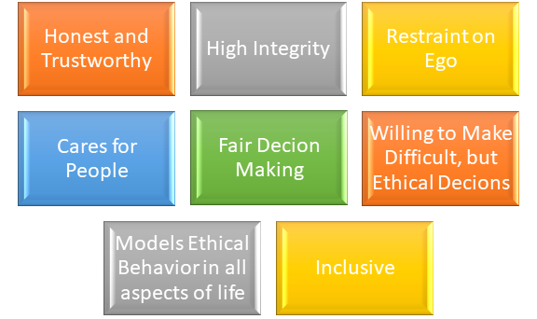

Ethics are especially important for political leaders for the following reasons.

* Political leaders are responsible for developing and implementing laws to guide a society.
* Laws rooted in a common understanding of right and wrong are more credible and effective.
* Political leaders are required to implement public policy that makes society more equitable.
* Political leaders also at times need to make difficult decisions that may hurt small groups of people for the good of the whole. These decisions are more credible when people believe decisions are based on ethical principles consistent with society.

## **Section C. Critical Thinking**

Critical thinking skills are essential to political leadership. To win an election, support community advocacy initiatives, or push legislation, political leaders must build coalitions of support from diverse groups of people to achieve success. A strategy that may make sense on paper does not always translate to reality.

A political leader needs to understand how to balance two main challenges: ***conflicting interests of different groups, and limited resources***.

**Conflicting Interests**. Priorities of different important groups within a coalition create conflict and place limitations on how much a leader can do for each group. In these situations, the leader must balance the interest of each group, the interest of the party, and their own self-interest to keep everyone moving together in the right direction.

**Limited Resources.** Political leaders are also restrained by limited resources to address all the interests of different groups of people. This is especially true for political parties. Different groups will focus all on demand with little regard to supply (of resources). Leaders need to understand the total available resources that can be split up among the different interests.

Common Examples of both challenges are listed in the chart below.

Leaders must work hard to balance these conflicts and restraints to achieve the best outcome for everyone involved. To create this balance, a leaders should consider 4 points:

Critical thinking skills are foundation of developing good judgment to make difficult decisions. The ability to see all sides, weigh all options, and make decisions are essential to political leadership.

## **Section D. Communication Skills**

A political leader needs to develop a variety of communication skills to be effective. Political leaders lead more by persuasion and influence than by directives or orders. Political leaders must:

* Communicate complicated ideas to different audiences in a simple manner that each can understand.
* Connect with diverse groups of people at an emotional level that builds trust.
* Learn how to listen to understand what matters to citizens.

The following chapters will walk through the most critical technical communication skills for political leaders. This includes developing a strategic communication plan, public speaking, and media engagement.

## **Section E. Organizational Skills**

Like all types of leaders, political leaders will need to possess effective managerial skills to over-see day to day operations of any initiative.

**Internal Party Leadership**.

For leaders within a political party, some responsibilities may look like that of any manger in the private sector or other field. This includes:

* Manage a budget.
* Supervise staff.
* Develop schedules and timelines.
* Evaluate the individual or group performance.

**External Political Leadership.**

For external party initiatives or leadership for other political initiatives like campaigns or advocacy initiatives, organizational responsibilities will focus more on coordinating collective efforts with peers than top-down management. This includes:

* Coordinating schedules.
* Pooling resources.
* Developing a common message.
* Keeping records of partner interests,
* Working toward a common goal.

**Self-Organization**.

Political leaders also need to keep themselves organized as well. Political leaders must engage and understand the interests of a wide variety of groups and individuals. One of the worst mistakes a political leader can make is confusing one contact for another. Political leaders must have an organized schedule to avoid over committing themselves to different engagements.

While there are a variety of technical skills that are useful to political leaders, these four basic attributes are essential. The following chapters of this course cover some of the important technical skills essential for leaders. While most of the skills are communication skills in nature, they serve to support the development of all 4 of these capacities.

### Infographic 2: Key traits of a political leader

### Quiz 3

1. The four traits of a political leader include Ethics, _______, Communication, and Organization.
   1. Vision
   2. **Critical Thinking**
   3. Decisiveness
   4. Passion
   5. None of the above.
2. Which of the following is ***NOT*** one of the 5 traits of a ***Democratic Leader***?
   1. Vision
   2. Passion
   3. **Wealth**
   4. Discipline
   5. Service
3. Critical Thinking must balance _______, and Limited Resources.
   1. **Conflicting Interests**
   2. Passion and Vision
   3. Power and Greed
   4. None of the above.
4. **True** or False: Political leaders need to keep themselves organized because they must engage and understand the interests of a wide variety of groups and individuals.
5. True or **False**: Ethics have no practical application to political leadership.
6. Analyzing the following 4 points: Citizen Perspective, Political Landscape, Capacity, and Self-Evaluation are ways to…
   1. Become a Democratic Leader.
   2. Manage a Political Party.
   3. **Balance conflicting interests and limited resources.**
   4. Organize an advocacy initiative.
   5. All the above.

# **Chapter 4. Developing a Career Plan**

## **Section A. Develop a Plan**

To become a leader, you need a plan. A political career plan will help you become a successful political leader by identifying where you want to go and outlining the necessary steps take to get there. While each plan will be unique to the individual, most will include the following 4 important points.

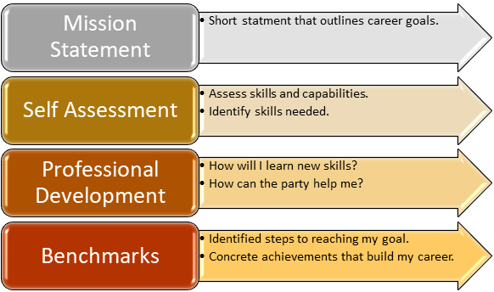

## **Section B. Mission Statement**

A ***personal mission statement*** clearly articulates your broader career goals. Looking ahead, 10, 20, or even 30 years, what would you like to have achieved? Would you like to serve on a city council? Run for Parliament?

The late American professor and career advisor Stephen Covey describes a mission statement as follows:

*“A mission statement describes what makes you unique and defines your place in the world. You can use a personal mission statement to define who you are and what you want to become in the future. It should define your character and guide you in your achievements and the contributions you make in your life.”*

Your mission statement is simply a few short sentences that describe the key purpose that drives your life. This combines both personal and professional ambitions and articulates the key values and principles that guide you.

These five steps will help in developing an effective mission statement.

Once you have answered these 5 questions, create a few short sentences that articulate your mission.

* Where is it that you want to go?
* How far have you come?
* What matters the most to you?
* How can your success in politics reinforce your success in life?

It will likely take a few attempts before you get it right. Put down a few different examples on paper and see which one feel right.

### Infographic 3: Drafting a Mission Statement

## **Section C. Self-Assessment**

Next, conduct an honest self-assessment. What attributes do you already possess? What are your biggest weaknesses related to politics? What external assets do you possess or lack? What skills do you possess that make you unique?

**SWOT Analysis**

One of the most common ways to make this assessment is to conduct a “SWOT” Analysis for your political profile. A SWOT analysis is an easy way to assess your personal, or inner, traits; and to assess external factors that contribute to your potential success. SWOT stands for strengths, weaknesses, opportunities, and threats.

* S = Strengths
* W= Weaknesses
* O= Opportunities
* T = Threats

***Strengths and weaknesses assess your personal skills***. What are your personal strengths as a politician? What are your weaknesses?

***Opportunities and threats assess external factors***. Opportunities refers to chances for growth or progress, threats are external factors that can hurt your success.

The following diagram outlines the 4 steps.

This exercise is helpful to structure the analysis of your self-assessment. It is a useful starting point to determine what you have achieved and what you need to improve.

## **Section D. Professional Development**

The next step is to identify specific skills and assets that you need in your political career. The skills will largely depend on what you determine to be your weaknesses in the self-assessment exercise.

Start imagining a high-level position of political leadership, consistent with your mission statement. This can be an MP, mayor, or chair of an important party committee.

Think of each position and ask these questions:

* What functions do they perform every day?
* What professional skills are needed for that position?
* What other assets like network connection can be useful?

A political leader needs to develop a variety of different skills both to reach these positions as well as perform once they get there. Some common examples include:

This course will cover each of these in the following chapters.

## **Section E. Benchmarks**

Benchmarks clearly articulate tangible identified goals that the person strives to achieve in a specific period. These goals are the small steps that overtime guide the aspiring political leader to the vision described in their mission statement.

For example, think of a young member of a political party that is continually active in the party’s youth wing.

* They are 25 years old and have been active in the party for five years.
* They are currently the number 4 ranking member of the youth wing and chair of the youth policy initiative committee.
* They want to build from their current achievements to become an influential leader in the party.
* Their mission statement declares that they want to be one of the prominent voices within the party on economic development.

The following benchmarks would make sense for this path:

These benchmarks are ambitious and specific to this example, but they provide a basic idea of how to outline specific steps to achieve identified goals.

Once you have developed your mission statement, conducted a self-assessment, identified needed professional skills, and outline concrete benchmarks, put it all together and write your political career plan. This plan will serve as a road map to help you work through your political career.

### Quiz 4

1. A SWOT analysis assess which of the following elements?
   1. Strengths
   2. Weaknesses
   3. Threats
   4. Opportunities
   5. **All the above**.
2. The 4 important points a political career plan include drafting a mission statement, self-assessment, professional development, and ________.
   1. Raising money
   2. **Setting Benchmarks**
   3. Public Speaking
   4. Networking
   5. None of the above.
3. To determine which skills are needed to achieve career objectives, it useful to consider a high-level position of political leadership and ask all the following questions except…
   1. What functions do they perform every day?
   2. What professional skills are needed for that position?
   3. **Why is that position necessary?**
   4. What other assets like network connections can be useful?
4. True or **False**: In a SWOT analysis, ***Opportunities*** refers to traits or skills that set you apart from others.
5. **True** or False: When writing a career plan, it is important to separate personal goals and career goals.

# **Chapter 5. Strategic Communication**

## **Section A. Communication Road Map**

A communication road map is a strategy for telling your story as a political leader. Successful political leaders introduce themselves in a way that tells a personal story, weaving experiences, personal interests, and values into a clear narrative that relates to any audience.

A strong communication road map consists of 5 main elements:

Thinking through these 5 steps will help you plan to organize, develop, and deliver your personal story.

### Infographic 4: Steps of a Personal Strategic Communication Plan

## **Section B. Story Telling**

After laying out your communication road map, the next step is to articulate your story. Telling your story should blend both political career ambitions with personality and personal history to form a unique and compelling narrative. Your story should include all things that make you uniquely “you”.

The main ingredients to a good story include:

The elements of a message are discussed in more detail in the campaign management course.

## **Section C. Your Personal Brand**

***Your brand is the image of you as perceived in the minds of others.*** It includes the defining characteristics of who you are as a person, as a professional, and what you offer to others. A strong brand will be authentic, memorable, and descriptive. It will amplify the best aspects of your personality and reputation.

An effective brand will communicate 5 key elements about you:

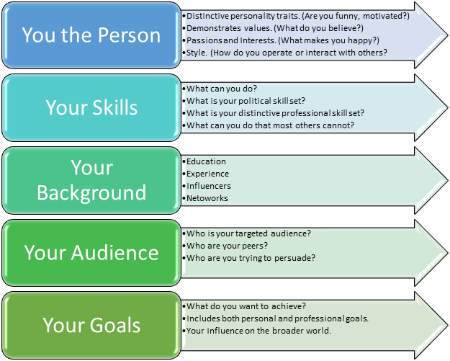

**Branding Statement**

Your personal brand statement summarizes everything you want to convey in a few sentences. It is like a mantra which you live by both professionally and personally.

An effective personal statement is typically no more than 3 or 4 sentences and includes two main elements: a theme and a person’s main points of difference.

**Theme**. The theme is the overarching concept that encompasses all 5 of the key elements. In a few words, what do you want to be known for?

**Points of Difference**. Points of difference are the personal qualities, skills, and experiences you possess that make you unique. What makes you special? What makes you authentic in relation to your theme? For example, if your theme is to be a champion for the less fortunate you can highlight previous work advocating for Persons with Disabilities (PWD).

Your branding statement is simply a brief description of yourself that you present to others for them to create a positive memorable image associated with your name.

### Quiz 5

1. The 2 main elements of a branding statement are *theme* and ______.
   1. Benchmarks
   2. Values
   3. Points of Difference
   4. **Your “From-To” Gap**
   5. None of the above.
2. All the following are ingredients for telling your story except…
   1. The “Why”
   2. Your “Good, Bad, and Ugly”
   3. Your Stakeholders
   4. Your message
   5. **Career Plan**
3. The 5 elements of a Strategic Communication Road Map include Context, Vision, Strategy, Message, and _______.
   1. **Tactics**
   2. Theme
   3. Points of Difference
   4. Brand
   5. None of the above.
4. **True** or False: You the person, your skills, your background, your audience, and your goals are the 5 elements of a brand.

# **Chapter 6. Public Speaking Skills**

## **Section A. Public Speaking**

### Animation 2: How is Public Speaking use in politics? Useful tips of Public Speaking. Dos and Don’ts of Public Speaking.

Public speaking is the most visible communication skill for political leaders. Political leaders speak to audiences of all shapes and sizes. Short speeches to supporters, also known as a “stump speech” are the most common and will be the focus of this chapter.

Different types of speeches can include:

* Speeches to large audiences in public events.
* Speeches to high level audiences and government officials.
* Presentations to group meeting with partners and allies
* Speeches to potential voters and supporters.

**The “Stump Speech”**

The main characteristics of a stump speech are like those of a campaign message. This is logical as a stump speech is one method of delivering a message.

A stump speech will be:

* Short, 90 seconds or less.
* Uses Clear Terms
* Repeated
* Can adapt to audience but must maintain core points.

The following sections will outline the speech communication process, speech delivery and nonverbal communication, speech construction, persuasion, and preparation.

## **Section B. The Speech Communication Process**

The success of a speech is measured by the amount information retained by the audience and the personal connection created with the speaker. To make a real connection, the speaker needs to command the flow of information to and from the audience.

The process by which information is exchanged between the speaker and the audience is known as the communication cycle. The cycle consists of the 5 key elements below.

A common mistake made by political leaders is to overload a speech. At most, your audience will be able to take away 3-4 key points. As a leader, you need to be able to both clearly articulate your key points and assess if these points are being received.

## **Section C. Non-Verbal Communication**

While the speaker can carefully construct the words of a speech to convey the desired message, non-verbal communication can often be more difficult to manage. Nonverbal refers to aspects of the communication process beyond the spoken words.

Mastering non-verbal communication is a critical part of becoming an effective public speaker. The audience is more likely to connect with the tone of your voice, the way you present yourself, and how you move than the by the words in the speech.

Non-verbal communication can be divided into 3 categories.

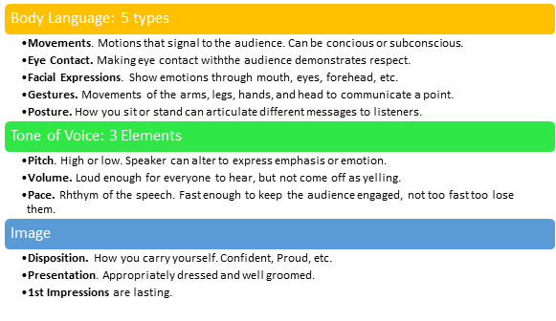

### Infographic 5: Nonverbal Communication

## **Section D. Speech Construction**

Writing a stump speech can be challenging. It is important when drafting to the speech to write to the ear and not to the eye. Include as much information as you think people will understand and remember.

The typical speech can be broken into 7 parts.

## **Section E. Persuasion - Making the Pitch**

As you construct your speech, remember that you are ultimately making a pitch. Whether it is trying to win the support of voters, convince an audience of a policy position, or contrast your differences with your opponent, your speech is most likely trying to persuade someone of something.

To help make your pitch, remember to ***LEAD*** your audience: ***Leverage, Engage, Advocate, Deliver.***

## **Section F. Preparation**

Delivering a great speech takes a lot of time and preparation. Carefully plan the logistics of the speech, understand your audience, structure your speech in a clear and concise manner, practice as many times as needed.

When preparing for your speech, consider the following key details.

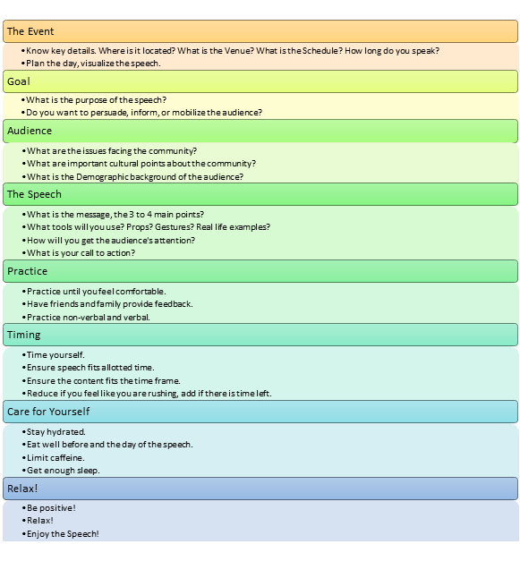

### Quiz 6.

1. Which of the following are one of the 3 element(s) of non-verbal communication?
   1. Body Language
   2. Voice
   3. Image
   4. **All the above.**
2. When making your pitch, remember to LEAD. LEAD is an acronym for ________?
   1. Learn, Earn, Add, and Divide
   2. **Leverage, Engage, Advocate, Deliver**
   3. Learn, Engage, Advocate and Deliver
   4. Leverage, Earn, Advocate, Deliver
   5. None of the above.
3. **True** or False: A speech should end with a Call to Action, that mobilizes the audience with a specific ask.
4. The 5 elements of the communication cycle include the speaker, the message, the audience, ________, and the context.
   1. Call to action.
   2. Opening
   3. **Feedback**
   4. Venue
   5. None of the above.
5. True or **False**: A stump speech should only be given once, never repeated.
6. **True** or False: It is a good idea to time yourself before a speech to ensure the content matches the time frame.

# **Chapter 7. Networking Skills**

## **Section A. Political Networks**

Individuals do not become leaders on their own. Anyone who rises to a position of leadership likely had help along the way. Throughout their careers, successful political leaders will develop their own political network of influential connections. These connections will be valuable at all phases of your career from helping you in door at the beginning or wining election to the national legislature. Successful leaders know how to build relationships that both benefit specific immediate objectives and serve a broader purpose in achieving life-long goals.

**Network Functions**

Your political network are the contacts you possess both in and out of your party that will help you succeed. Think about the position you are aiming for, what specific assets will get you there? Who are the people that can help you get those assets?

Influential members of your network can perform a variety of functions that assist in attaining these assets.

5 common functions include:

Its common that certain members of your network can perform more than one of these functions. The important thing is that your network provides these 5 functions.

## **Section B. Where to Grow your Network**

For an aspiring politician, professionals from a variety of fields can contribute to your success. Some of the most common fields are listed in the diagram below.

### Quiz 7.

1. True or **False:** Most political leaders never receive help in building their career.
2. The 5 main functions of your political network include connector, ______, expert advisor, peer, and promoter.
   1. Leader of Civil Society organization
   2. Union leader
   3. Mentor
   4. Media member
   5. None of the above.
3. **True** or False: Community leaders, private industry leaders, and leaders of civil society organization typically make good political network connections.

# **Chapter 8. Media Engagement**

## **Section A. Cultivate Relationships**

Cultivate relationships with the journalists that help you tell your story is essential for political leaders.

Journalists and media outlets have their own agenda. Whether that agenda is a political slant away from your interests, the desire to sell newspapers, or a lack of interest in politics all together, they are not likely to present you the way you want them to present you right away. You must develop a plan to grow these relationships.

Your plan should include:

* Comprehensive breakdown of the influential journalists and outlets in the community
* One by one strategy to engage each one.
* Respectful and honest engagement, good reporters see through inauthentic approaches.
* Strategic thinking and good communication skills.

## **Section B. Interviews - Preparation**

No matter what the media (radio, television, or newspaper), and no matter who the interviewer, the key principle is that you must always remain in control of the interview situation. This means:

* Gathering all the information about the interviewer and outlet from your media plan.
* Deciding what you want to achieve through the interview.
* Deciding and understanding your audience.
* Be prepared.
* Expect the Unexpected.

The following graphic demonstrates the main steps of preparing for an interview.

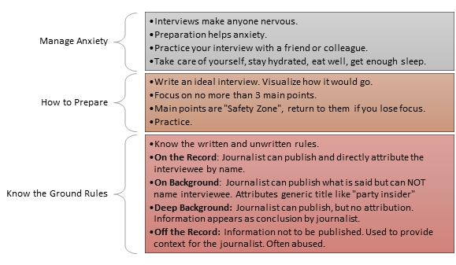

## **Section C. TV and Radio Interviews.**

Television interviews can be especially challenging. It is important to not let yourself get overwhelmed by the experience. The below diagram outlines how to deal with the interview process.

**Radio Interviews**

Most of the general rules for TV interviews apply to radio interviews as well, but the interviewee needs to account for the lack of visual image. This makes it even more important to speak clearly about the content of your ideas.

* Speak in a simple language.
* Limit Statistics.
* Limit technical terms.
* Be aware of audience dialects.
* Create word pictures.

To create a word picture, use visual comparisons. For example, you can say, 'about the size of a cricket field' 140 by 150 meters. Use words that are common to the audience you are addressing.

### Infographic 6: Dos and Don’ts of TV interviews.

## **Section D. Print Media**

There are many different print media outlets that are essential for political leaders. Become familiar with your local outlets, build relationships with reporters and editors. Push for the different outlets to help tell your story.

Below are the 4 main types of print media useful for political leaders.

Political leaders can also push for similar coverage in other written outlets like. Newsletters and Magazines.

### Quiz 8

1. Cultivating relationships with media outlets is important for pollical leaders because they
   1. Reach a broad and diverse audiences.
   2. Tell your story as a credible third-party source.
   3. Contrast you with opponents.
   4. Help promote political initiatives.
   5. **All the above**.
2. **True** or False: When doing a radio interview, the interviewee must use simple words and try and create a visual image for listeners.
3. True or **False:** When being interviewed on TV, you should always look directly into the camera.
4. When speaking with a journalist _________, they can publish what you say and use your name directly for attribution.
   1. **On the Record**
   2. Off the Record
   3. On deep Background
   4. In a Letter to the Editor
   5. None of the above.
5. **True** or False: Recording an interview can be helpful in assessing your performance and identifying how you can improve.
6. Newspapers will publish _______ pieces, that provide a more personal perspective of a political leader.
   1. News Stories
   2. **Feature Piece**
   3. Opinion Piece
   4. Letter to the Editor
   5. None of the above.

# **Chapter 9. Social Media**

## **Section A. Social Media Page**

A professional Facebook page is a useful tool for political leaders. It helps leaders tell their story in a unique way using both personal and professional content. This includes videos, blog posts, or pictures that highlight professional achievements and personal characteristics.

The following 6 tips are helpful to design an attractive Facebook page.

Leaders can design personal pages on other platforms like Twitter, Instagram, and personal webpages. When designing additional pages, it is important to keep all content consistent, telling the same story.

## **Section B. Don’ts of Social Media**

Social media can also be a negative influence. Posting incorrect, insensitive, or unappealing content and not only drive away followers, but also create a long-lasting stain on your brand and reputation. To make sure your social media is a positive force in your career, follow the “Do’s” and “Don’ts” listed below.

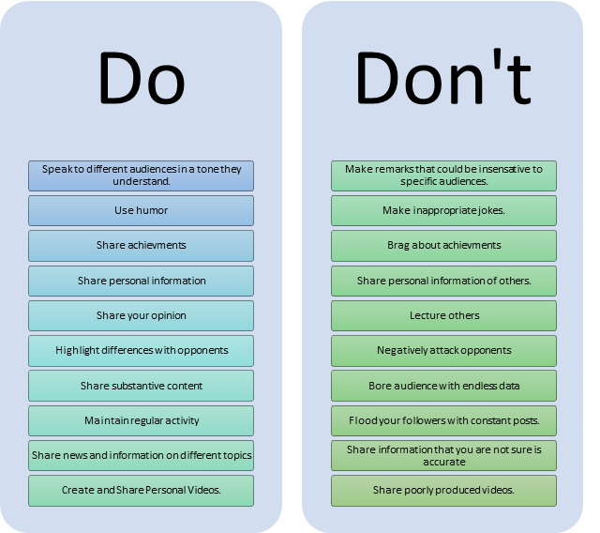

When using social media, always use common sense and good judgment. Remember that once content is created, it can never be completely deleted. Share content wisely.

### Infographic 7: Dos and Don’ts of Social Media

### Quiz 9

1. 6 useful tips to create a Facebook page include ________, Be Active, Tell a Story, Define your Audience, Sell Achievements, and Create Positive Interactions.
   1. Include long lists of facts and data.
   2. **Use Colors and Symbols**
   3. Share any information.
   4. Share personal information of others.
   5. None of the above.
2. **True** or False: It is ok to highlight differences with an opponent if you do not attack them personally.
3. **True** or False: Using videos is a great way to create engaging content that tells your story.

### Final Exam

1. The four traits of a ***political leader*** include ethics, __________, communication, and organizational skills.
   1. Vision
   2. Discipline
   3. **Critical Thinking Skills**
   4. A great voice
   5. None of the above.
2. The 5 traits of a ***democratic leader*** include vision, discipline, _______, conscience, and service.
   1. **Passion**
   2. Intelligence
   3. Great Public Speaker
   4. Organizational Skills
   5. None of the above.
3. **True** or False: Political Leaders need to use critical thinking skills to balance conflicting interests of a group and limited resources.
4. True or **False:** When you tell a reporter, a conversation is off the record, this means they can publish what you tell them.
5. **True** or False: During a speech, the audience will provide both verbal and nonverbal feedback that signals whether they understand the speaker.
6. **True** or False: Colors and symbols can be useful tools for a Facebook page.
7. Political leaders can publish a __________ in a newspaper to make an argument about an issue.
   1. News Stories
   2. Feature Piece
   3. **Opinion Piece**
   4. Letter to Editor
   5. None of the above.
8. **True** or False: Your safety zone in an interview, where you return to when you lose focus are your 3 main points that you want to communicate.
9. Connector, Mentor, Expert Advisor, Peer, and _______ are the 5 main functions of your political network.
   1. **Promoter**
   2. Community Leader
   3. Union Leader
   4. Media Member
   5. None of the above.
10. True or **False**: In a SWOT analysis, threats refer to bad habits and professional skills you lack.
11. Which of the following is ***NOT*** part your ***strategic communications road map***?
    1. Context
    2. Vision
    3. Strategy
    4. **Education**
    5. Message
    6. Tactics.
12. Which of the Following Statements is ***NOT*** a way for political parties to develop leaders?
    1. Provide gradual experience where political leaders can take on more experience one position at a time.
    2. Provide leadership skills training to young political activists.
    3. **Require young activists to become candidates**.
    4. Provide a support system to leader in different positions.