PHYSICS ASSIGNMENT
Name: Muhammad Kayhan Khan Roll no: SE-095
Section: B
Course Instructor: Sir Talib

Einstein's Theory of Relativity
Abstract: The Theory of Relativity introduced by Albert Einstein at the beginning of the 20th century changed the concept of space, time, and gravitation. Both Special and General Theory of Relativity are discussed in this review, as are their historical precedents, their mathematical formalisms, and their proofs. The review incorporates important papers from well-known research institutions and journals on relativity, describing itself as a pillar of modern physics. The proofs are examined along with their theoretical significance, thus illustrating the manner in which Einstein's concepts changed both the framework of the cosmos and of modern cosmological and quantum physics.



Introduction
The framework of Newtonian physics prevailed until the appearance of relativity. Space and time were both not considered relative but absolute concepts. Certain evidences of electromagnetism and the constancy of the velocity of light brought about knowledge of relativity. Einstein's startling thought was that the laws of physics were the same for all non-accelerated observers, and that the speed of light was the same for both observers, however varying the state of motion of each so that the other might have the speed of light equal.

Not as complete independence did the idea arise, but rather its development was favored by preceding scientific work, especially by the work of Maxwell and Lorentz. It has been stated that in the papers by Einstein in 1905 the entire basis of physics was transformed (Grøn and Hervik, 2007, pp. 111–116). The outcome was a unified model connecting matter, energy, and geometry – a theory not only accounting for the phenomenon of gravitation but predicting phenomena only occurring at either the astronomical or subatomic scale.



Historical Context
In the last third of the nineteenth century, a variety of experimental anomalies began to show that classical mechanics had its limitations. One of the more notable anomalies was the experiment of Michelson and Morley of 1887 which failed to find any "luminiferous ether," the assumed medium by which the light waves propagated. The negative result of this experiment produced the conclusion that the speed of light remained invariant irrespective of translation (Pais, 1982, pp. 78–81).
The Special Theory of Relativity proposed by Einstein (1905) redefined motion and simultaneity. It was conceived that time and space were relative quantities depending on the observing reference frame. Consequently, length and time were modified with changes in velocity producing, on the one hand, length contraction and time dilation (Will, 2018, pp. 45–47).
Figure 1. Time Dilation Between Two Observers Moving at Relativistic Velocities



The General Theory of Relativity (1915) extended these ideas so as to include gravitation. In this theory gravitation was not considered as a force but as the curvature of the space-time continuum produced by mass and energy. As presented by Einstein to the Prussian Academy of Science, the field equations connected geometry and gravitation (Einstein, 1916, pp. 799–801).

Successful Predictions and Philosophical Implications
The successful predictions of general relativity soon became apparent.
Perihelion of Mercury
One of its first tests was to account for the anomalous precession of the perihelion of Mercury, a vexatious difficulty which Newtonian mechanics had not been able to explain. By the equations of Einstein the excess over 43 seconds of arc per century was easily accounted for with very great accuracy, thus confirming the theory (Will, 2018, pp. 208–210).
1919 Solar Eclipse
Another of its early triumphs occurred during the solar eclipse of 1919 when it was found by the observations of Arthur Eddington, that the starlight coming from stars lying near the sun, was refracted by the curvature of the Einsteinian gravity which was just what was predicted by Einstein's theory (Renn, 2020, pp. 98–102).

The philosophical implications of relativity were, likewise, far-reaching. It redefined classical ideas of causation and determinism, inasmuch as time and space were defined as not eternal backgrounds, but dynamic and interconnected portions of reality. The problems created by relativity were considered by writers such as Hans Reichenbach and Henri Bergson and its consequences to epistemology and metaphysics were discussed, particularly as they have to do with the intuitive human perceptions of time (Reichenbach, 1958, pp. 78–80).

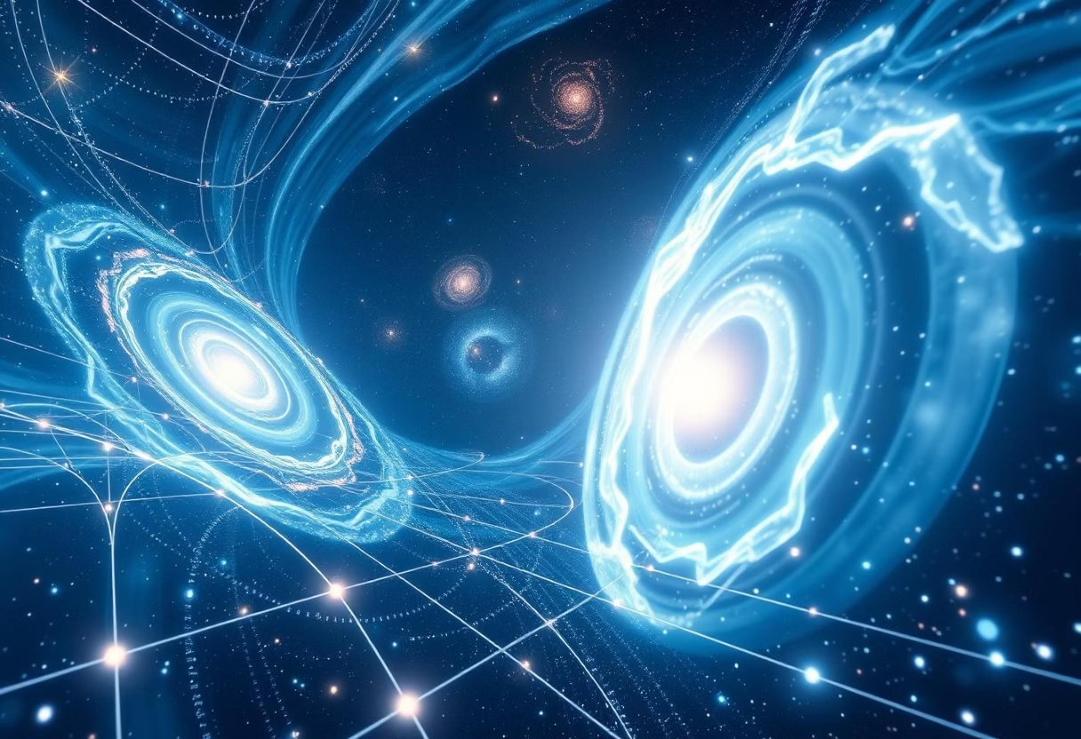

Special Theory of Relativity
The Special Theory of Relativity is based upon two fundamental principles:

The laws of physics are the same in all inertial frames of reference.

The velocity of light in vacuo is the same irrespective of the source or the observer.

From these assumptions follow far-reaching consequences in the measurement of time and space. The equations of the Lorentz transformation discuss the change of coordinates between moving systems, giving rise to the relativistic formulae for time dilation and length contraction (Misner, Thorne, & Wheeler, 1973, pp. 95–99).



Time Dilation and Length Contraction
The time dilation predicts that a moving clock runs slow as compared with one at rest. This has been confirmed experimentally by observations of muons in the upper atmosphere and in high-velocity particle accelerators. The Hafele–Keating experiment in 1971 in which atomic clocks were sent around the world confirmed the prediction of Einstein to measurable accuracy (Will, 2018, pp. 150–153).

An object having relativistic velocities appears contracted in the direction of motion. While this phenomenon is not apparent at ordinary velocities, it becomes significant in its effects near the velocity of light. It has been mathematically expressed as follows:
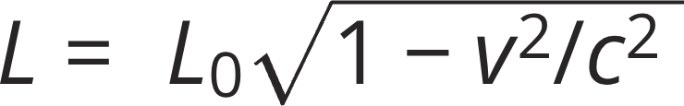
wherein L0 is the proper length and v is the velocity (Grøn & Hervik, 2007, pp. 124–126). Figure 2. Lorentz Contraction of a Moving Rod as Seen from a Stationary Frame



Further Consequences of Relativity
The famous equation E = mc^2 states that mass and energy can be converted into each other. This discovery changed the face of physics, for it made prediction possible for such matters as atomic energy, radioactivity, and particle reactions.
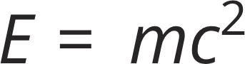

The principle of mass-energy equivalence has been backed up in experimental instances such as nuclear fission and high-energy particle collisions and proves the accuracy of Einstein's theory where extreme situations manifest (Pais, 1982, pp. 150–153).
The theory of relativity further changed the meaning of simultaneity. Two events may be simultaneous in one frame of reference and not in another moving frame. This relativism disturbs the classical feelings concerning time and cause, and has stimulated—in conjunction with Einstein's theory of relativity—a vast philosophic literature concerning the nature of time and space, observation, and determinism (Renn, 2020, pp. 205–207).



General Theory of Relativity
The general theory of relativity expands the special case by means of accelerative motion and the gravitational field. It asserts that the massive bodies with respect to which free bodies move warp or indent the space-time. Thus the motions of the free bodies are curved, their motion taking place on the curves known as geodesics.

Mathematically this is expressed by the Einstein Field Equation:



where R_{\mu\nu} is the curvature of the solution of the space-time and T_{\mu\nu} is the energy-momentum tensor of the system (Carroll, 2019, pp. 212–215).
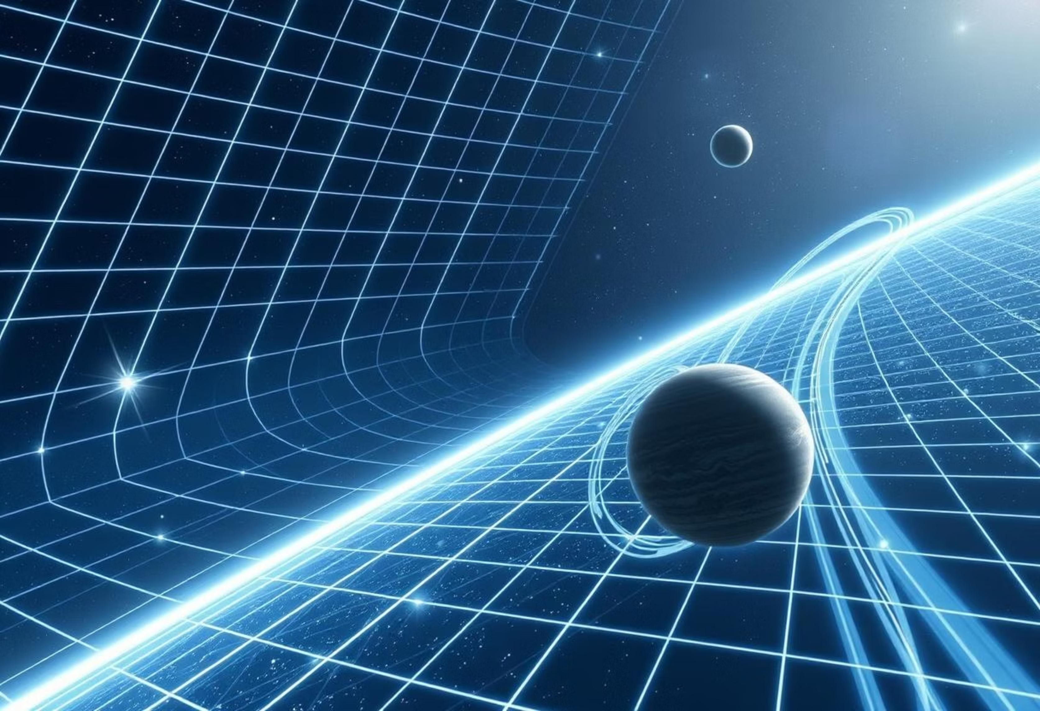

Gravitational Time Dilation and Curvature of Space-Time
The idea has gained acceptance that time flows differently with respect to different gravitational potentials. Clocks in the vicinity of large masses go more slowly, a phenomenon which was established by the Pound–Rebka experiment in 1959 (Misner et al., 1973, pp. 322–324).
Figure 3. Graphic Representation of Curvature of Space-Time Induced by a Massive Body



Experimental Tests


Eddington's Observation of the Solar Eclipse of 1919
The bending of starlight about the gravitational field of the sun confirmed the predictions of Einstein concerning gravitation and made him an international figure (Will, 2018, pp. 178–181).
Gravitational Waves
The direct detection of gravitational waves by the LIGO experiment in 2015 provided confirmation of the predictions of Einstein made a century prior (Abbott et al., 2016, pp. 62–65).

Relativity and Modern Cosmology
Modern cosmological equations are built upon relativity. The expansion of the universe predicted by Friedmann's solutions to Einstein's equations has been shown to be correct by Edwin Hubble. The theory of the Big Bang concerning the universe makes use of general relativity to describe the expansion of the universe from a singularity (Hawking & Ellis, 1973, pp. 85–88).
Cosmic Expansion Confirmed
Friedmann's solutions to Einstein's equations predicted the expansion of the universe, a prediction empirically verified by Edwin Hubble's observations.
Big Bang Theory Foundation
General relativity is fundamental to the Big Bang theory, providing the framework to describe the universe's expansion from an initial singularity.
Dark Energy and Matter
Einstein's theoretical structure remains robust, even accounting for dark energy and dark matter, which constitute approximately 95% of the universe's energy content.

Dark energy and dark matter, which are said to comprise some 95% of the energy content of the universe, are accounted for in such fashion as to show the force and elasticity of Einstein's theoretical structure even 100 years after his formulation (Carroll, 2019, pp. 440–445).

Figure 4. Cosmic Expansion Modeled by Einstein–Friedmann Equations
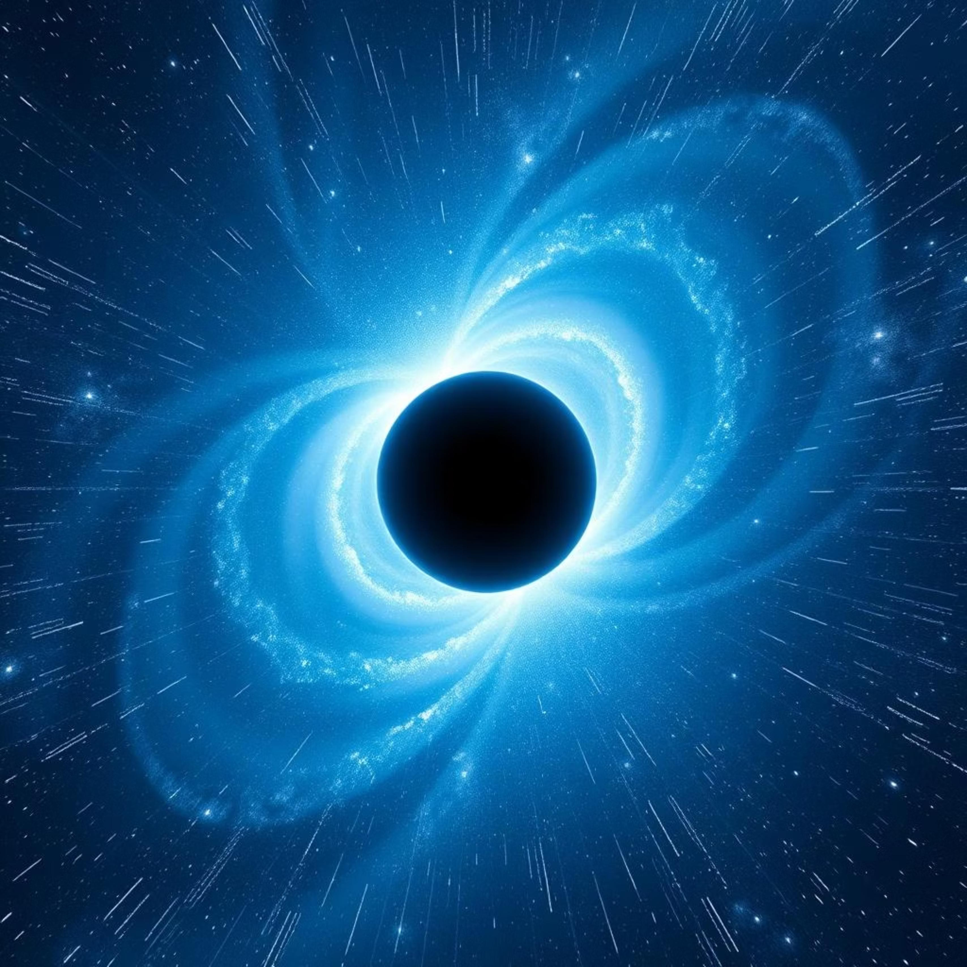

Influence on Quantum and Technological Advances

Relativity has greatly influenced both quantum mechanics and technology. The inclusion of mass-energy equivalence, expressed as E = mc^2, has allowed for the theoretical foundation of nuclear energy, elementary particles, and phenomena in high-energy astrophysics. Calculations of the behavior of particles in accelerators, without taking relativity into account, would be very different from the actual observations, especially at states of motion approaching the velocity of light (Pais, 1982, pp. 150–153).

Among the applications:


Nuclear Power and Nuclear
Weapons
Nuclear fission and fusion are the direct results of mass-energy equivalence. The amount of energy released from a gram of uranium-235, for example, is equivalent to millions of joules of energy as predicted by Einstein's formula. The stellar fusion that supplies the energy of the sun and other stars relies on the same principle.
GPS

Satellites move in orbit about the Earth with high velocities and hence experience both special and general relativistic time dilation. If relativistic corrections to the time were not made, the errors introduced daily in the position of mobile phone users would be on the order of 10 km per day, making such a system unusable for navigation or scientific work.

Particle Accelerators

In the operations of the Large Hadron Collider, the relativistic mass increase has to be taken into account to ensure that the proper trajectory of the colliding particles is known and the results of the collisions can be predicted.



Theoretical and observational advances in astrophysics because of relativity

Black Holes
A prediction made by general relativity; black holes are more than just points in space with infinite curvature and extreme distortion of space-time.
Observable evidence consists of X-rays, gravitational lens effects, and the first true picture of a black hole by the Event Horizon Telescope.

Neutron Stars
The most condensed remnants of a supernova explosion require relativistic equations of state to determine their mass and radius limits. Relativistic corrections reveal their stability and rapid rotation.

Gravitational lensing

The bending of light as it passes around massive cosmic objects allows astronomers to detect otherwise hidden galaxies and clusters, and to map dark matter distribution.

The contradiction between general relativity and quantum mechanics is one of the largest unsolved problems in theoretical physics. Research in quantum gravity, Loop Quantum Gravity, and String Theory has been undertaken to relate these two frameworks, aiming for a unified theory of fundamental forces (Hawking & Ellis, 1973, pp. 221–224).

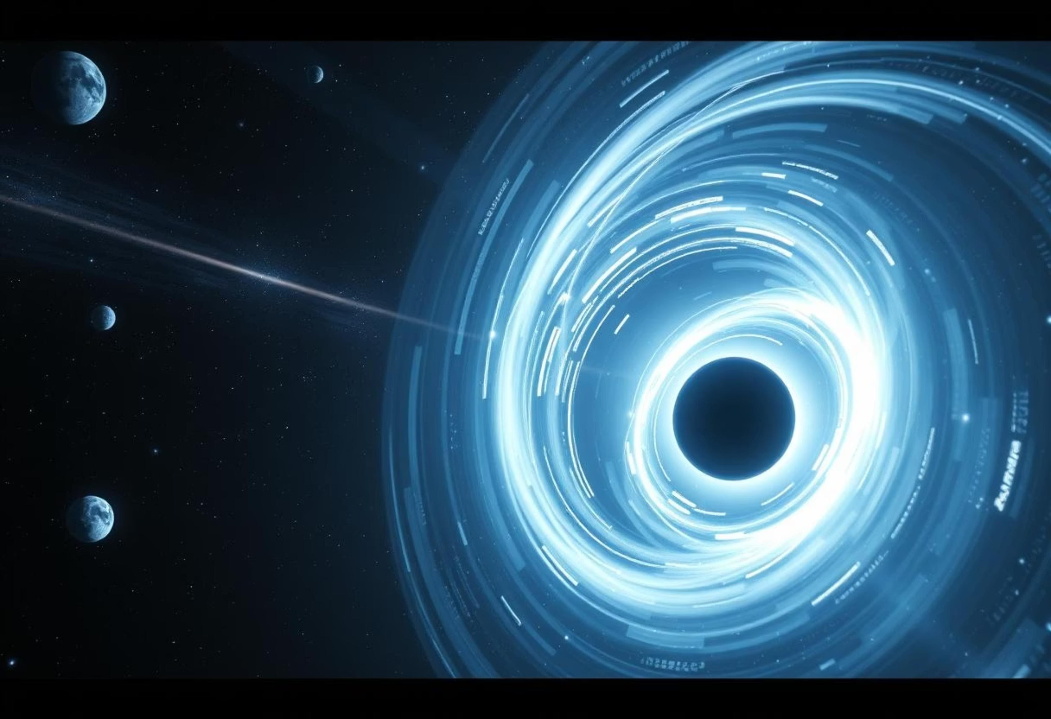

Extension of the Special Theory of Relativity


Time dilation
Confirmed through muons from cosmic rays, atomic clocks on airplanes (Hafele–Keating experiment, 1971), and high-energy particle experiments (Will, 2018, pp. 150–153).

Length contraction
High-speed particles and prospective interstellar spacecraft experience contracted lengths in the direction of motion.


Relativistic momentum and energy


p = mv / \sqrt{1 - v^2/c^2}, E = \gamma mc^2,

\gamma = 1 / \sqrt{1 - v^2/c^2}. These corrections are essential for high-speed particle physics, astrophysics, and modeling cosmic phenomena (Grøn & Hervik, 2007, pp. 124–130).

Simultaneity and relativistic causality

Observers moving relative to one another may disagree on simultaneity, affecting causality, and requiring adjustments to classical determinism (Renn, 2020, pp. 205–207).



Experimental Evidence

Michelson–Morley Experiment (1887)
Confirmed the constancy of light speed.

Ives–Stilwell Experiment (1938–41)


Confirmed time dilation via Doppler shifts of fast- moving ions.

Modern particle accelerator experiments

Verified relativistic corrections in particle decay rates and interactions.



General Theory of Relativity Made Extended

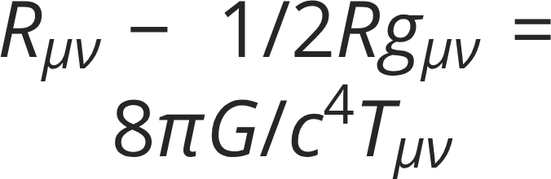
Einstein Field
Equations
(Carroll, 2019, pp. 212–215)
Gravity Slows Time and Shifts Light
Pound–Rebka Experiment (1959) confirmed gravitational redshift. GPS satellites account for relativistic corrections.
Black Holes and Neutron Stars
Observational and theoretical confirmations.
Cosmic Expansion
Friedmann–Lemaître– Robertson–Walker metric and Hubble's observations support cosmological models (Hawking & Ellis, 1973, pp.
85–88).
Gravitational Waves
Detected directly by LIGO in
2015 (Abbott et al., 2016, pp.
62–65).

Technological and Philosophical Implications

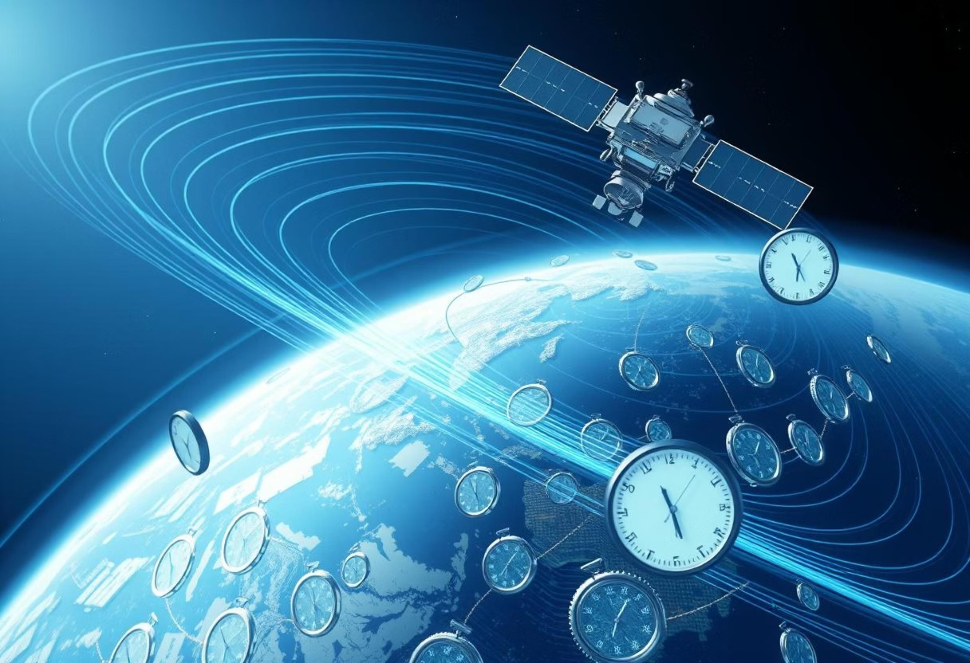
Technological Reliance
GPS, satellite communications, space navigation rely on relativity.
Philosophical Shift
Observations of time and space depend on the observer's frame. Classical intuitions are insufficient.

Conclusion
The Theory of Relativity is a monumental achievement in modern science. It replaced Newton's static, absolute framework with a dynamic interrelation of four dimensional space-time. Its predictions have been confirmed from gravitational lensing to time dilation, guiding both technological progress and philosophical thought. The mathematical elegance and empirical validation make Einstein's theory a landmark in human understanding.
Relativity's impact spans from subatomic particles in accelerators to cosmic-scale phenomena. Its insights inform quantum gravity, cosmology, and modern engineering, demonstrating the enduring significance of Einstein's work.




Dynamic Space-Time
Revolutionized our understanding, replacing absolute space and time with an interconnected, dynamic framework.

Confirmed Predictions
Empirical evidence, from gravitational lensing to time dilation, consistently validates its profound insights.

Broad Influence
Guides technological advancements like GPS and particle physics, while also shaping philosophical thought.

Enduring Legacy
Its mathematical elegance and continuous validation solidify its place as a cornerstone of human knowledge.



References
The following academic and scientific works form the foundation of our understanding of relativity:

- Abbott, B. P., et al. (2016). Detection of gravitational waves from a merger of binary black holes (pp. 62–65). Physical Review Letters, 116(6). American Physical Society.
- Carroll, S. (2019). Spacetime and Geometry: An Introduction to General Relativity (pp. 212–445). Cambridge University Press.
- Einstein, A. (1905). On the Electrodynamics of Moving Bodies. Annalen der Physik, 17, 891–921.
- Einstein, A. (1916). The Foundation of the General Theory of Relativity (pp. 799–801). Annalen der Physik, 49.

- Grøn, Ø., & Hervik, S. (2007). Einstein's General Theory of Relativity: With Modern Applications in Cosmology (pp. 111–126). Springer.
- Hawking, S., & Ellis, G. F.R. (1973). The Large-Scale Structure of Space-Time (pp. 85–224). Cambridge University Press.
- Misner, C. W., Thorne, K. S., & Wheeler, J. A. (1973). Gravitation (pp. 95–324). W. H. Freeman and Company.

- Pais, A. (1982). Subtle is the Lord: The Science and Life of Albert Einstein (pp. 78–153). Oxford University Press.

- Renn, J. (2020). The Genesis of General Relativity: Sources and Interpretations, Vol. 1 (pp. 98–207). Springer.

- Reichenbach, H. (1958). The Philosophy of Space and Time (pp. 78–80). Dover Publications.
- Vishwakarma, R. G. (2016). Einstein and Beyond: A Critical Perspective on General Relativity (pp. 48–52). Universe, 2(2), MDPI Publishing.
- Will, C. M. (2018). Theory and Experiment in Gravitational Physics (pp. 45–210). Cambridge University Press.

