S1 data
It includes:
- Six verified MLPerf Training v4.0 ResNet-50 configurations
- Thirty official benchmark runs
- Training-time statistics and deadline feasibility
- H100 power calibration from published measurements
- Average power, energy/run, annual energy, and heat calculations
- Dell and HPE server dimensions, weight, rack units, and power evidence
- Rack-space, rack-power, PDU, weight, and reserve checks
- Oracle cloud cost estimates
- K-Electric peak/off-peak electricity scenarios
- Clearly separated sourced facts, calculated results, and case-study assumptions
- Complete source ledger and warnings
- No detected spreadsheet formula errors
Important limitation: exact on-premises CAPEX, installation, maintenance, TCO, and ROI cannot be finalized without comparable dated vendor quotations. I did not invent these values. The workbook uses one reseller listing only as a clearly labelled sensitivity anchor.
S1 is ready for simulation and paper-result generation. One can calculate deadline feasibility, energy, heat, rack feasibility, cloud operating cost, and bounded electricity cost using the current dataset. The main supporting evidence comes from MLPerf Training results, IEEE Access/Lawrence Berkeley Lab power measurements, Dell XE9680 engineering guidance, HPE XD670 QuickSpecs, Oracle pricing, and K-Electric tariffs.

S1 asks:
For an AI-training workload, which evaluated H100 configuration meets the user’s training deadline, and is it preliminarily feasible?
Main findings:
- Fastest: OCI-64G - 2.483 minutes.
- For a 3–5 minute deadline: OCI-64G is the only feasible option.
- For an 8–10 minute deadline: HPE-16G is the smallest feasible option.
- For a 15–20 minute deadline: an 8-GPU configuration is sufficient.
- For 30 minutes or more: all evaluated configurations are feasible.
- Lowest supported energy estimate: DELL-8G - 1.923 kWh/run under the common calibration and PUE assumptions.
- Faster training did not necessarily mean lower energy per run.
- All six constraint tests and five arithmetic checks passed.
The energy result is a calibrated estimate, not direct Dell power measurement.
How S1 was performed
Official MLPerf raw logs
↓
Extract system configuration and five training runs
↓
Calculate representative training time
↓
Provide user deadline, rack limit and budget
↓
Python checks every evaluated configuration
↓
Return minimum-GPU feasible configuration
↓
Calculate preliminary power, energy, heat, rack and cost outputs
↓
Run validation and sensitivity tests
↓
Save results to JSON and workbook

results reproduced by Python
Configuration | GPUs | Training time | Facility-energy estimate/run | Cloud cost/run
Dell-4G | 4 | 26.882 min | Not calculated—exact power unavailable | Not applicable
Dell-8G | 8 | 13.163 min | 1.923 kWh | Not applicable
HPE-8G | 8 | 13.619 min | 1.989 kWh | Not applicable
HPE-16G | 16 | 7.930 min | 2.317 kWh | Not applicable
OCI-8G | 8 | 13.273 min | 1.939 kWh proxy | €16.46
OCI-64G | 64 | 2.483 min | 2.902 kWh proxy | €24.63

S1 & S2
- S1 asks: “Can training finish before the deadline?”
- S2 asks: “Can the system serve the required number of requests without exceeding the response-time limit?”
Together, S1 and S2 show that the framework changes its decision according to the workload.

S2’s main question
S2 should answer:
Which evaluated infrastructure configuration can provide the required Llama 2 70B inference throughput while satisfying latency, power, memory, rack and budget constraints?
S2 data
S2 uses official MLPerf Inference v5.0 results, official raw result logs, system JSON files, accuracy logs, the MLPerf Llama 2 70B benchmark definition, and HPE/NVIDIA specifications.

conclusion from S1 and S2
Together, the scenarios demonstrate that WISP-DC can support two different AI workload profiles using workload-specific performance metrics:
major finding is:
Infrastructure recommendations must be workload-specific. Training must be planned using completion-time requirements, whereas online inference must be planned using throughput, latency and accuracy requirements. A single generic GPU-sizing rule is insufficient for both workloads.

Aspect | S1: Training | S2: Inference
Workload | ResNet-50 training | Llama 2 70B inference
Primary requirement | Completion deadline | Output throughput
Additional performance condition | Required benchmark quality | Latency and accuracy
Primary resource | H100 GPU count | GH200/H100/H200 accelerator count
Recommendation | Minimum-GPU deadline-feasible configuration | Minimum-resource throughput-feasible configuration
Infeasible result | No configuration meets deadline/constraints | No configuration meets throughput/constraints
Evidence | MLPerf Training v4.0 | MLPerf Inference v5.0

Important limitations you must report
Your results are valid within clearly defined boundaries:
- The simulations replay published benchmark measurements; they do not retrain ResNet-50 or execute Llama 2 70B locally.
- Recommendations are limited to evaluated MLPerf configurations.
- The framework must not predict untested hardware performance through arbitrary linear extrapolation.
- S2 has no matched whole-system power measurements for the selected configurations, so operational energy is not claimed.
- Exact on-premise monetary optimization is unavailable without comparable dated quotations.
- S2 recommends the minimum-resource feasible alternative, not necessarily the cheapest purchasing option.
- The results may not generalize to different models, software stacks, precisions or benchmark versions.
These limitations do not invalidate the study. They define exactly what was tested.

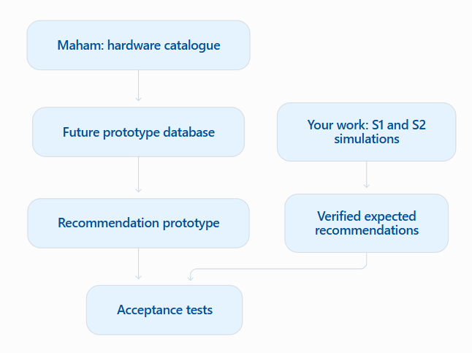

Dataset | Actual coverage | Use in the paper
AI servers | 32 systems | Yes, selectively
GPUs | 20 accelerators | Yes, selectively
CPUs | 12 processors | Mostly prototype database
Networking | 32 devices | Prototype/future implementation
Storage | 21 products | Prototype/future implementation
Racks | 12 products | Limited physical cross-checking
PDUs | 10 products | Limited rack-power cross-checking
UPS | 12 systems | Outside current evaluation
Cooling hardware | 12 products | Outside current detailed scope
Power distribution | 12 products | Outside current detailed scope

