

**INTRODUCTION TO DATABASE SYSTEMS LAB**

**Name: Rabail Fiaz**

**Reg. No: L1F22BSCS1096**

**Section: D-16**

**Project: Fuel Pump Management System**

**Date of Submission: 19-04-2024**

**Submitted To: Sir Afham Nazir**

***Phase-01***

**Description:**

The Fuel Pump Management System streamlines gas station operations by tracking pump details, sales transactions, and customer information. It ensures fuel availability and maintains equipment through maintenance records. Employees are associated with transactions and maintenance tasks, while suppliers provide fuel and maintenance services. Fuel types are categorized for efficient management, linking pumps, tank refills, and suppliers. This integrated system enhances operational efficiency, customer service, and inventory control, optimizing the overall management of the gas station.

**Entities:**

1. **Fuel pump**

|  |  |  |
| --- | --- | --- |
| Attributes | Datatype |  |
| Pump_ID | Int | Primary key |
| Location | Varchar |  |
| Capacity | Float |  |
| Fuel_type | Char |  |
| Status | char |  |

1. **Transaction**

|  |  |  |
| --- | --- | --- |
| Attributes | Datatype |  |
| Transaction_ID | Int | Primary key |
| Date time | Date |  |
| Fuel Amount | Float |  |
| Payment_method | Char |  |

1. **Customer**

|  |  |  |
| --- | --- | --- |
| Attributes | Datatype |  |
| Customer_ID | Int | Primary key |
| Name | char |  |
| Contact Number | int |  |
| Email | Varchar |  |
| Address | Varchar |  |

1. **Employee**

|  |  |  |
| --- | --- | --- |
| Attributes | Datatype |  |
| Employee_ID | Int | Primary key |
| Name | char |  |
| Contact Number | int |  |
| Email | Varchar |  |
| Position | Varchar |  |

1. **Fuel Tank**

|  |  |  |
| --- | --- | --- |
| Attributes | Datatype |  |
| Tank_ID | Int | Primary key |
| Location | char |  |
| Capacity | float |  |
| Fuel_type | Char |  |
| Current_level | Float |  |

1. **Payment**

|  |  |  |
| --- | --- | --- |
| Attributes | Datatype |  |
| Payment_ID | Int | Primary key |
| Amount | float |  |
| Payment method | char |  |
| Date_Time | DateTime |  |

1. **Fuel Type**

|  |  |  |
| --- | --- | --- |
| Attributes | Datatype |  |
| Fuel_Type_ID | Int | Primary key |
| Type_Name | char |  |

1. **Tank Refill**

|  |  |  |
| --- | --- | --- |
| Attributes | Datatype |  |
| Refill_ID | Int | Primary key |
| Date_Time | DateTime |  |
| Refill_Amount | Float |  |

1. **Maintenance Record**

|  |  |  |
| --- | --- | --- |
| Attributes | Datatype |  |
| Maintenance _ID | Int | Primary key |
| Date_Time | DateTime |  |
| Description | Varchar |  |
| Cost | Float |  |

1. **Supplier**

|  |  |  |
| --- | --- | --- |
| Attributes | Datatype |  |
| 1. Supplier _ID | Int | Primary key |
| Name | char |  |
| Contact Number | int |  |
| Email | Varchar |  |
| Address | Varchar |  |

**Relationships**

1. **Fuel Pump and Transactions:**

One-to-Many with Transaction: Each fuel pump can have multiple transactions.

1. **Fuel Pump and Maintenance Records:**

One-to-One with Maintenance Record: Each fuel pump can have multiple maintenance records.

1. **Transaction and Fuel Pump**:

Many-to-One with Fuel Pump: Many transactions can be associated with one fuel pump.

1. **Transaction and Customer**:

Many-to-One with Customer: Many transactions can be associated with one customer.

1. **Transaction and Payment**:

One-to-One with Payment: Each transaction has one payment associated with it.

1. **Transaction and Fuel Type:**

Many-to-One with Fuel Type: Each transaction involves a specific fuel type.

1. **Customer and Transaction**:

One-to-Many with Transaction: Each customer can have multiple transactions.

1. **Employee and Transaction**:

One-to-Many with Transaction: An employee can handle multiple transactions.

1. **Employee and Maintenance Record:**

One-to-Many with Maintenance Record: An employee can be associated with multiple maintenance records.

1. **Supplier and Tank Refill:**

One-to-Many with Tank Refill: A supplier can provide fuel for multiple tank refills.

1. **Supplier and Maintenance Record:**

One-to-Many with Maintenance Record: A supplier can be associated with multiple maintenance records (e.g., supplying parts or services).

1. **Supplier and Fuel Type**:

One-to-Many with Fuel Type: A supplier can provide multiple types of fuel.

1. **Fuel Tank and Tank Refill**:

One-to-Many with Tank Refill: Each fuel tank can have multiple tank refill records.

1. **Payment and Transaction**:

One-to-One with Transaction: Each payment is associated with one transaction.

1. **Fuel Type and Fuel Pump**:

One-to-Many with Fuel Pump: Multiple fuel pumps can dispense the same type of fuel.

1. **Fuel Type and Tank Refill:**

One-to-Many with Tank Refill: The same type of fuel can be used to refill multiple tanks.

1. **Tank Refill and Fuel Tank**:

Many-to-One with Fuel Tank: Many tank refills can be associated with one fuel tank.

1. **Maintenance Record and Fuel Pump**:

Many-to-One with Fuel Pump: Many maintenance records can be associated with one fuel pump.

******************************************************************************

***Phase-02***

**ERD:**

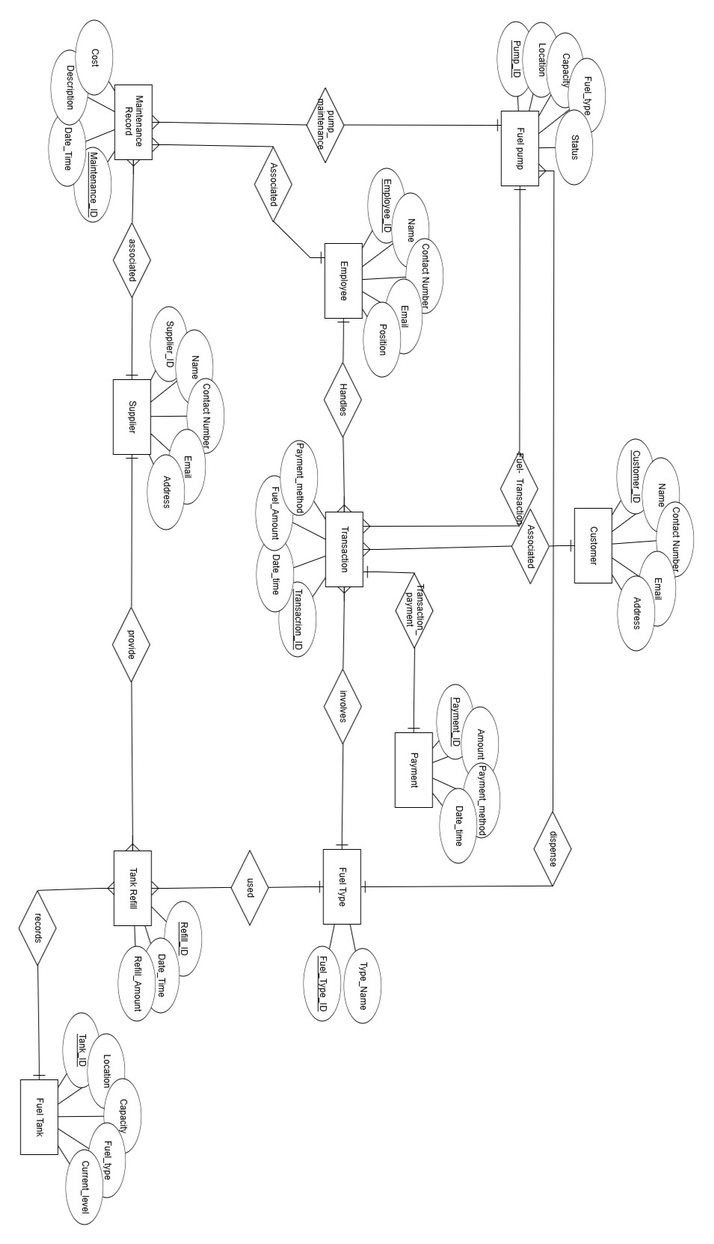

**RELATIONAL SCHEMA:**

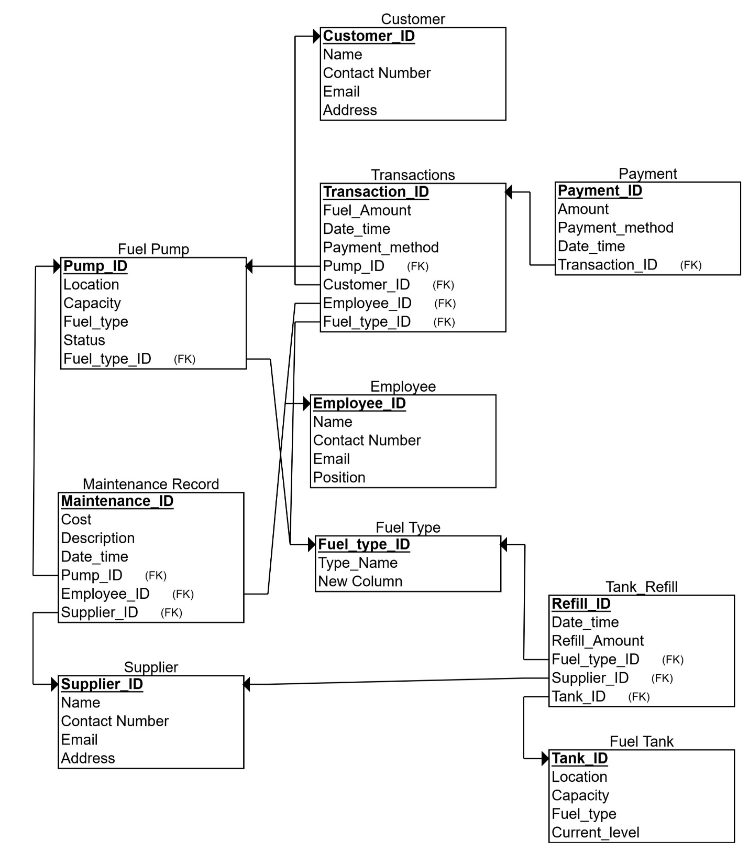

***Phase-03***

**“DDL”**

1. **Insertion:**

create database project;

use project;

create table Fuel_pump(

Pump_ID int(5),

Location varchar (20),

Capacity float(20),

Fuel_type char(10),

status char (20)

);

create table Transaction(

Transaction_ID int(5),

Date_time Date,

Fuel_Amount float(20),

Payment_method char(10)

);

create table customer(

Customer_ID int(5),

Name char(20),

Contact_Number int(50),

Email varchar(25),

Address varchar(20)

);

create table Employee(

Employee_ID int(5),

Name char(20),

Contact_Number int(50),

Email varchar(25),

Position varchar(10)

);

create table Fuel_Tank(

Tank_ID int(5),

Location char(20),

Capacity float(20),

Fuel_Type char(10),

Current_level float(20)

);

create table Payment(

Payment_ID int(5),

Amount float(20),

Payment_method char(10),

Date_time datetime

);

create table Fuel_type(

Fuel_type_ID int(5),

Type_name char(10)

);

create table Tank_Refill(

Refill_ID int(5),

Date_time datetime,

Refill_Amount float(10)

);

create table Maintenance_Record(

Maintenance_ID int(5),

Date_time datetime,

Description varchar(20),

Cost float(20)

);

create table Supplier(

Supplier_ID int(5),

Name char(10),

Contact_Number int(50),

Email varchar(25),

Address varchar(20)

);

insert into Fuel_pump (Pump_ID, Location, Capacity, Fuel_type, Status) values

(1, 'Location_1', 892.95, 'Diesel', 'Inactive'),

(2, 'Location_2', 695.61, 'Petrol', 'Inactive'),

(3, 'Location_3', 704.34, 'Petrol', 'Inactive'),

(4, 'Location_4', 701.52, 'Gas', 'Inactive'),

(5, 'Location_5', 828.62, 'Diesel', 'Active'),

(6, 'Location_6', 544.03, 'Gas', 'Active'),

(7, 'Location_7', 952.81, 'Gas', 'Active'),

(8, 'Location_8', 615.62, 'Petrol', 'Active'),

(9, 'Location_9', 584.34, 'Petrol', 'Inactive'),

(10, 'Location_10', 831.40, 'Diesel', 'Inactive');

select*from Fuel_pump;

insert into Transaction (Transaction_ID, Date_time, Fuel_Amount, Payment_method) values

(1, '2023-01-22', 86.40, 'Cash'),

(2, '2023-09-01', 96.64, 'Cash'),

(3, '2023-11-23', 82.48, 'Card'),

(4, '2023-10-09', 65.46, 'Cash'),

(5, '2023-05-10', 17.39, 'Card'),

(6, '2023-08-07', 82.46, 'Cash'),

(7, '2023-07-01', 41.96, 'Cash'),

(8, '2023-10-25', 31.30, 'Card'),

(9, '2023-08-08', 45.02, 'Cash'),

(10, '2023-10-02', 61.36, 'Card');

select*from Transaction;

insert into Customer (Customer_ID, Name, Contact_Number, Email, Address) values

(1, 'Customer_1', 619993791, 'email1@example.com', 'Address_1'),

(2, 'Customer_2', 356731234, 'email2@example.com', 'Address_2'),

(3, 'Customer_3', 578755580, 'email3@example.com', 'Address_3'),

(4, 'Customer_4', 626374693, 'email4@example.com', 'Address_4'),

(5, 'Customer_5', 722520902, 'email5@example.com', 'Address_5'),

(6, 'Customer_6', 343480754, 'email6@example.com', 'Address_6'),

(7, 'Customer_7', 833398957, 'email7@example.com', 'Address_7'),

(8, 'Customer_8', 430518438, 'email8@example.com', 'Address_8'),

(9, 'Customer_9', 732227830, 'email9@example.com', 'Address_9'),

(10, 'Customer_10',436676712, 'email10@example.com', 'Address_10');

select*from customer;

insert into Employee (Employee_ID, Name, Contact_Number, Email, Position) values

(1, 'Employee_1', 270863327, 'email1@company.com', 'Clerk'),

(2, 'Employee_2', 133568672, 'email2@company.com', 'Manager'),

(3, 'Employee_3', 191005173, 'email3@company.com', 'Clerk'),

(4, 'Employee_4', 151017849, 'email4@company.com', 'Attendant'),

(5, 'Employee_5', 254715837, 'email5@company.com', 'Clerk'),

(6, 'Employee_6', 130657187, 'email6@company.com', 'Attendant'),

(7, 'Employee_7', 030846552, 'email7@company.com', 'Manager'),

(8, 'Employee_8',857032973, 'email8@company.com', 'Manager'),

(9, 'Employee_9', 856267391, 'email9@company.com', 'Clerk'),

(10, 'Employee_10', 933766050, 'email10@company.com', 'Manager');

select*from Employee;

insert into Fuel_Tank (Tank_ID, Location, Capacity, Fuel_Type, Current_level) values

(1, 'Location_1', 4851.44, 'Petrol', 2110.15),

(2, 'Location_2', 4033.89, 'Gas', 1053.55),

(3, 'Location_3', 2924.48, 'Diesel', 456.83),

(4, 'Location_4', 1190.37, 'Diesel', 509.62),

(5, 'Location_5', 3762.69, 'Gas', 1859.54),

(6, 'Location_6', 4126.03, 'Petrol', 1933.62),

(7, 'Location_7', 2455.72, 'Petrol', 2425.74),

(8, 'Location_8', 2843.82, 'Diesel', 1964.91),

(9, 'Location_9', 2781.35, 'Gas', 1488.78),

(10, 'Location_10', 2673.50, 'Petrol', 493.72);

select*from Fuel_Tank;

insert into Payment (Payment_ID, Amount, Payment_method, Date_time) values

(1, 203.72, 'Cash', '2023-04-19 08:17:25'),

(2, 255.48, 'Card', '2023-06-08 14:43:15'),

(3, 73.98, 'Cash', '2023-10-28 05:01:11'),

(4, 276.20, 'Cash', '2023-02-13 10:30:47'),

(5, 475.72, 'Card', '2023-01-27 03:04:48'),

(6, 109.80, 'Card', '2023-11-03 11:32:01'),

(7, 438.24, 'Card', '2023-03-18 02:09:54'),

(8, 64.86, 'Cash', '2023-07-13 00:06:52'),

(9, 390.33, 'Cash', '2023-04-11 23:19:07'),

(10, 199.71, 'Card', '2023-09-16 00:51:57');

select*from Payment;

insert into Fuel_type (Fuel_type_ID, Type_name) values

(1, 'Gas'),

(2, 'Petrol'),

(3, 'Petrol'),

(4, 'Petrol'),

(5, 'Diesel'),

(6, 'Gas'),

(7, 'Gas'),

(8, 'Diesel'),

(9, 'Diesel'),

(10, 'Gas');

select*from Fuel_type;

insert into Tank_Refill (Refill_ID, Date_time, Refill_Amount) values

(1, '2023-11-25 19:00:37', 117.12),

(2, '2023-04-04 12:49:12', 567.15),

(3, '2023-08-12 10:21:25', 527.34),

(4, '2023-01-31 03:57:15', 406.93),

(5, '2023-08-23 01:37:21', 433.05),

(6, '2023-04-15 10:46:04', 468.33),

(7, '2023-01-14 22:28:51', 798.16),

(8, '2023-07-25 13:23:40', 112.49),

(9, '2023-06-04 17:25:58', 766.26),

(10, '2023-03-09 16:08:47', 637.31);

select*from Tank_Refill;

insert into Maintenance_Record (Maintenance_ID, Date_time, Description, Cost) values

(1, '2023-09-01 19:00:02', 'Description_1', 909.85),

(2, '2023-11-22 04:33:49', 'Description_2', 310.92),

(3, '2023-07-19 02:45:46', 'Description_3', 495.51),

(4, '2023-05-18 07:44:41', 'Description_4', 678.57),

(5, '2023-04-27 21:28:46', 'Description_5', 586.72),

(6, '2023-09-14 11:32:51', 'Description_6', 864.85),

(7, '2023-12-19 15:29:04', 'Description_7', 498.55),

(8, '2023-06-19 13:28:17', 'Description_8', 273.12),

(9, '2023-11-30 06:06:25', 'Description_9', 364.54),

(10, '2023-04-18 15:47:51', 'Description_10', 831.34);

select*from Maintenance_Record;

insert into Supplier (Supplier_ID, Name, Contact_Number, Email, Address) values

(1, 'Supplier_1', 518149973, 'supplier1@mail.com', 'Address_1'),

(2, 'Supplier_2', 745876443, 'supplier2@mail.com', 'Address_2'),

(3, 'Supplier_3', 209385859, 'supplier3@mail.com', 'Address_3'),

(4, 'Supplier_4', 755352322, 'supplier4@mail.com', 'Address_4'),

(5, 'Supplier_5', 839647875, 'supplier5@mail.com', 'Address_5'),

(6, 'Supplier_6', 608036272, 'supplier6@mail.com', 'Address_6'),

(7, 'Supplier_7', 890998849, 'supplier7@mail.com', 'Address_7'),

(8, 'Supplier_8', 421819594, 'supplier8@mail.com', 'Address_8'),

(9, 'Supplier_9', 958091141, 'supplier9@mail.com', 'Address_9'),

(10, 'Suppler_10', 66812936, 'supplier10@mail.com', 'Address_10');

select*from Supplier;

1. **Primary keys:**

alter table Fuel_pump

add primary key (Pump_ID);

alter table Transaction

add primary key (Transaction_ID);

alter table customer

add primary key (customer_ID);

alter table Employee

add primary key (Employee_ID);

alter table Fuel_Tank

add primary key (Tank_ID);

alter table Payment

add primary key (Payment_ID);

alter table Fuel_type

add primary key (Fuel_type_ID);

alter table Tank_Refill

add primary key (Refill_ID);

alter table Maintenance_Record

add primary key (Maintenance_ID);

alter table Supplier

add primary key (Supplier_ID);

1. **Foriegn keys:**

-- Transaction and Fuel Pump: Many-to-One with Fuel Pump

alter table Transaction

add foreign key (Pump_ID) references Fuel_pump(Pump_ID);

-- Transaction and Customer: Many-to-One with Customer

alter table Transaction

add foreign key (Customer_ID) references Customer(Customer_ID);

-- Transaction and Payment: One-to-One with Payment

alter table Payment

add foreign key (Transaction_ID) references Transaction(Transaction_ID);

-- Transaction and Fuel Type: Many-to-One with Fuel Type

alter table Transaction

add foreign key (Fuel_Type_ID) references Fuel_type(Fuel_type_ID);

-- Employee and Transaction: One-to-Many with Transaction

ALTER TABLE Transaction

ADD Employee_ID INT(5),

ADD FOREIGN KEY (Employee_ID) REFERENCES Employee(Employee_ID);

-- Employee and Maintenance Record: One-to-Many with Maintenance Record

alter table Maintenance_Record

ADD M_Employee_ID INT(5),

add foreign key (M_Employee_ID) references Employee(Employee_ID);

-- Supplier and Tank Refill: One-to-Many with Tank Refill

alter table Tank_Refill

add foreign key (Supplier_ID) references Supplier(Supplier_ID);

-- Supplier and Maintenance Record: One-to-Many with Maintenance Record

ALTER TABLE Maintenance_Record

ADD M_Supplier_ID INT(5),

ADD FOREIGN KEY (M_Supplier_ID) REFERENCES Supplier(Supplier_ID);

-- Supplier and Fuel Type: One-to-Many with Fuel Type

alter table Fuel_type

ADD Supplier_ID INT(5),

add foreign key (Supplier_ID) references Supplier(Supplier_ID);

-- Fuel Tank and Tank Refill: One-to-Many with Tank Refill

alter table Tank_Refill

add foreign key (Tank_ID) references Fuel_Tank(Tank_ID);

-- Fuel Type and Fuel Pump: One-to-Many with Fuel Pump

alter table Fuel_pump

ADD Fuel_type_ID INT(5),

add foreign key (Fuel_type_ID) references Fuel_type(Fuel_type_ID);

-- Fuel Type and Tank Refill: One-to-Many with Tank Refill

alter table Tank_Refill

ADD Fuel_type_ID INT(5),

add foreign key (Fuel_type_ID) references Fuel_type(Fuel_type_ID);

-- Maintenance Record and Fuel Pump: Many-to-One with Fuel Pump

alter table Maintenance_Record

add foreign key (Pump_ID) references Fuel_pump(Pump_ID);

1. **Updation:**

update Transaction

set Fuel_Amount = 150.00

where Transaction_ID = 1;

select* from Transaction;

update Maintenance_Record

set Cost = 510.5

where Maintenance_ID = 4;

select* from Maintenance_Record;

update Employee

set Position = 'HR'

where Employee_ID = 2;

select* from Employee;

1. **Changing datatypes:**

-- Change Supplier_ID from INT(5) to INT(10)

alter table Fuel_type

modify Supplier_ID int(10);

-- Change Contact_Number from BIGINT(15) to VARCHAR(20)

alter table Supplier

modify Contact_Number varchar(20);

-- Change Capacity from FLOAT(20) to DECIMAL(10,2)

alter table Fuel_pump

modify Status varchar(50);

-- Change Current_level from FLOAT(20) to DECIMAL(8,2)

alter table Fuel_Tank

modify Location varchar(50);

-- Change Amount from FLOAT(20) to DECIMAL(10,2)

alter table Payment

modify Payment_method varchar(50);

-- Change Refill_Amount from FLOAT(10) to DECIMAL(8,2)

alter table Tank_Refill

modify Refill_Amount int(50);

-- Change Cost from FLOAT(20) to DECIMAL(10,2)

alter table Maintenance_Record

modify Description char(50);

**output:**

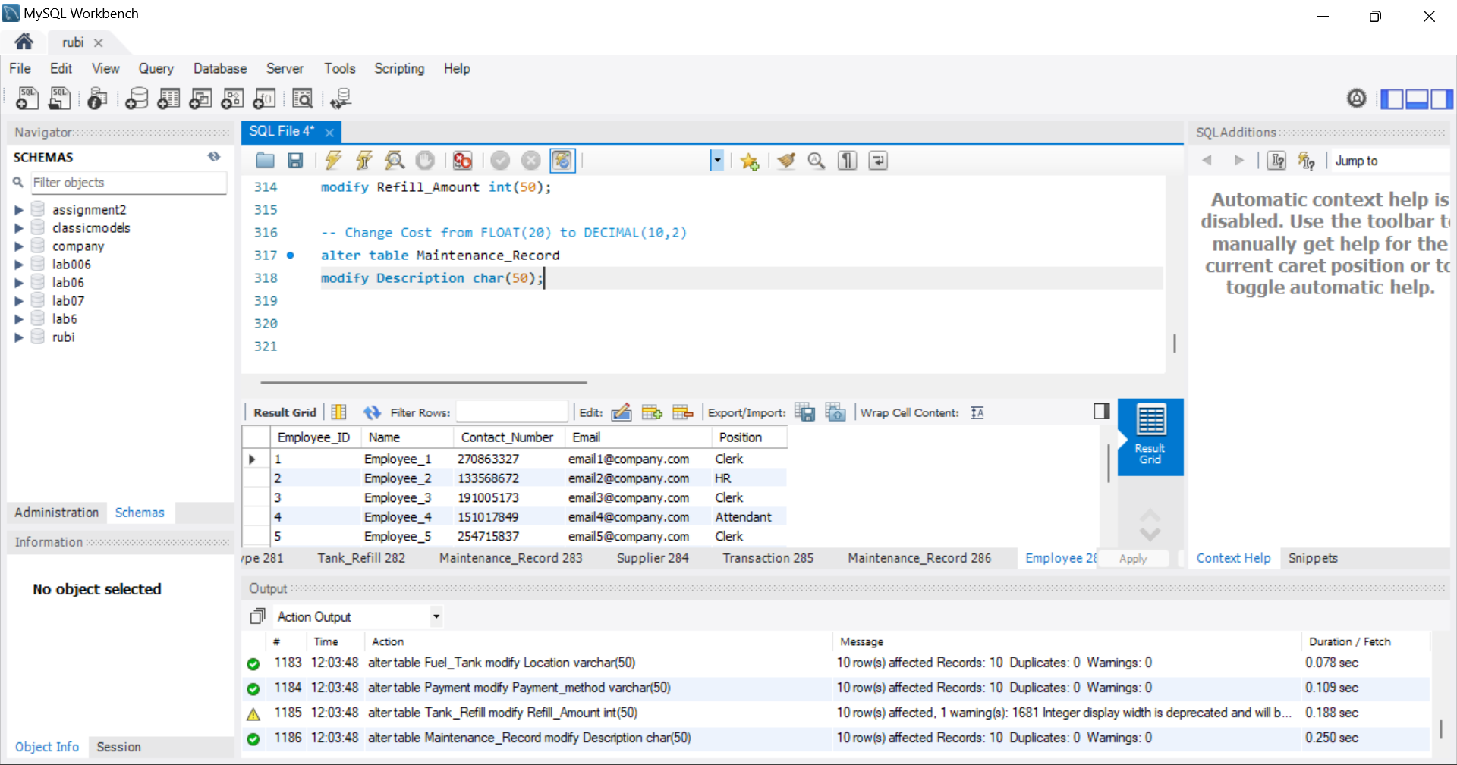

1. **Rename table:**

alter table Fuel_Tank rename to FuelTank;

alter table Transaction rename to TransactionRecord;

alter table Payment rename to PaymentInfo;

alter table Tank_Refill rename to TankRefill;

alter table Maintenance_Record rename to MaintenanceRecord;

alter table Employee rename to EmployeeInfo;

alter table Customer rename to CustomerInfo;

alter table Fuel_pump rename to FuelPump;

alter table Supplier rename to SupplierInfo;

alter table Fuel_type rename to FuelType;

**output:**

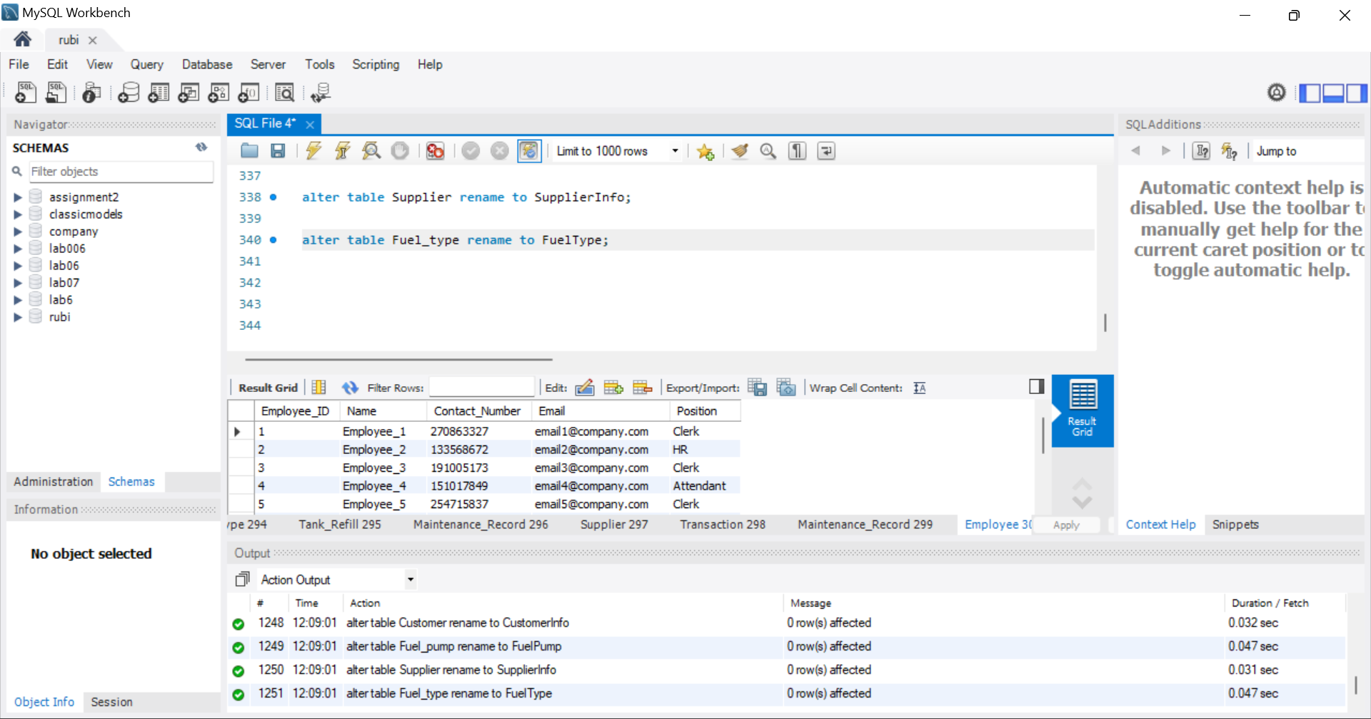

1. **Drop columns:**

alter table FuelType

drop column Supplier_ID;

alter table SupplierInfo

drop column Contact_Number;

alter table FuelPump

drop column Status;

alter table CustomerInfo

drop column Email;

alter table EmployeeInfo

drop column Contact_Number;

alter table FuelTank

drop column Current_level;

alter table TransactionRecord

drop column Fuel_Amount,

drop column M_Employee_ID;

alter table PaymentInfo

drop column Payment_method;

alter table TankRefill

drop column Date_time;

alter table MaintenanceRecord

drop column Supplier_ID;

**“DML”**

-- 1. Select FuelType with a specific ID:

SELECT * FROM FuelType WHERE Fuel_type_ID = 1;

-- 2. Select SupplierInfo where the name is not 'Supplier_5':

SELECT * FROM SupplierInfo WHERE Name <> 'Supplier_5';

-- 3. Select FuelPump with a capacity greater than 800:

SELECT * FROM FuelPump WHERE Capacity > 800;

-- 4. Select CustomerInfo where the Contact_Number is less than 500000000:

SELECT * FROM CustomerInfo WHERE Contact_Number < 500000000;

-- 5. Select EmployeeInfo where the position is 'Manager':

SELECT * FROM EmployeeInfo WHERE Position = 'Manager';

-- 6. Select FuelTank where the capacity is between 3000 and 5000:

SELECT * FROM FuelTank WHERE Capacity BETWEEN 3000 AND 5000;

-- 7. Select TransactionRecord where the payment method is 'Card':

SELECT * FROM TransactionRecord WHERE Payment_method = 'Card';

-- 8. Select PaymentInfo where the amount is greater than or equal to 200:

SELECT * FROM PaymentInfo WHERE Amount >= 200;

-- 9. Select TankRefill where the Refill_Amount is less than or equal to 500:

SELECT * FROM TankRefill WHERE Refill_Amount <= 500;

-- 10. Select MaintenanceRecord where the cost is not equal to 600:

SELECT * FROM MaintenanceRecord WHERE Cost <> 600;

-- 11. Select FuelType where the Type_name starts with 'P':

SELECT * FROM FuelType WHERE Type_name LIKE 'P%';

-- 12. Select SupplierInfo where the address contains 'Address':

SELECT * FROM SupplierInfo WHERE Address LIKE '%Address%';

-- 13. Select FuelPump where the location ends with '3':

SELECT * FROM FuelPump WHERE Location LIKE '%3';

-- 14. Select CustomerInfo where the name includes 'Customer':

SELECT * FROM CustomerInfo WHERE Name LIKE '%Customer%';

-- 15. Select EmployeeInfo where the email ends with 'company.com':

SELECT * FROM EmployeeInfo WHERE Email LIKE '%@company.com';

-- 16. Select FuelTank where the location starts with 'Location_1':

SELECT * FROM FuelTank WHERE Location LIKE 'Location_1%';

-- 17. Select TransactionRecord where the date is in the year 2023:

SELECT * FROM TransactionRecord WHERE YEAR(Date_time) = 2023;

-- 18. Select PaymentInfo where the datetime is after '2023-06-01 00:00:00':

SELECT * FROM PaymentInfo WHERE Date_time > '2023-06-01 00:00:00';

-- 19. Select TankRefill where the Refill_Amount is between 400 and 800:

SELECT * FROM TankRefill WHERE Refill_Amount BETWEEN 400 AND 800;

-- 20. Select MaintenanceRecord where the description includes 'Description':

SELECT * FROM MaintenanceRecord WHERE Description LIKE '%Description%';

******************************************************************************

***Phase-04***

**“Joins”**

1. **Inner join:**

SELECT Transaction.Transaction_ID,Customer.Name AS Customer_Name, Employee.Name AS Employee_Name, Transaction.Fuel_Amount

FROM Transaction

INNER JOIN Customer ON Transaction.Customer_ID = Customer.Customer_ID

INNER JOIN Employee ON Transaction.Employee_ID = Employee.Employee_ID;

SELECT Tank_Refill.Refill_ID,Supplier.Name AS Supplier_Name, Fuel_Tank.Location AS Tank_Location, Tank_Refill.Refill_Amount

FROM Tank_Refill

INNER JOIN Supplier ON Tank_Refill.Supplier_ID = Supplier.Supplier_ID

INNER JOIN Fuel_Tank ON Tank_Refill.Tank_ID = Fuel_Tank.Tank_ID;

SELECT Payment.Payment_ID,Payment.Amount,Transaction.Fuel_Amount,Customer.Name AS Customer_Name

FROM Payment

INNER JOIN Transaction ON Payment.Transaction_ID = Transaction.Transaction_ID

INNER JOIN Customer ON Transaction.Customer_ID = Customer.Customer_ID;

SELECT Maintenance_Record.Maintenance_ID,Employee.Name AS Employee_Name, Fuel_pump.Location AS Pump_Location,Maintenance_Record.Description

FROM Maintenance_Record

INNER JOIN Employee ON Maintenance_Record.M_Employee_ID = Employee.Employee_ID

INNER JOIN Fuel_pump ON Maintenance_Record.Pump_ID = Fuel_pump.Pump_ID;

SELECT Fuel_type.Type_name,Supplier.Name AS Supplier_Name

FROM Fuel_type

INNER JOIN Supplier ON Fuel_type.Supplier_ID = Supplier.Supplier_ID;

1. **left outer join:**

SELECT Customer.Name AS Customer_Name,Transaction.Transaction_ID,Transaction.Fuel_Amount

FROM Customer

LEFT JOIN Transaction ON Customer.Customer_ID = Transaction.Customer_ID;

SELECT Fuel_pump.Location AS Pump_Location,Maintenance_Record.Maintenance_ID,Maintenance_Record.Description

FROM Fuel_pump

LEFT JOIN Maintenance_Record ON Fuel_pump.Pump_ID = Maintenance_Record.Pump_ID;

SELECT Supplier.Name AS Supplier_Name,Tank_Refill.Refill_ID,Tank_Refill.Refill_Amount

FROM Supplier

LEFT JOIN Tank_Refill ON Supplier.Supplier_ID = Tank_Refill.Supplier_ID;

SELECT Employee.Name AS Employee_Name,Transaction.Transaction_ID,Transaction.Fuel_Amount

FROM Employee

LEFT JOIN Transaction ON Employee.Employee_ID = Transaction.Employee_ID;

SELECT Fuel_Tank.Location AS Tank_Location,Tank_Refill.Refill_ID,Tank_Refill.Refill_Amount

FROM Fuel_Tank

LEFT JOIN Tank_Refill ON Fuel_Tank.Tank_ID = Tank_Refill.Tank_ID;

1. **right outer join:**

SELECT Transaction.Transaction_ID,Transaction.Fuel_Amount,Customer.Name AS Customer_Name

FROM Transaction

RIGHT JOIN Customer ON Transaction.Customer_ID = Customer.Customer_ID;

SELECT Fuel_pump.Location AS Pump_Location,Maintenance_Record.Maintenance_ID,Maintenance_Record.Description

FROM Maintenance_Record

RIGHT JOIN Fuel_pump ON Maintenance_Record.Pump_ID = Fuel_pump.Pump_ID;

SELECT Tank_Refill.Refill_ID,Tank_Refill.Refill_Amount,Supplier.Name AS Supplier_Name

FROM Tank_Refill

RIGHT JOIN Supplier ON Tank_Refill.Supplier_ID = Supplier.Supplier_ID;

SELECT Maintenance_Record.Maintenance_ID,Maintenance_Record.Description,Employee.Name AS Employee_Name

FROM Maintenance_Record

RIGHT JOIN Employee ON Maintenance_Record.M_Employee_ID = Employee.Employee_ID;

SELECT Transaction.Transaction_ID, Transaction.Fuel_Amount,Fuel_pump.Location AS Pump_Location

FROM Transaction

RIGHT JOIN Fuel_pump ON Transaction.Pump_ID = Fuel_pump.Pump_ID;

1. **natural join:**

SELECT Supplier.Name AS Supplier_Name,Tank_Refill.Refill_ID,Tank_Refill.Refill_Amount

FROM Supplier

NATURAL JOIN Tank_Refill;

SELECT Maintenance_Record.Maintenance_ID,Maintenance_Record.Description,Supplier.Name AS Supplier_Name

FROM Maintenance_Record

NATURAL JOIN Supplier;

SELECT Employee.Name AS Employee_Name, Transaction.Transaction_ID,Transaction.Fuel_Amount

FROM Employee

NATURAL JOIN Transaction;

SELECT Transaction.Transaction_ID,Customer.Name AS Customer_Name, Transaction.Fuel_Amount

FROM Transaction

NATURAL JOIN Customer;

SELECT Fuel_type.Type_name,Supplier.Name AS Supplier_Name

FROM Fuel_type

NATURAL JOIN Supplier;

1. **Self join:**

SELECT C1.Customer_ID AS Customer1_ID,C1.Name AS Customer1_Name,C2.Customer_ID AS Customer2_ID,C2.Name AS Customer2_Name,C1.Address

FROM Customer C1

JOIN Customer C2 ON C1.Address = C2.Address AND C1.Customer_ID < C2.Customer_ID;

SELECT E1.Employee_ID AS Employee1_ID,E1.Name AS Employee1_Name,E2.Employee_ID AS Employee2_ID,E2.Name AS Employee2_Name,E1.Contact_Number

FROM Employee E1

JOIN Employee E2 ON E1.Contact_Number = E2.Contact_Number AND E1.Employee_ID < E2.Employee_ID;

SELECT T1.Transaction_ID AS Transaction1_ID,T2.Transaction_ID AS Transaction2_ID,T1.Date_time

FROM Transaction T1

JOIN Transaction T2 ON T1.Date_time = T2.Date_time AND T1.Transaction_ID < T2.Transaction_ID;

SELECT FT1.Tank_ID AS Tank1_ID,FT2.Tank_ID AS Tank2_ID,FT1.Capacity

FROM Fuel_Tank FT1

JOIN Fuel_Tank FT2 ON FT1.Capacity = FT2.Capacity AND FT1.Tank_ID < FT2.Tank_ID;

SELECT FP1.Pump_ID AS Pump1_ID,FP2.Pump_ID AS Pump2_ID,FP1.Location

FROM Fuel_pump FP1

JOIN Fuel_pump FP2 ON FP1.Location = FP2.Location AND FP1.Pump_ID < FP2.Pump_ID;

* **Nested Queries:**

1. Select FuelType with a specific ID:

SELECT * FROM Fuel_type WHERE Fuel_type_ID = (SELECT Fuel_type_ID FROM Fuel_type WHERE Fuel_type_ID = 1);

1. Select SupplierInfo where the name is not 'Supplier_5':

SELECT * FROM Supplier WHERE Name IN (SELECT Name FROM Supplier WHERE Name <> 'Supplier_5');

1. Select FuelPump with a capacity greater than 800:

SELECT * FROM Fuel_pump WHERE Capacity > (SELECT MIN(Capacity) FROM Fuel_pump WHERE Capacity > 800);

1. Select CustomerInfo where the Contact_Number is less than 500000000:

SELECT * FROM Customer WHERE Contact_Number < (SELECT MAX(Contact_Number) FROM Customer WHERE Contact_Number < 500000000);

1. Select EmployeeInfo where the position is 'Manager':

SELECT * FROM Employee WHERE Position IN (SELECT Position FROM Employee WHERE Position = 'Manager');

1. Select FuelTank where the capacity is between 3000 and 5000:

SELECT * FROM Fuel_Tank WHERE Capacity BETWEEN (SELECT MIN(Capacity) FROM Fuel_Tank WHERE Capacity BETWEEN 3000 AND 5000) AND (SELECT MAX(Capacity) FROM Fuel_Tank WHERE Capacity BETWEEN 3000 AND 5000);

1. Select TransactionRecord where the transaction has a corresponding payment in PaymentInfo:

SELECT * FROM Transaction t1 WHERE EXISTS (SELECT * FROM Payment p1 WHERE p1.Transaction_ID = t1.Transaction_ID);

1. Select PaymentInfo where the amount is greater than or equal to 200:

SELECT * FROM Payment WHERE Amount >= (SELECT MIN(Amount) FROM Payment WHERE Amount >= 200);

1. Select TankRefill where the Refill_Amount is less than or equal to 500:

SELECT * FROM Tank_Refill WHERE Refill_Amount <= (SELECT MAX(Refill_Amount) FROM Tank_Refill WHERE Refill_Amount <= 500);

1. Select MaintenanceRecord where the cost is not equal to 600:

SELECT * FROM Maintenance_Record WHERE Cost <> (SELECT Cost FROM Maintenance_Record WHERE Cost = 600 LIMIT 1);

* **Correlated Subqueries:**

1. Select FuelType with a specific ID:

SELECT * FROM Fuel_type t1 WHERE EXISTS (SELECT * FROM Fuel_type t2 WHERE t1.Fuel_type_ID = t2.Fuel_type_ID AND t2.Fuel_type_ID = 1);

2. Select SupplierInfo where the name is not 'Supplier_5':

SELECT * FROM Supplier s1 WHERE NOT EXISTS (SELECT * FROM Supplier s2 WHERE s2.Name = 'Supplier_5' AND s1.Supplier_ID = s2.Supplier_ID);

3. Select FuelPump with a capacity greater than 800:

SELECT * FROM Fuel_pump f1 WHERE EXISTS (SELECT * FROM Fuel_pump f2 WHERE f1.Pump_ID = f2.Pump_ID AND f2.Capacity > 800);

4. Select CustomerInfo where the Contact_Number is less than 500000000:

SELECT * FROM Customer c1 WHERE EXISTS (SELECT * FROM Customer c2 WHERE c1.Customer_ID = c2.Customer_ID AND c2.Contact_Number < 500000000);

5. Select EmployeeInfo where the position is 'Manager':

SELECT * FROM Employee e1 WHERE EXISTS (SELECT * FROM Employee e2 WHERE e1.Employee_ID = e2.Employee_ID AND e2.Position = 'Manager');

6. Select FuelTank where the capacity is between 3000 and 5000:

SELECT * FROM Fuel_Tank ft1 WHERE EXISTS (SELECT * FROM Fuel_Tank ft2 WHERE ft1.Tank_ID = ft2.Tank_ID AND ft2.Capacity BETWEEN 3000 AND 5000);

7. Select TransactionRecord where the transaction has a corresponding payment in PaymentInfo:

SELECT * FROM Transaction tr1 WHERE EXISTS (SELECT * FROM Payment p1 WHERE p1.Transaction_ID = tr1.Transaction_ID);

8. Select PaymentInfo where the amount is greater than or equal to 200:

SELECT * FROM Payment p1 WHERE EXISTS (SELECT * FROM Payment p2 WHERE p1.Payment_ID = p2.Payment_ID AND p2.Amount >= 200);

9. Select TankRefill where the Refill_Amount is less than or equal to 500:

SELECT * FROM Tank_Refill tr1 WHERE EXISTS (SELECT * FROM Tank_Refill tr2 WHERE tr1.Refill_ID = tr2.Refill_ID AND tr2.Refill_Amount <= 500);

10. Select MaintenanceRecord where the cost is not equal to 600:

SELECT * FROM Maintenance_Record mr1 WHERE EXISTS (SELECT * FROM Maintenance_Record mr2 WHERE mr1.Maintenance_ID = mr2.Maintenance_ID AND mr2.Cost <> 600);

***THE END***

*****************************************************************************